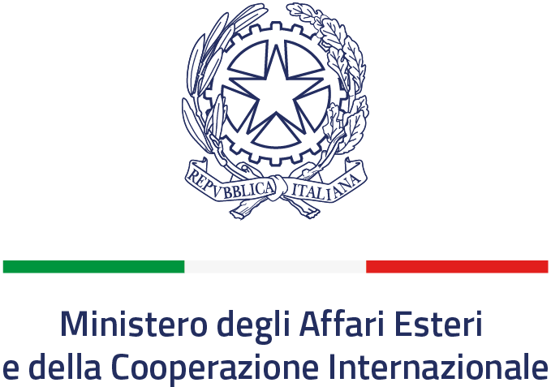 | Ministry of Education, Science, Culture and Sports

ITALY – MONTENEGRO
SCIENCE AND TECHNOLOGY COOPERATION
CALL FOR JOINT RESEARCH PROPOSALS FOR THE YEARS 2022-2024

CLOSING DATE: February 14th 2022, h 12:00 C.E.S.T.

BACKGROUND
Within the framework of the Scientific and Technological Cooperation between the Government of Italy and the Government of Montenegro, signed in Podgorica on September, 26, 2013, and entered into force on February, 19, 2018, the Directorate General for Cultural and Economic Promotion and Innovation – Office IX of the Italian Ministry of Foreign Affairs and International Cooperation and the Ministry of Education, Science, Culture and Sports of Montenegro, hereinafter referred to as the “Parties”, are opening a call for proposals for the second Executive Programme of Scientific and Technological Cooperation for the years 2022 - 2024.
- GENERAL INFORMATION
  - FUNDING SCHEMES
With regard to the present call, one funding scheme is available:
- “Joint Research Projects”: this funding scheme is aimed at supporting joint research activities. Inclusion of early career scientists in the research team will be positively evaluated. The expenses for research activities are co-funded by both Parties.
Further details on the funding scheme, including priority research areas, are given in below.
  - ELIGIBILITY REQUIREMENTS
Project proposals:
- must be written in English;
- must have the same duration of the Executive Programme (E.P.): 3 years, 2022-2024.
Each Principal Investigator (P.I.):
- must submit only one proposal;

Italian Party:
- the call is open to public or private (no-profit) research institutions;
- the PI must have Italian or any other EU nationality, legal residence in Italy, and must be affiliated with a public or private (no-profit) Italian research institution with a permanent position, or a temporary position covering at least the entire duration of the proposed project.

Montenegrin Party:
- For the Montenegrin Party, the call is open to public or private research organizations. Scientific researchers who are registered in the Register of the Ministry of Education, Science, Culture and Sports of Montenegro can apply for the competition. The project must meet the requirements in accordance with the Law on Scientific Research Activity.
- Principal Investigators must have Montenegrin or any other EU nationality, legal residence in Montenegro and a permanent working position or a temporary position covering at least the time extent of the project in the Organization they belong.

1.3 REASONS FOR EXCLUSION
- Lack of any one of the eligibility requirements listed above;
- incomplete application (including additional documents where applicable - see point 4 below);
- proposals submitted in different priority research areas by the collaborating PIs in the two countries;
- proposals submitted in only one of the two countries.

- Priority Research Areas
Projects of “Joint Research Projects” must be submitted in one of the following priority research areas only:
- Agriculture and Food Sciences
- Environment, with particular attention to Blue Growth
- Natural risk assessment and mitigation
- Cultural Heritage and related technologies

Proposals submitted in other research areas will not be considered for evaluation.
Only some of the above listed research areas may be funded, depending on the scientific quality of the submitted proposals.

- SUBMISSION PROCEDURES
Joint proposals must be submitted to both Parties. The proposals must be written English and have the same duration of the E.P. (3 years: 2022-2024).

Italian Party:
- Proposals shall be submitted exclusively online, by filling the dedicated forms at the following link: http://web.esteri.it/pgr/. For any inquiry concerning the present call, please contact the following email address: dgsp-09bandi2@esteri.it
- For projects involving experiments with animals, the status of ethics approval by the competent Ethics Committee must be provided when submitting the proposal. Please note that formal authorization by the competent Ministry of Health is mandatory to start the activities (D.Lgs 26_04/03/2014 and Directive 2010/63 EU). Proof of submission to the institutional OPBA (Organismo Preposto al Benessere degli Animali) is acceptable at the proposal submission stage. Projects involving experiments with human beings must be performed in accordance with the Directive 536/2014/EC. The Italian Principal Investigator should include a self-declaration of adhesion to the above cited rules in the Methods section of the proposal.
- Applications for the Joint Research Projects funding scheme must be accompanied by an endorsement letter signed by the legal representative of the applying Institution, or her/his delegate duly authorized by formal provision [a template is available at the URL https://www.esteri.it/it/diplomazia-culturale-e-diplomazia-scientifica/cooperscientificatecnologica/avvisiincaricobandi/
The letter has to be uploaded at the following link: http://web.esteri.it/pgr/

Montenegrin Party:
- The Montenegrin coordinator must submit the proposal in English and Montenegrin language exclusively through the following e-mail address: ivana.lagator@mpnks.gov.me and on the official address of the Ministry of Education, Science, Culture and Sports, Vaka Djurovića bb, 81000 Podgorica.
- Any inquire about the present call can be sent to the coordinator, in charge for the bilateral cooperation with the Republic of Italy: ivana.lagator@mpnks.gov.me.

- EVALUATION OF PROPOSALS AND SELECTION AT NATIONAL AND BILATERAL LEVEL

4.1 Evaluation process
After the call closure, all submitted proposals will undergo formal eligibility check before moving to the two-steps evaluation process. The first step will be performed at the national level to identify a shortlist of proposals. The second step of the evaluation process will be performed at the bilateral level. The two Parties will reach consensus on the final list of projects eligible for funding during the meeting of the Joint Commission, which includes representatives from both countries. The selected projects will be included in the text of the Executive Programme that will be posted in the websites of both Parties at the end of the process (see point 5.2 below).

Project proposals will be evaluated according to the following criteria:

- Scientific relevance of the proposed research
- Methodology and documentation
- Qualification and expertise of the research teams
- Added value of the bilateral cooperation
- Involvement of early career scientists
- Exploitation and dissemination of the results
- Budget adequacy

Preference will be awarded to:
- Proposals involving more than one national public/private research organization
- Initiatives carrying potential industrial impact and/or involving industrial partners (a letter stating the Expression of Interest of the company can be included in the latter case)

4.2 Outcome of the evaluation
For the Italian Party the official text of the Executive Protocol, including the list of selected projects, will be published in the MAECI website at the following link:
https://www.esteri.it/it/diplomazia-culturale-e-diplomazia-scientifica/cooperscientificatecnologica/programmiesecutivi/accordi_programmi_culturali_tecnologici/
Only the PIs of the selected projects will be directly informed by e-mail of the outcomes of the selection process.
For the Montenegrin Party, the list of the selected projects and funding procedures will be posted exclusively on the website of the Ministry of Education, Science, Culture and Sports at the following address: https://www.gov.me/mpnks
Both parties commit not to provide information on selected/excluded projects (including the outcomes of the formal eligibility check mentioned in the point 4.1 above) until the end of the process, with the signature of the Executive Programme.

- FUNDING PROCEDURES

Funding will be granted to the projects listed in the Executive Programme within the limits of the available annual resources of each Party.
5.1 Funding scheme “Joint Research Projects”
Italian Party: Funding for projects selected and listed in the EP will be provided on a yearly basis. In particular, according to Italian law Nr. 401/90, and in accordance with the specific call issued by Office IX of the Directorate General for Cultural and Economic Promotion and Innovation of the Italian Ministry of Foreign Affairs and International Cooperation, the PIs of the projects listed in the Executive Programme will be invited to submit a request for funding at the beginning of each year of project activity.
After the end of the first year of activity, the Montenegrin and the Italian coordinators must submit an annual report on the progress of their project by January 31st as indicated in the text of the Executive Programme. The coordinating Institution is expected to anticipate all project expenses and will be reimbursed on a yearly basis, upon submission of the financial documents and positive evaluation of the corresponding scientific report.
Funding for the following year will not be granted if the coordinators fail to submit their progress reports.
The contribution granted by MAECI to “Joint Research Projects” is intended as co-funding support for the project, and therefore co-funding by the coordinating Italian Institution of approximately 50% of the total costs of the project is mandatory. Co-funding can include salaries of the involved personnel and indirect costs. Any other financial contribution from public or private, Italian or Montenegrin Institutions, will be positively evaluated.
The average cost of a project is approximately 60K€/year, including co-funding by the applying institution.
The Montenegrin Party will also consider granting financial contribution, within the limits of the available financial resources to these projects. Based on the provisions of the Law on Scientific Research Activity (“Official Gazette of Montenegro”, no.80 of 31/12/2010, 40/11, 57/14), Article 12 and Article 13, institutions will be invited to submit a request for funding at the beginning of each year of project activity.
The contribution granted by the Ministry of Education, Science, Culture and Sports of Montenegro to “Joint Research Projects” is intended as co-funding support for the projects, and therefore co-funding by the coordinating Montenegrin Institution of approximately 50% of the total costs of the project is mandatory. Co-funding can include salaries of the involved personnel and indirect costs. Any other financial contribution from public or private, Montenegrin or Italian Institutions, will be positively evaluated.
The average cost of a project is approximately 20-25 K€/year, including co-funding by the applying institution.

6. CONTACT INFORMATION
For additional information on the present call, applicants can refer to the following contacts
In Italy | In Montenegro
Office IX - Directorate General for Cultural and Economic Promotion and Innovation Ministry of Foreign Affairs and International Cooperation (MAECI)  E-mail: dgsp-09bandi2@esteri.it | Ministry of Education, Science, Culture and Sports-Directorate for European Integration, Programming and Implementing of EU funds and International Cooperation  E-mail: ivana.lagator@mpnks.gov.me

In-kind personnel costs excluded.

