FAAI: Teacher training 4.5 has been conducted at University of Montenegro

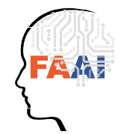

During May 15-19, 2023 teacher training activity was hold at Podgorica (Montenegro) within Erasmus+ Project No. 2022-1-PL01-KA220-HED-000088359 “The Future is in Applied Artificial Intelligence” (FAAI)
The training was hosted by University of Montenegro as the hosting organization. The representatives of 5 HEIs were trained, prepared educational materials, guides, and reported for 5 days (35 hours). Totally 25 participants were trained within the framework of the project, namely from University of Bielsko-Biala (UBB), University of Library Studies and Information Technologies (ULSIT), University of Nis (UNi), University of Ss Cyril and Methodius in Trnava (OSCM), University of Montenegro (UoM).
The goal of the joint staff training was to transfer and share the knowledge regarding the developed "Artificial Intelligence Competency Framework", "Artificial Intelligence Learning Requirements" and "Мain content and topics of the curriculum". The given training activity was organized within a framework of the work package 4, as a result of which there should be developed learning methodology and learning materials for training teachers.
The meeting was started from the greeting of the participants from the host institution. Prof. Igor Jovancevic has sent the wishes of the authorities of UoM with the successful conducting of the Ersmus+ activity. Then the institutional coordinators introduced the participants of the training.
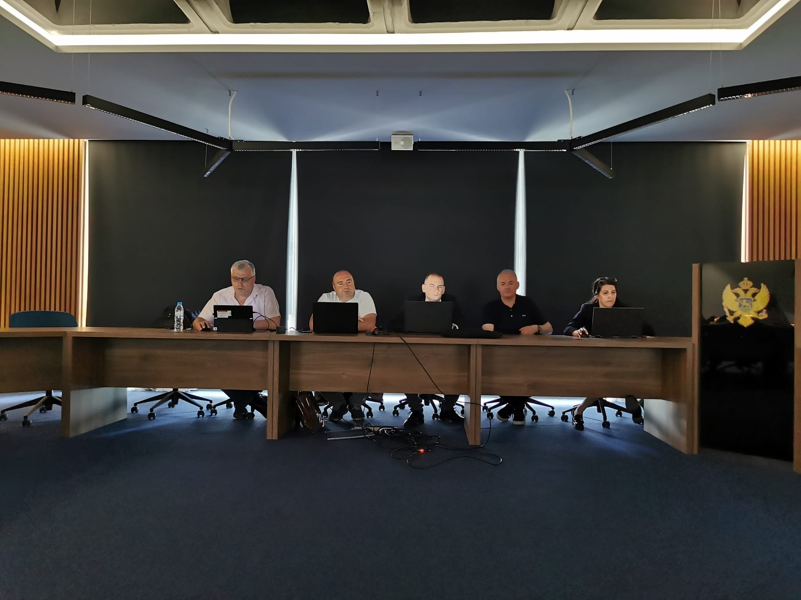
Photo. Steering Team of FAAI at opening ceremony of the activity A4.5

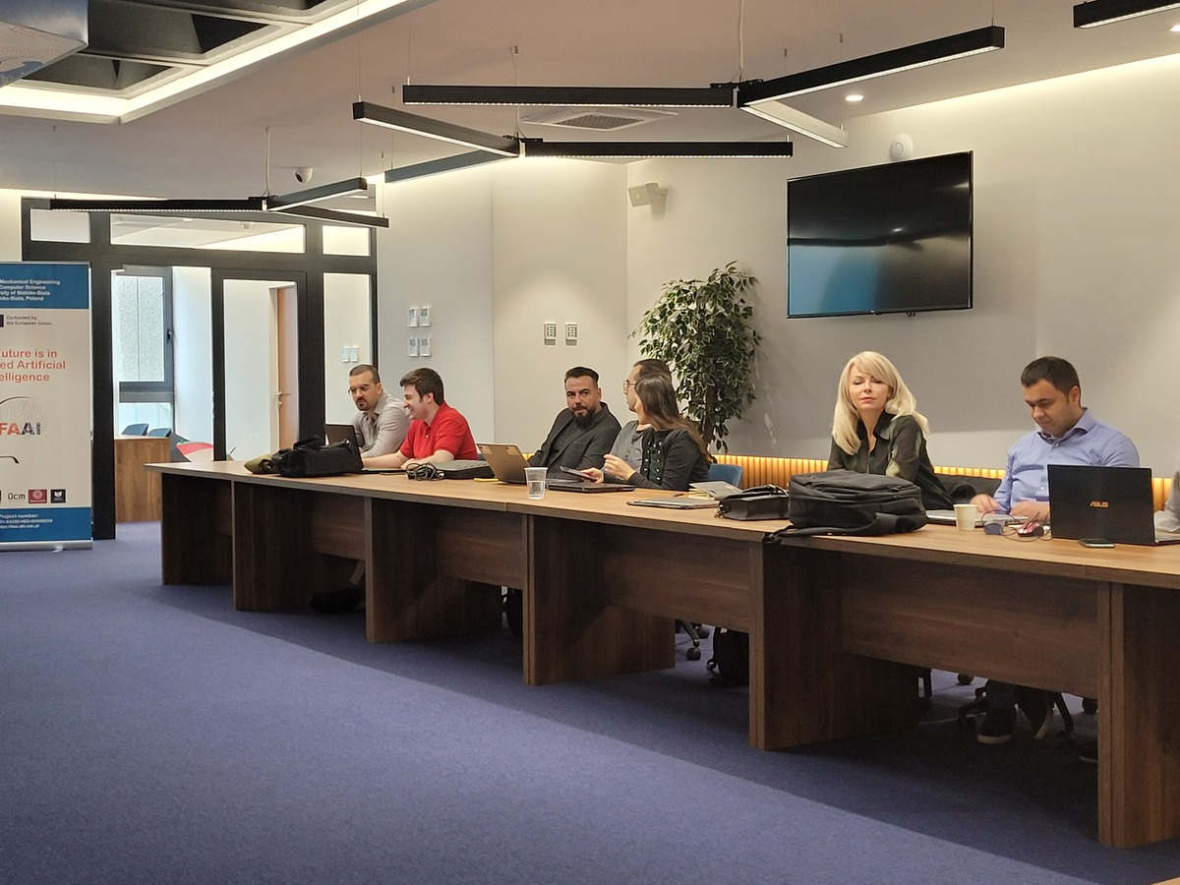
Photo. Participants at the training

The official part of the meeting was started by professors Vasyl Martsenyuk (UBB) and Georgi Dimitrov (ULSIT).
In the speech they introduced the trainees to the project FAAI. They focused primarily on the objectives and target groups of the project.
State-of-the-art analysis of the requirements in the field of AAI was reported by prof. dr hab. Vasyl Martsenyuk.
Prof. Georgi Dimitrov presented the most important results of the project concerning work package 2 “Artificial Intelligence framework for training in HE: requirements to the course”.

For the better awareness of the project the trainees were informed about the studies performed at the previous stages.

Namely, Aleksandar Plamenac (UoM) has presented two reports: “State-of-the-art analysis on Research 1: Existing Training Courses in the Field of Applied AI” and “State-of-the-art analysis based on Research 2: Study of the labor market in the field of applied AI”.
The team from USCM led by Professor Iveta Dirgova-Luptakova reported on their analysis of the research. In turn, Professor Jiri Pospichal introduced the trainees to the studies: “State-of-the-art analysis based on Research 3: Survey of scientific projects in applied AI” and “State-of-the-art-analysis based on Research 4: Survey for Academics (lecturers)”.
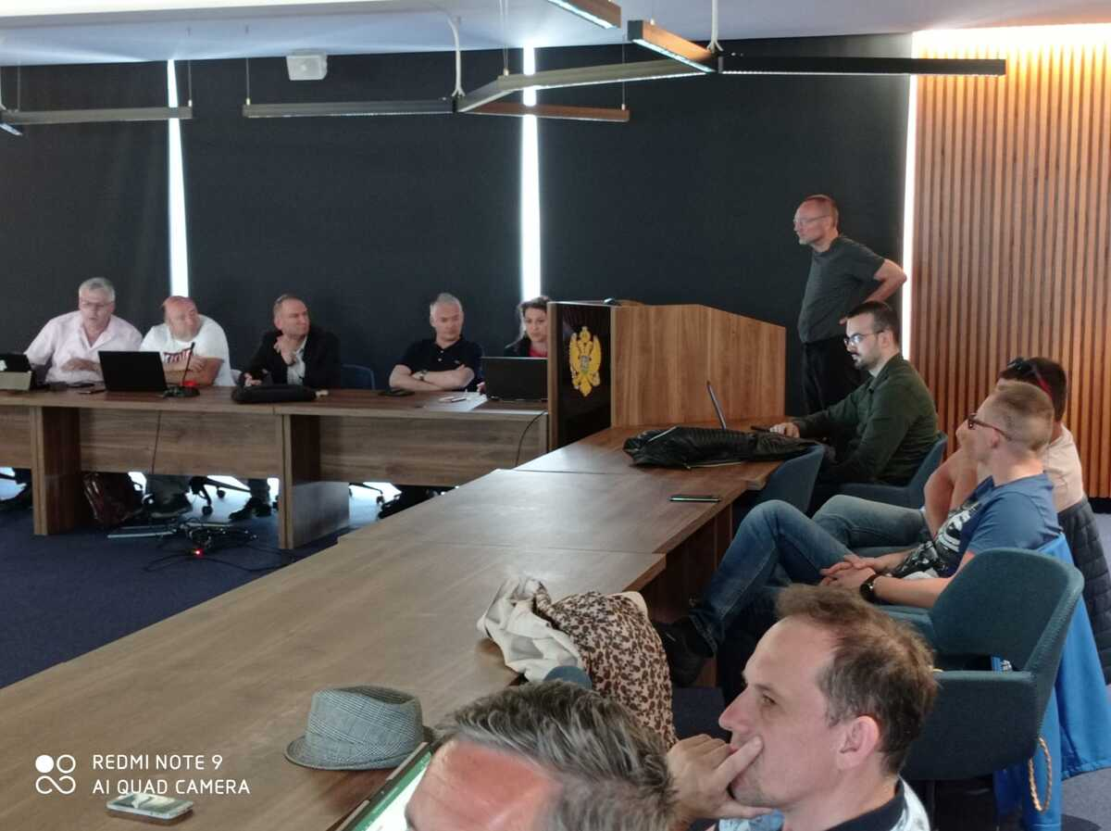
Photo. Prof. Jiri Pospichal is presenting the analysis of research

The team from UNi led by Professor Dejan Rancic reported on their analysis of the research. Thus Professor Marko Milojkovic introduced the trainees to the studies: “Analysis of the surveys by filled in by students and alumni on AAI (Research 5)” and “State-of-the-art analysis based on Research 6: Questionnaire for employers: Specifying Graduate Competencies in Data Science”.

The team from ULSIT played very important role for the analysis of existing use cases in field of AAI. Professor Georgi Dimitrov reported on the studies entitled “State-of-the-art analysis based on Research 7: Collecting IT specifications of good practices in AI” and “State-of-the-art analysis based on Research 8: Collecting real cases of AAI”.

Ethical problems are requiring a special attention in area of AAI. Professor Eugenia Kovatcheva prepared the report “Ethical perspective of AAI” where she focused on the most important ethical challenges of AAI.

On Tuesday 16th of May the meeting started from introducing the methodology for training in AAI which was conducted by team from ULSIT. Professors Georgi Dimitrov and Eugenia Kovatcheva presented the conceptual model of the methodological approach for competence-based education in area of AAI.
Special attention was given by participants to preparing the lectures in AAI in the form of Question and Answer Sessions. A corresponding report was displayed by team from UNi (led by prof. Dejan Rancic).

One of the objectives of the project is that academic institutions will get knowledge transfer from industry and external experts (practitioners), new pedagogical approach and methodology and quality of education measured in terms of transversal skills and graduates’ preparation for current and future job markets. We are trying that HEIs will also build stronger and longer partnerships with employers, make a switch to student-and problem-centered learning regarding pedagogy, curriculum, and quality assurance; increased capacity of HEIs to adapt to changing needs and to re-connect with their communities. For this reason, special session was organized with the reporting of IT companies from Montenegro specializing in AAI entitled “Study of good practice in the field of AAI based on IT area in Montenegro: the ways of cooperation with HEIs”.
Three reports were presented concerning the real cases and involvement the IT companies into the educational projects. Nikola Bulatovic and Itana Bulatović shared the experience of MAIA (the Montenegrin AI Association).
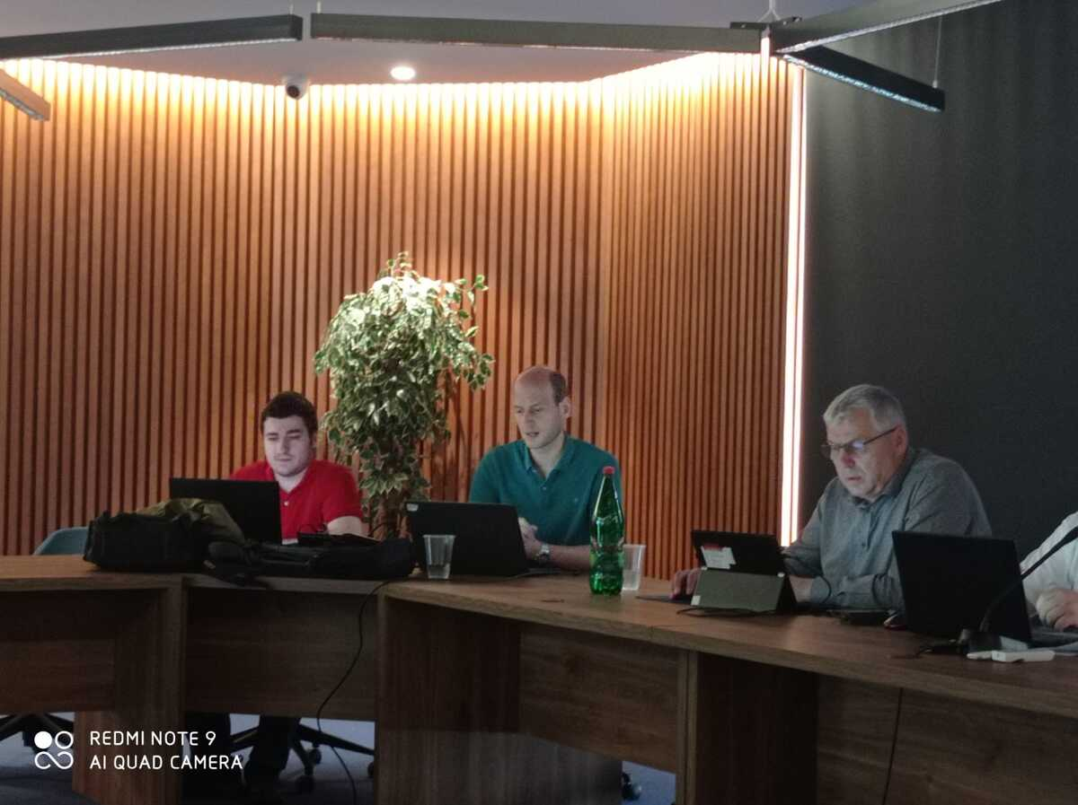
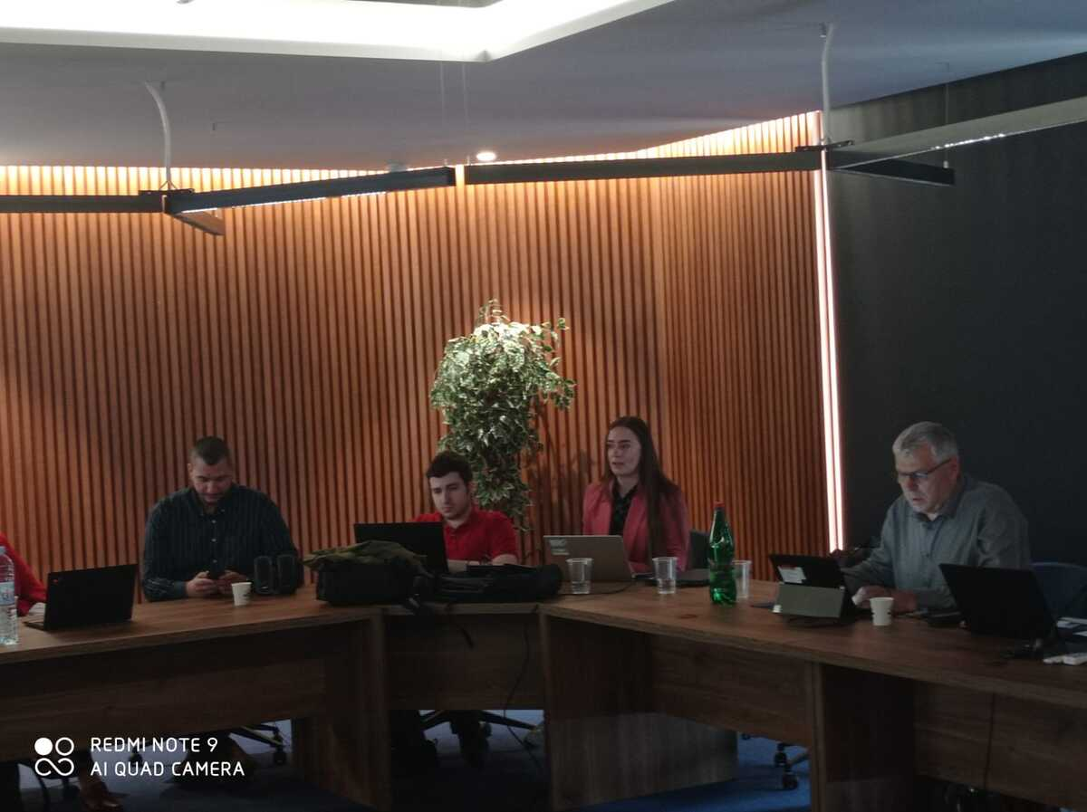
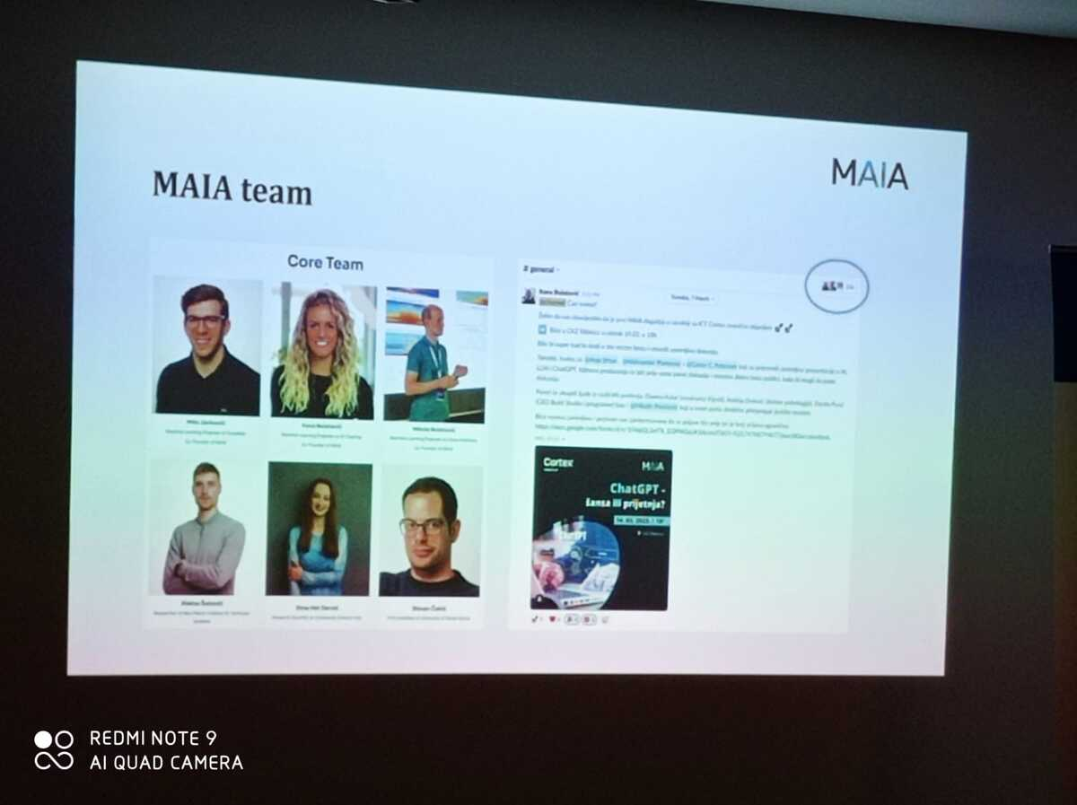
Maja Rolevski has shown interesting AI problems from company Uhura Solutions.
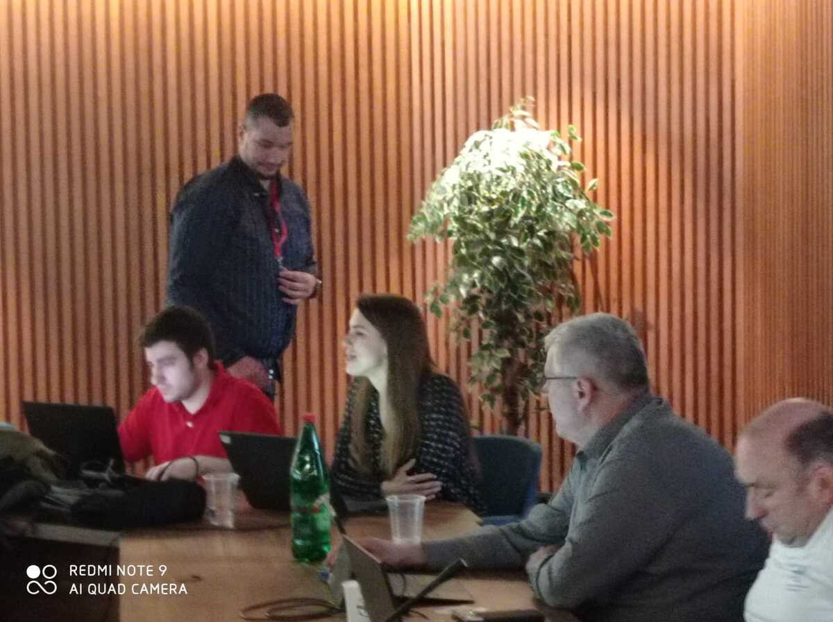
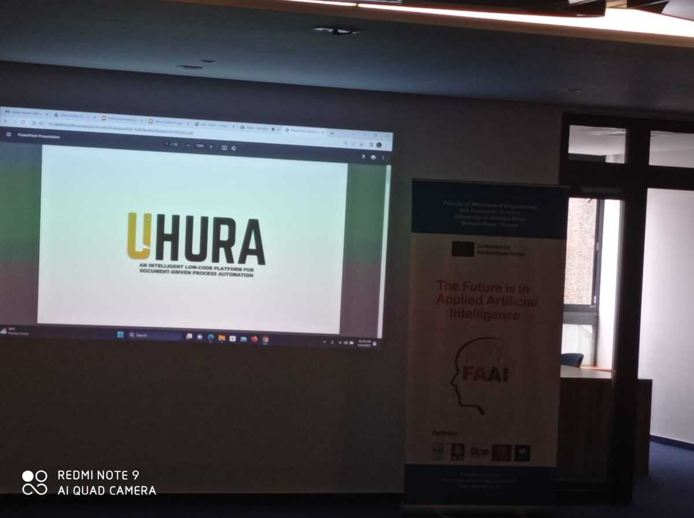
Ana Ašanin has shown the results of company Spectro regarding AI (intelligent fire detection service).
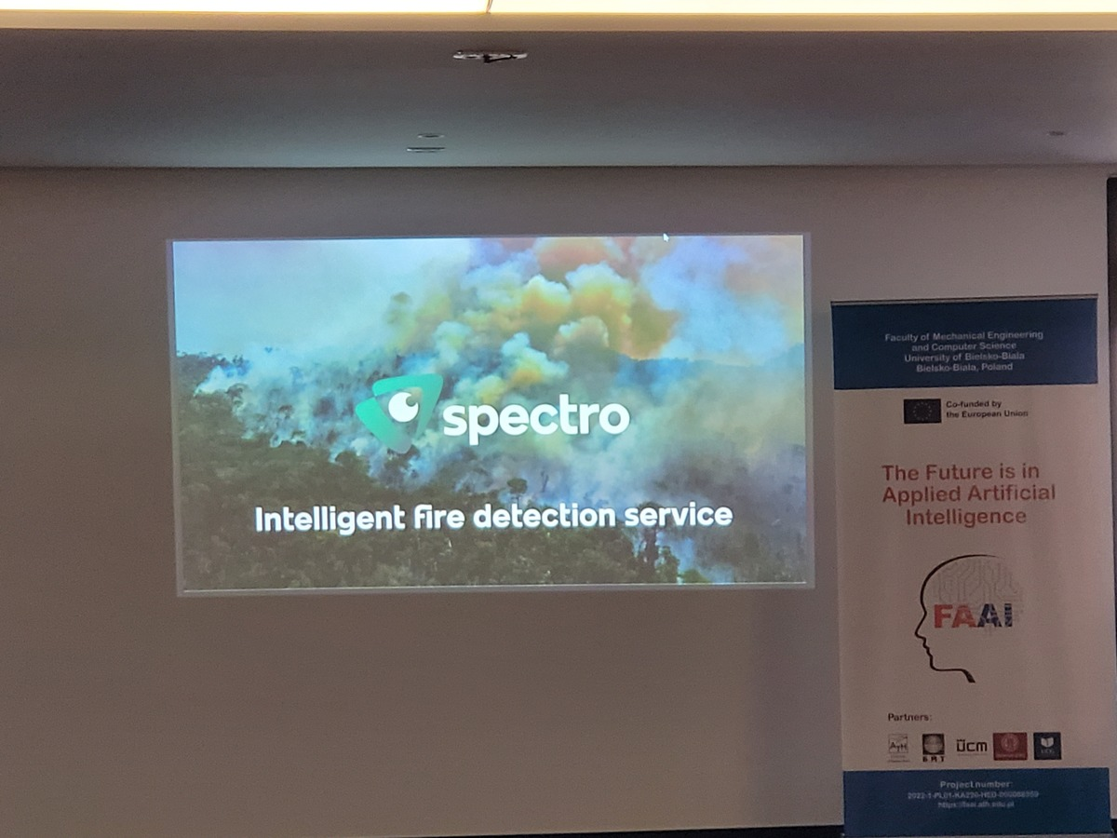
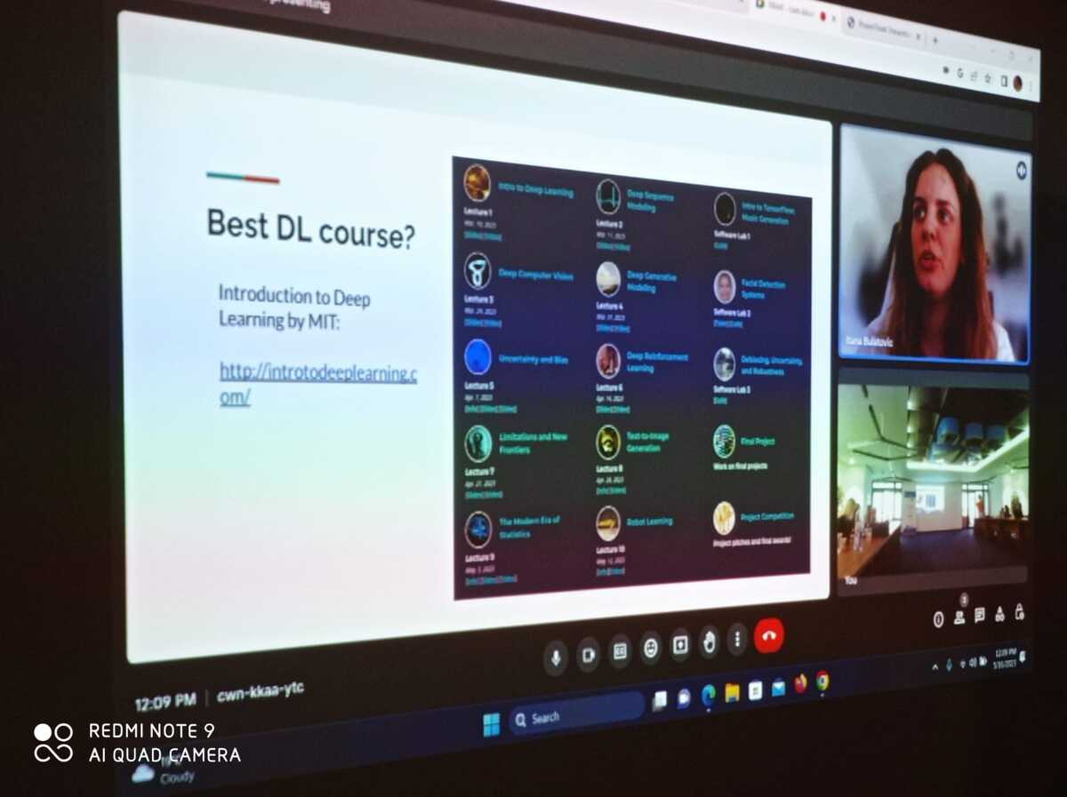
When summarizing the perspective ways of interaction between IT companies and HEIs Nikola Bulatovic has offered innovative approach for AI training in the report “Preparing the classes in AAI for competence-based education”.

Prof. Jiri Pospichal presented the approach for preparing use cases in AAI for competence-based education (case study, team working).
Prof. dr hab. Vasyl Martsenyuk has focused on preparing methodologies for the competence examination (quizzes etc.). Also, he described the ways in which to develop learning trajectories.
The participants of the training were planned to have opportunity for team working, as a result of which there were developed guidance for the AAI course as well as curriculum.

During the training a lot of attention was paid to presenting and studying the experience of AI teaching. Tijana Marković, PhD, Assistant Professor from Malardalens University (Sweden) shared her background on the teaching of AI in the report “Applied AI from teaching perspective”.
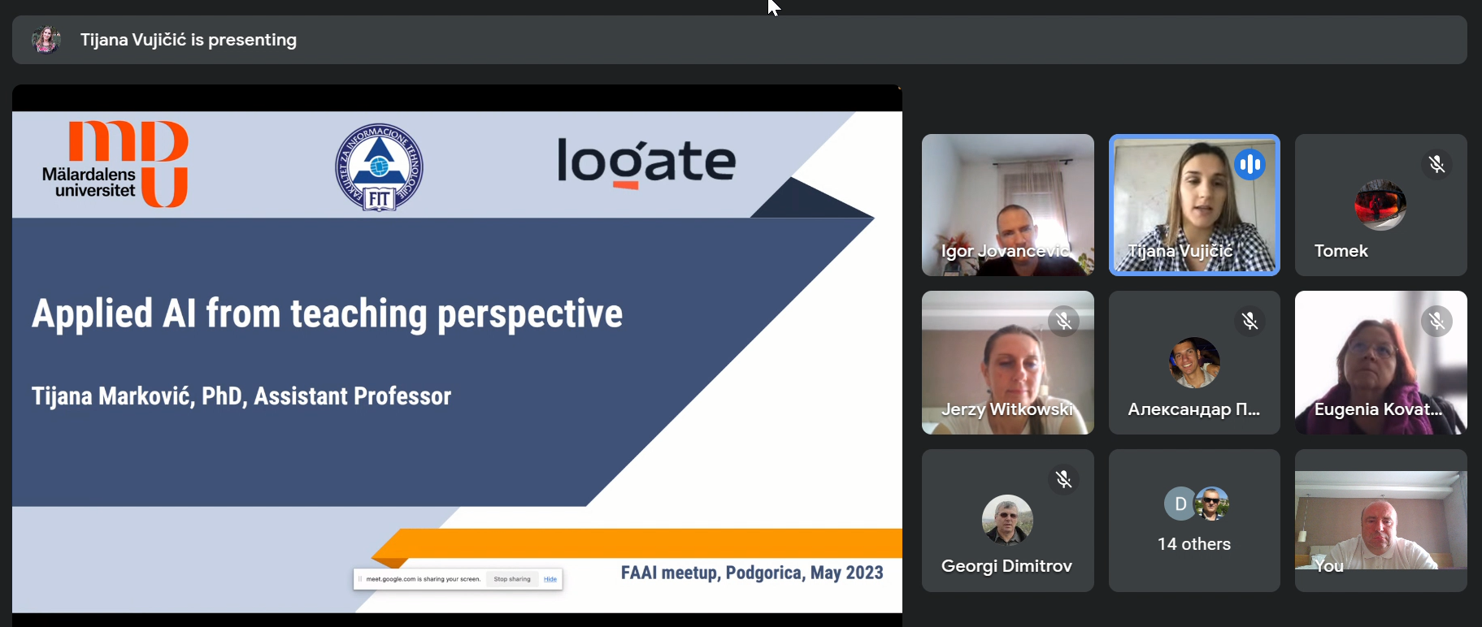
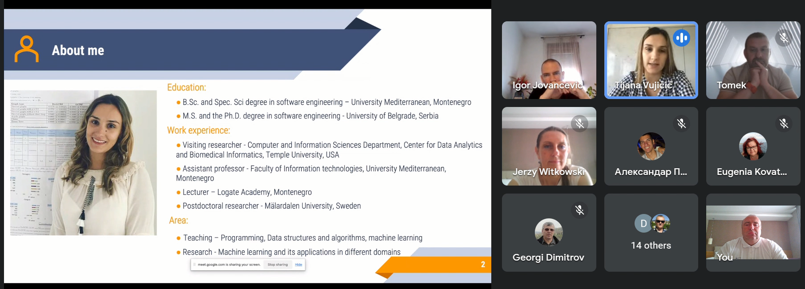
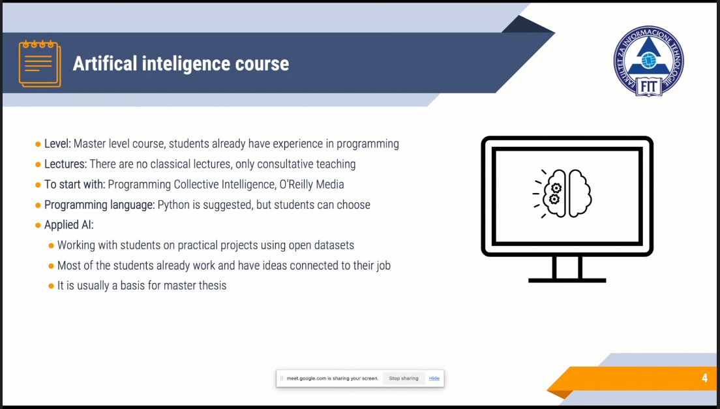

During the 18th of May, the attention of the participants was paid to the presentation of the educational materials developed by the teams from UBB, ULSIT, UNi, USCM, UoM. The curriculum including the general requirements for the learning activities and assessment was presented by prof. Georgi Dimitrov and Eugenia Kovatcheva (ULSIT).
The outlines of the separate module of the course were presented by the responsible teams.
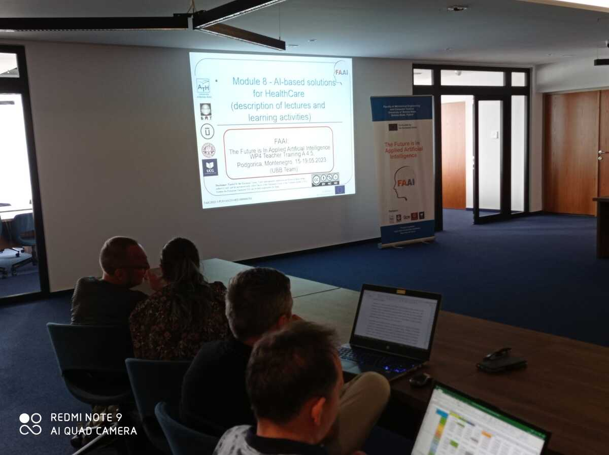
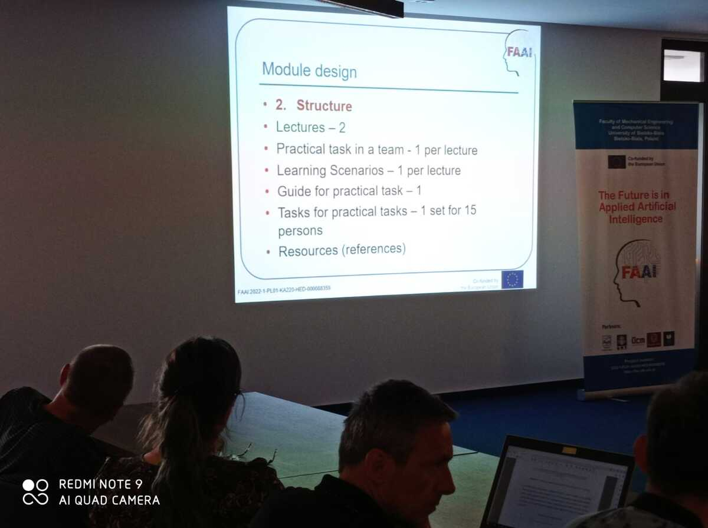

The results of the teacher training mentioned above will be of great importance for the future FAAI project activities.
Also, great attention was paid to the development of skills of preparing the dissemination materials of the project. The participants were encouraged to prepare and submit the works to the 16th IEEE Conference TELSIKS 2023 with the special section devoted to FAAI.

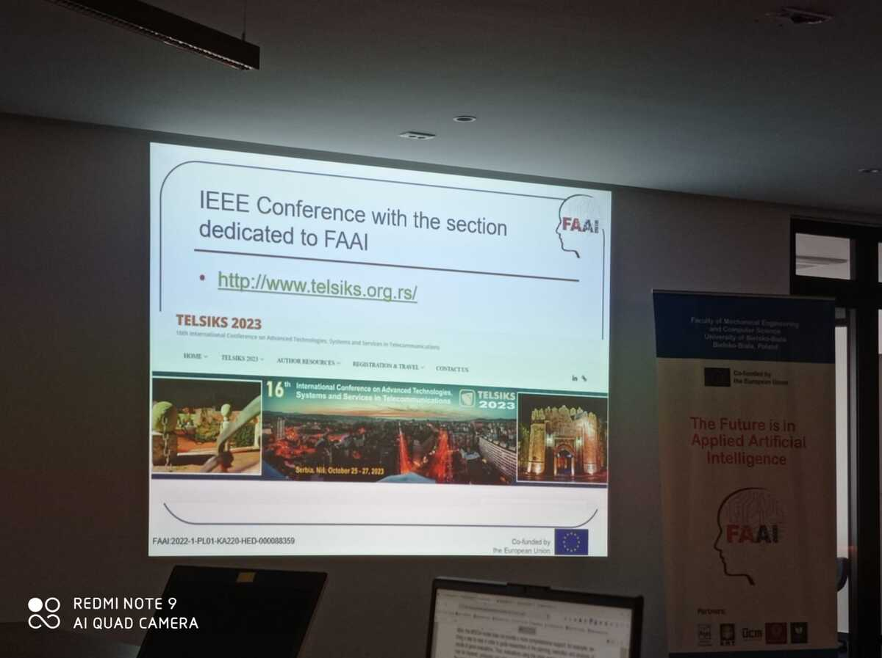

As a result of the common work of the teams professor Vasyl Martsenyuk presented an outline and sketch of the all-consortium publication entitled "Design of competency-based course on Applied AI basing on advanced system research of business requirements” which is planned to be publish in a prestigious journal.
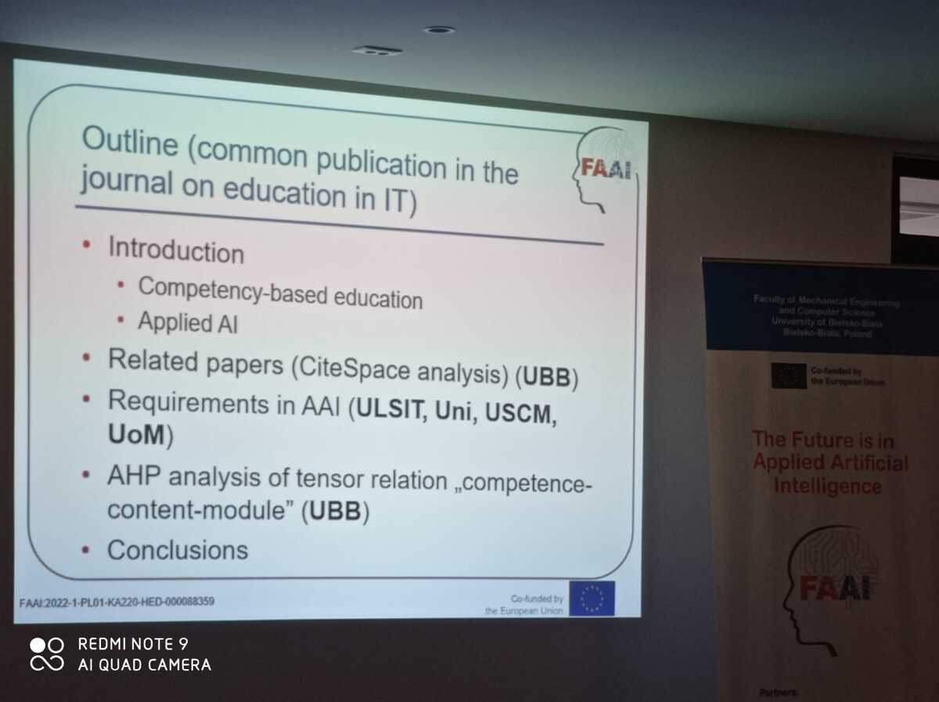

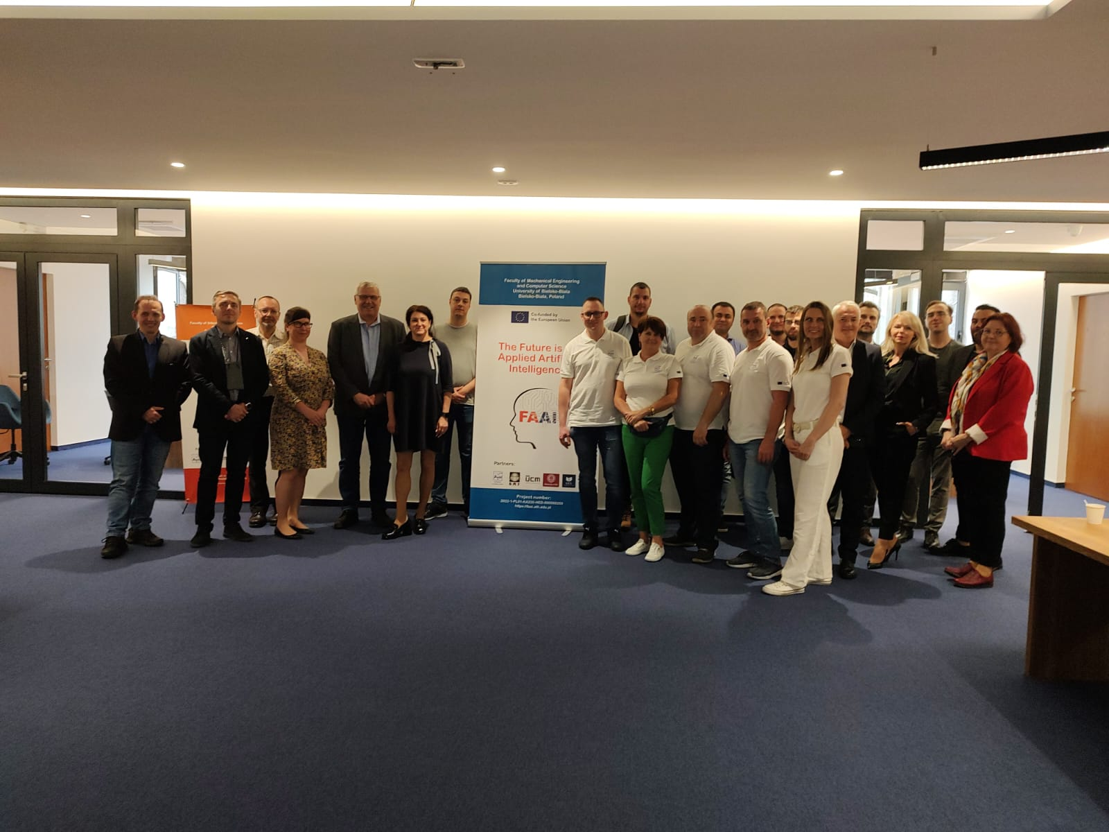
Photo. After the opening ceremony

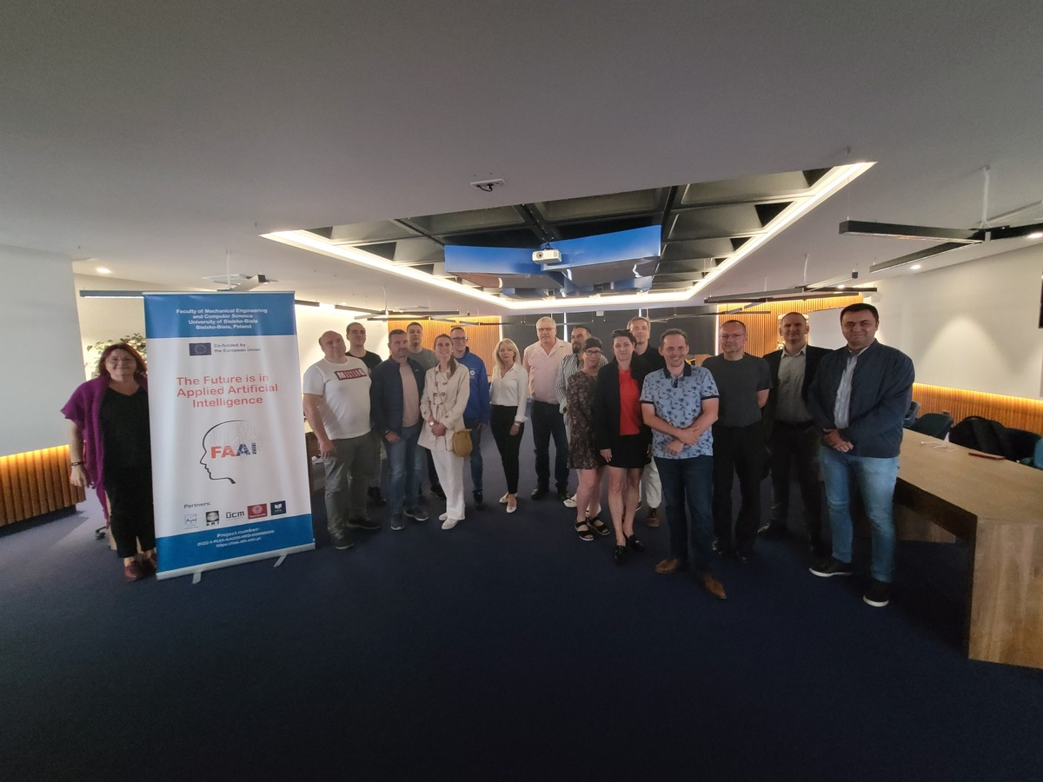
Photo. After the closing ceremony

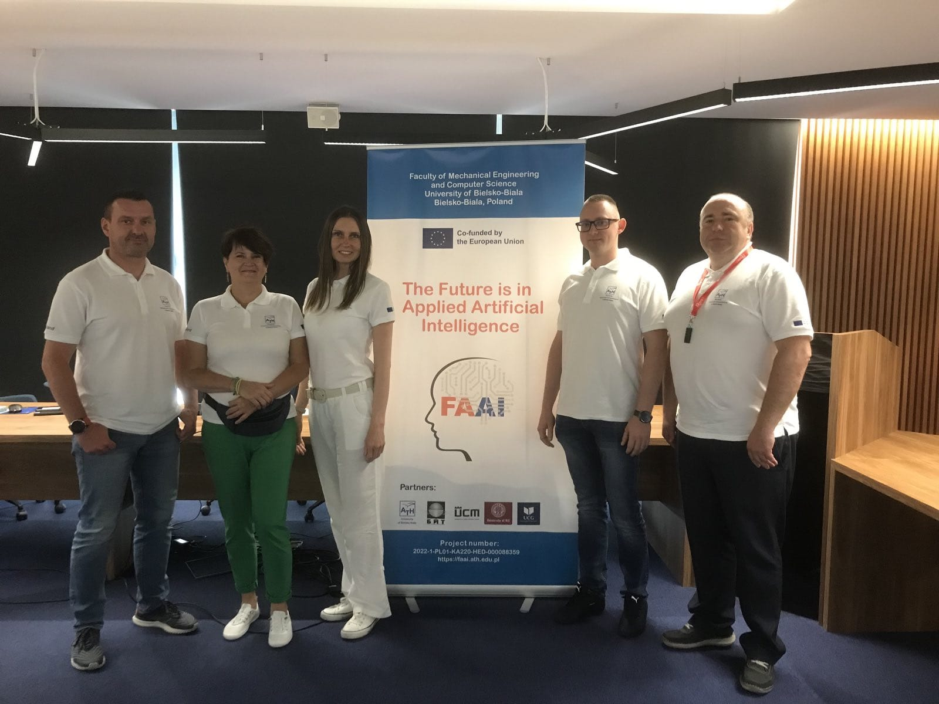
Photo. The team of UBB at the opening ceremony

Conclusions: Preparing staff members to create educational materials on Applied AI is crucial for ensuring the quality and relevance of the content of FAAI project. They can leverage their expertise and practical experience to design engaging and informative materials that effectively convey the principles and applications of AI.
For the reasons given, teacher training A4.5 became valuable for fostering collaboration and AAI knowledge sharing among project teams. By providing a platform for educators to exchange their experiences and insights, the training will enable the development of more effective educational materials on Applied AI.
During the training, it was beneficial for the staff to explore various teaching methodologies and strategies that are best suited for teaching Applied AI concepts. They can learn how to incorporate real-world examples, case studies, and hands-on activities to enhance student understanding and engagement for getting AI competencies.
Additionally, staying updated on the latest advancements and trends in Applied AI is essential for teachers. This will enable the staff to provide current and relevant information in their educational materials and keep pace with the rapidly evolving field of AI.
Overall, the teacher training A4.5 will equip the staff with the necessary skills and knowledge to develop high-quality educational materials on Applied AI, thereby facilitating effective AI education for students which is one of the objectives of FAAI project.

