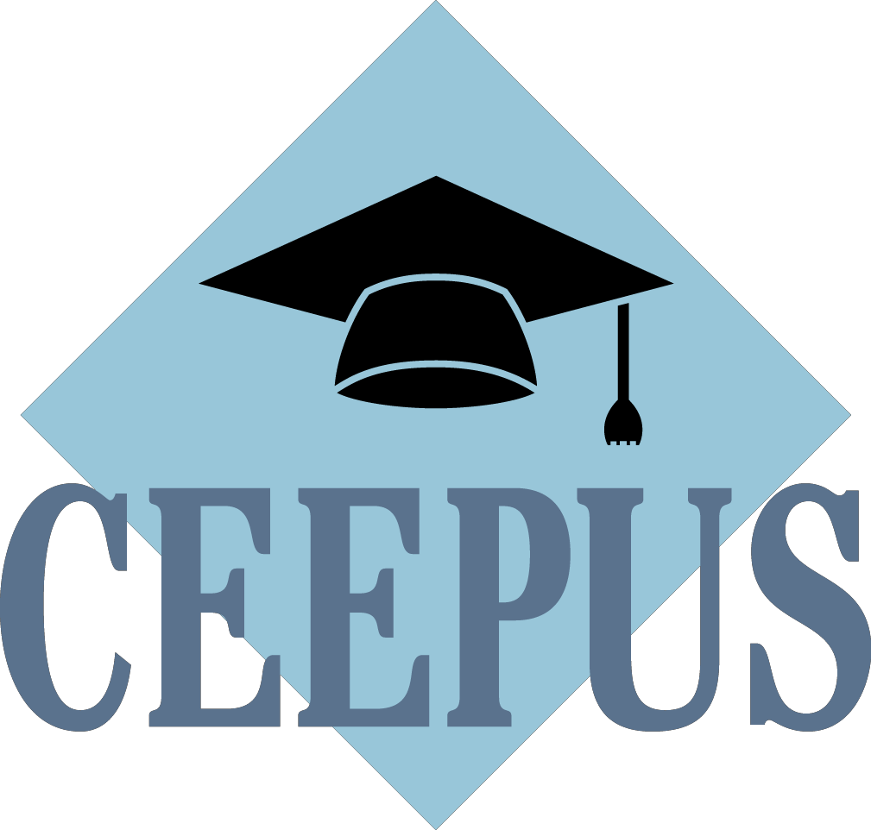

Guideline to the
Network Application Round
2022/23
First steps for a new application:

Always get in contact with your local National CEEPUS Office (NCO) for further assistance.
Please have in mind, that it is essential for a successful network application, to stay in good contact with all your network partners.

Your network is active in 2021/22 (also in umbrella status) and you want to prolong it:
Please access your network in 21/22 and click on the button “prolong”!
Some data (and Letters) will be copied to 22/23 for editing. Please note, that the application form was simplified, but you must fill out most of the entry fields new this year.

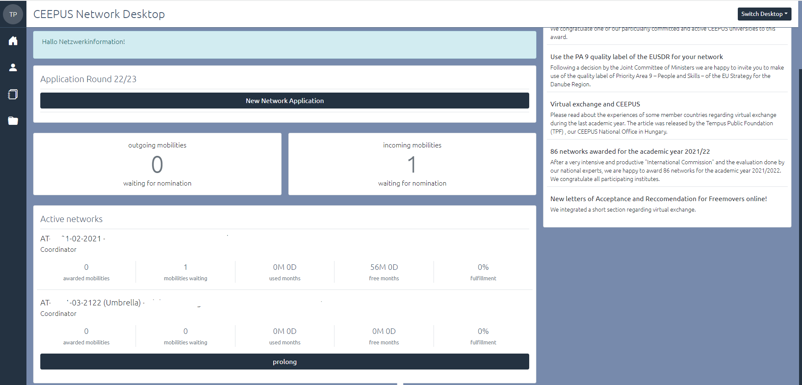

For further information please read the document HOW TO PROLONG A NETWORK

Your network has not been active in 21/22:
If your network was rejected: Please access your network in 21/22 and click on the button “renew” so that your data will be copied for editing to 22/23. Please have in mind that all documents (Letter of Endorsement, Letter of Intent) have to be uploaded again.
If you did not submit your network application in 21/22: Access it in 21/22 and click on “transfer”.

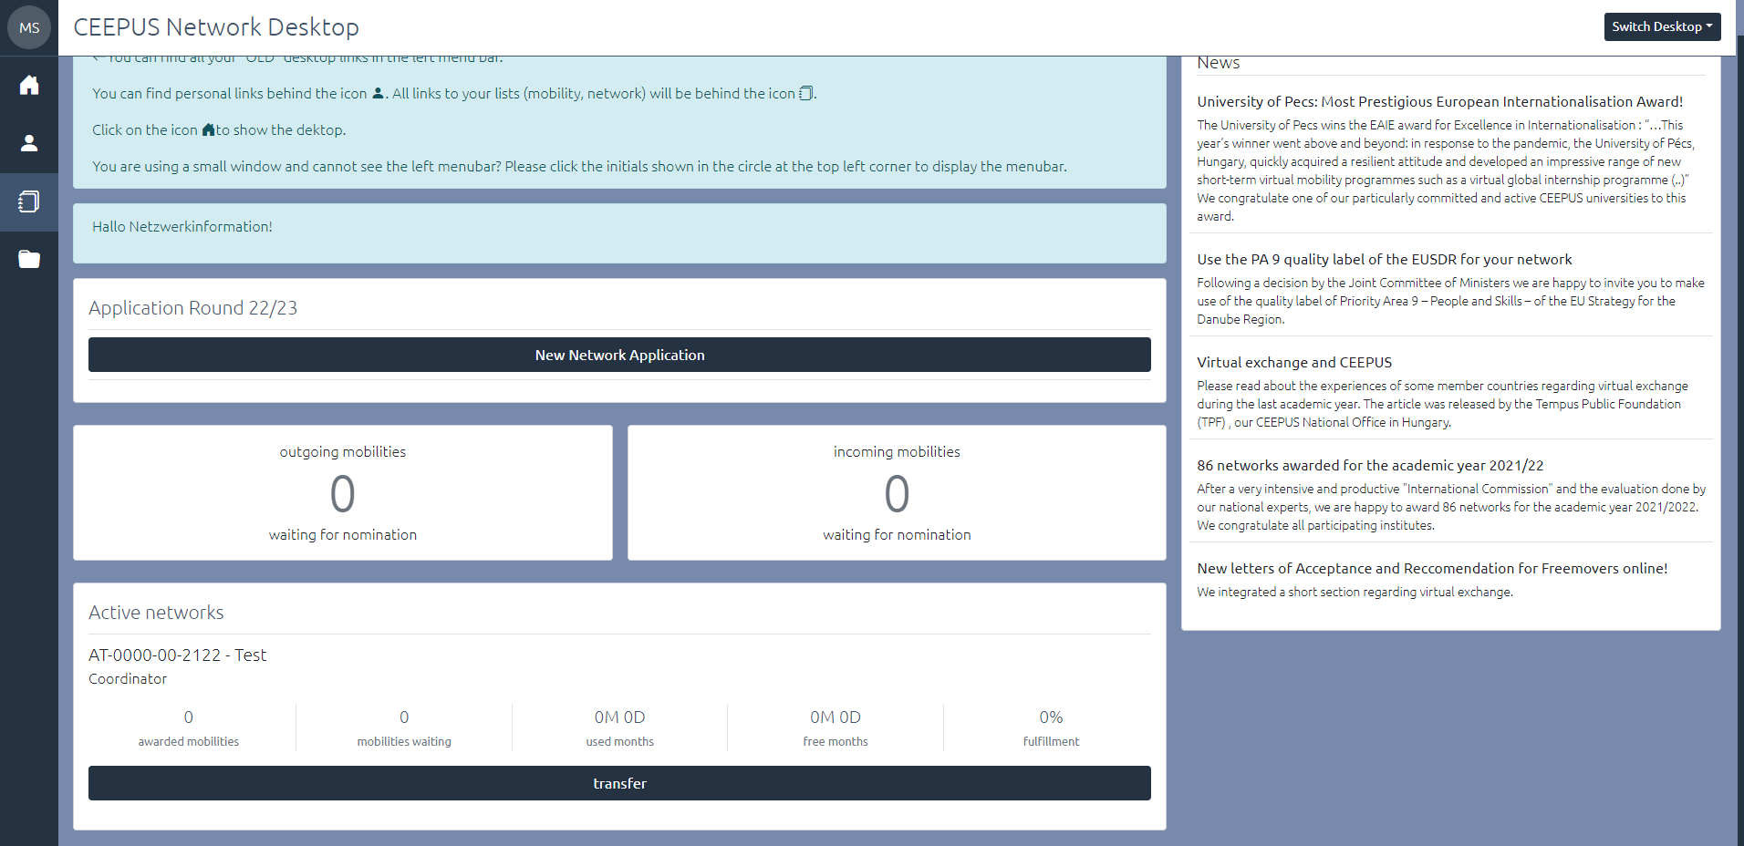

For further information please read the document HOW TO TRANSFER A NETWORK

You want to create a new network:

Please note, before you can start to create a new network application you need to register for managing a CEEPUS network at our system.
Please activate your registered CEEPUS account for network managing. Your local National CEEPUS Office needs to confirm your registration, please get in contact before applying. You will then obtain our software role “network”.
If you already have the CEEPUS “network” role, you can create or join as many networks as you want.

Only the academic coordinator of a whole network is allowed to create a new network.
Please click on the “New Network Application”.

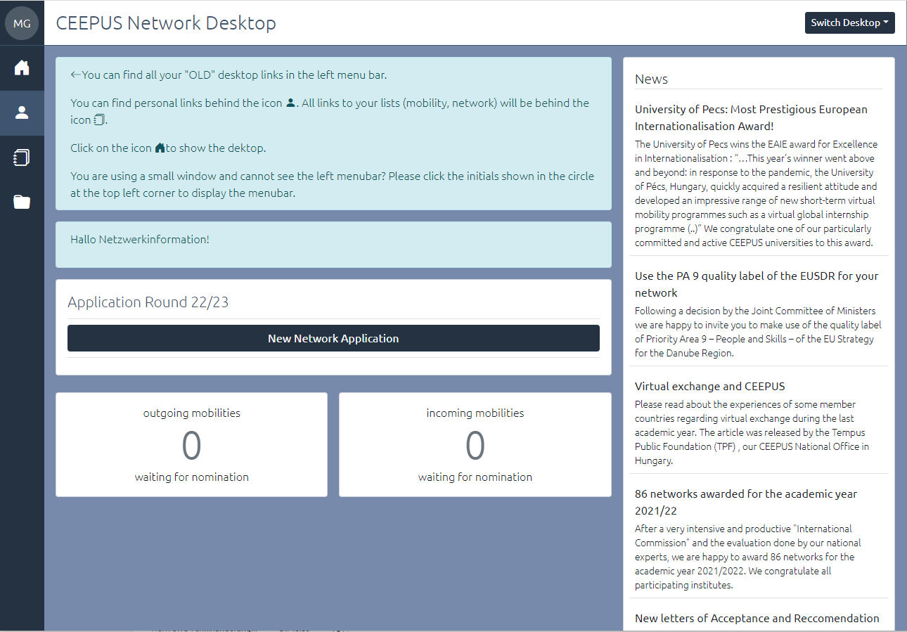

For further information please read the document HOW TO CREATE A NETWORK

If you click on “manage your network applications” you have also access to networks where you are a participating unit.

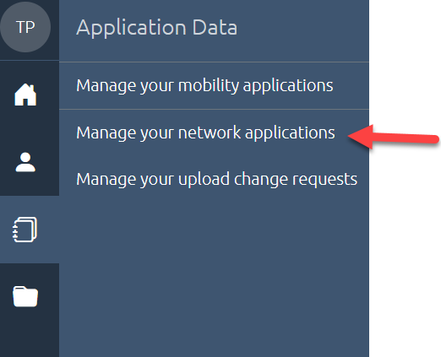

Please do not register more than once for managing a CEEPUS network
Once you have obtained the “network role” in our system, you can create a network and join several networks. If you only have the role “mobility” at the moment, use the registration link in your personal settings to request the role “network”.

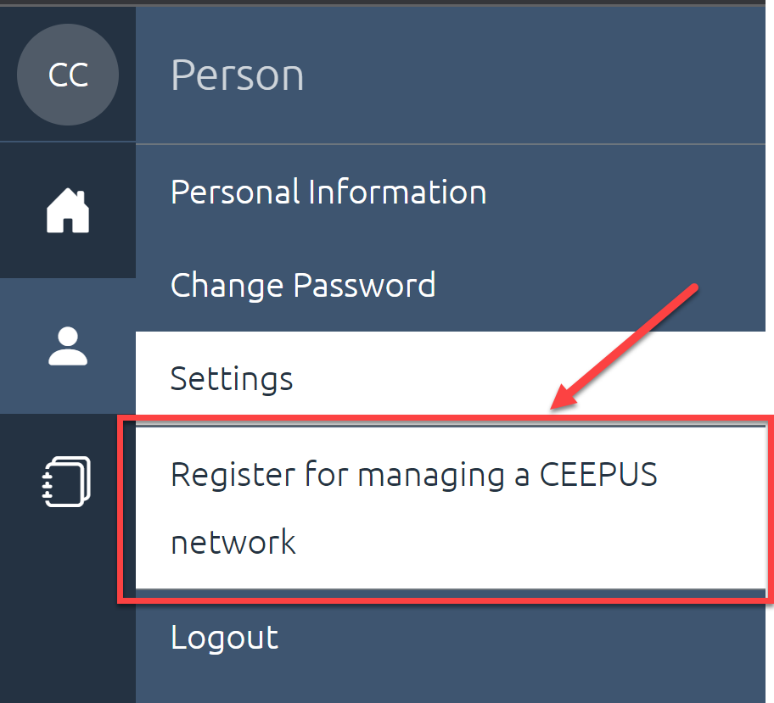

If you are /will be a network partner
Please do not create your own network application. Your coordinator will add you to the main application and then you can access the joint application.

Steps for a successful application:

Step 1:
Present your plans and achievements in a clear and crisp way so that experts have an easy time reading your application and evaluate your contribution.

Step 2:
Use the expert feedback contained in your Letter of Award/Umbrella/Rejection from the previous year.

Step 3:
Make sure you fill in the Network Report of the previous year and submit it in time so that experts get a clearer picture of your actions/achievements.
NOTE: Umbrella networks do not have to fill in a Network Report.

Step 4:
For Coordinators it is crucial to keep the data of each Participating Unit (PPU) and Silent Partner up to date. Each PPU must communicate in time, if they want to leave the network or change the contact person, however the responsibility for a correct network application ultimately lies with the coordinator. Please ensure regularly that your partner institutes continue to work actively in your network.

NEW SINCE 2021:

New network application form
To simplify the application process, we renewed the software design and shortened the form. Some questions remain as usual, some were adopted. Important: The main administrative fields of the network (like the participating units) remain unchanged and will be taken over when prolonging the network from last year`s application.

Be aware, that due to the merge of some questions, most of the fields related to the content of your networks (like “planned activities”, “special merit”) can no longer be copied from last year´s to this year´s application during the prolongation process. That means that you will need to fill them in again. Please plan in some extra time for your application this year.

LIVE SUPPORT - if you need help or have questions during the network application round you will find the support button ? here:

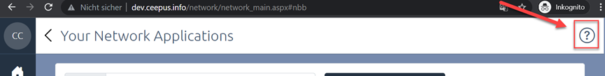

Joint Activities
Focus on Joint Programmes and These en Cotutelle:

The Joint Committee of Ministers in their New CEEPUS Work Programme decided to specify the definition of joint programmes within CEEPUS: Joint programmes are programmes leading up to double, joint or multiple degrees, and joint thesis supervision.

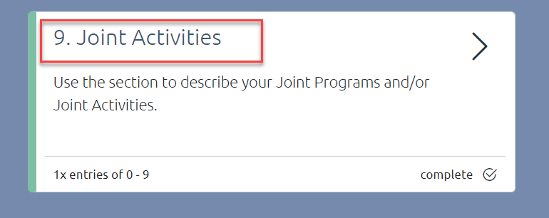

The section of joint programmes in the application form was adapted and was renamed to “joint activities”. Three new categories can be selected under “joint activities”:

I. Joint Programme leading to a double, multiple or joint degree:
integrated curriculum coordinated and offered jointly by different universities and leading to double/multiple degrees or a joint degree.

II. These en Cotutelle:
doctoral (or student) network with a joint supervision and graduation: based on a cotutelle agreement

III. Other joint activities: summer schools, winter schools, joint student group activities, joint intensive programs, joint certificate programmes etc…

Under category 3 you can - like before - enter all other forms of planned or active joint activities.

For category 1 and category 2 inter-university agreements, cotutelle agreements etc. related to the implementation of a joint programme are obligatory. Make sure that you upload the respective documents until Jan 30th , 2022.

Each joint activity must consist of at least 2 participating units from different countries.

Joint activities will be - as before - assessed by national experts and will receive experts´ scoring points.

But the Joint Programmes (category 1) and the These en cotutelle (category 2) will additionally receive a total of 5 extra points per application in the scoring.

General Information

Data Management
How to create a new Participating Unit (PPU):

- Please register at www.ceepus.info (NOTE: if you already have an account, a new registration is not possible)
- Apply for network rights by registering for managing a network, either choose an already existing Institution or create the institution. Please only create the institution if it doesn't already exist
- Afterwards the coordinator can add you/the PPU to the network

How to edit the contact information of a Participating Unit (=PPU):
- Email address: Every user him-/herself can update his Email under personal information

  - Address details of PPU, website: user with the role network/IRO for the PPU he/she is registered for
Where: Network Desktop - Edit your Participating Unit under base data

NOTE: the name of the PPU can only be changed by the National or the Central CEEPUS Office. Please be aware, that if a PPU´s name is changed, changes will appear in all networks it is involved in.

- New or changed contact person: During the year, only the National CEEPUS Office (NCO) can change contact persons.
ONLY during the NW application round the overall network coordinator can change contact information directly in the network application.

- Special cases: A PPU or a person has been moved to or merged with another institution: The NCO of the respective country needs to inform IT.

When prolonging, please make sure to check and enable/disable the correct partner units you want to / you do not want to work with in 22/23.

PLEASE NOTE that according to the way GDPR related documents were signed by CEEPUS countries 2019, exchange between the University of Prishtina et al* and BiH, MD, RO, RS and SK.is not possible.

Reminder: Applying for the scholarship quota
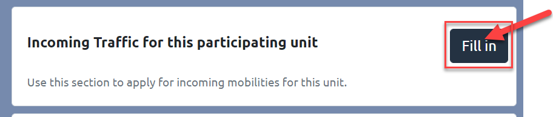
You need to separately apply for the incoming scholarship quota of each participating unit. Please access the respective participating unit in your network application and fill in the incoming traffic. This is called tendered traffic.

Please have the following scholarship categories in mind:

Category | Min-Max | Comments
Student | 3-10 months | Students only
Short Term Student | 6 days - 3 months | Students only
Teacher | Semester & Excursions: min 1 work week & 6 teaching hrs, Short Term Excursions | ONLY category for  teachers
Short Term Excursion | 3 days – 6 days | Students only

As the Traffic Sheet system is built on full calendar MONTHS, please apply in months only:

Students: e.g. you are planning a Short Term Excursion lasting 3 days for 10 students:
3 x 10 = 30 days = 1 month for 10 persons (students)

Teachers: same principle but must be entered in the Teacher column.

PLEASE NOTE: there might be special scholarship rates for excursions, depending on the guest country.
Background information:
Once a network is awarded the International Commission will assign the actual number of scholarship months for your mobilities, based on your tendered traffic.

Types of documents

- Letter of Endorsement
4 Types
- Letter of Intent
- Curriculum
- Documents related to Joint Programs/Joint Activities

Letter of Endorsement (LoE) has to be signed by the RECTOR or VICERECTOR of each university listed in the application. Letters signed by Deans or Vice deans will not be accepted.
Exception: Institutions that do not have a rector as a board member. Here we ask for an additional upload of an accompanying letter, that the signing person is the highest-ranking person in this institution, E.g. the general director of a college.

Letter of Intent (LoI) has to be signed by the person/body in charge of mutual recognition at each university listed in the application.
Please note, the software generates all new letters for you with a QR code.
The Upload Section of your network application also contains a Download Section! You only need to fill in name/function of the signatory and have the document signed and stamped.c

Curriculum
The use of ECTS/compatible is a formal requirement for CEEPUS III networks, i.e. a MUST.
You can provide information on the use of ECTS/compatible either by

  - Uploading the information OR
  - By entering a link

PLEASE NOTE: In order to clearly identify PPUs that only exchange “Theses students” there is a TICK BOX they can check. These PPUs do NOT need to submit ECTS information as in this case letters by their supervisors are sufficient (together with the respective mobility application).

Interuniversity Agreements related to the implementation of Joint or Double Degrees:
These Agreements/information are obligatory in case of existing Joint Programs and for These en Cotutelle. If you are developing a JP, please report the steps that you have taken and the status quo of your planned activity. Further information is also a great way to find out more about your activities.

Compulsory documents
Letters of Endorsement, Letters of Intent and the Curriculum are obligatory if your participating unit is a new member.
If the letters and the Curriculum are already uploaded, you don´t have to do it again.

If you prolong your network, you don´t need to provide any new documents/letters.
If your network is an “umbrella network”, you also do not need any new letters.

EXEMPTION: if you add a new partner, this new Participating Unit must submit both Letters.

If you renew your network, you need all Letters by all participating universities.
(renew = your network is NOT active in the current academic year, but you have data from a previous academic year you are transferring to the new application round.)

Silent Partners do NOT need any Letters.

If your faculty is moved to another university, you are kindly asked to provide new Letters for your PPU and for all your partners.

Curriculum: Instead of a document you can also provide a link to the curriculum of your university. Please have in mind that the curriculum needs to be in English.

Please have in mind that for category 1 (joint programme) and category 2 (These en Cotutelle) of joint activities documents related to the implementation of a joint programme are also obligatory and must be uploaded.

Deadlines
The network application has to be submitted by the coordinator until Jan 15th, 2022, 23:59 server time.
We strongly advise not to wait until the very last moment since we cannot influence internet problems or local technical issues.

- All new documents have to be uploaded until JAN 31st, 2022, 23:59 server time.

This will be possible because the upload area will be available for editing until this date (but not any other sections of the network application)

Upload Change Request (= UCR)
Background Information
Any PPU, for which no document has been uploaded in time, will be de-activated in the application for that year.

HOWEVER, in order to avoid these unnecessary troubles, we are conducting the UPLOAD CHANGE REQUEST during the application round and ask for your kind compliance.

The Upload Change Request is a special form mailed to you by the Central CEEPUS Office (CCO) containing a link that lets you access / upload the document in question at any time of the year upon request.

We use this option in order to assist networks in

  - getting their mandatory documents uploaded correctly in due time and
  - assisting network to exchange outdated documents.

Please answer to the UCR mail and upload the document in question via the provided link or access your UCRs also on your network desktop. Simply click on “Manage your upload change requests”.
Coordinators see all UCRs of their network!

