Faculty of Agronomy in Čačak
University of Kragujevac

 | 

in cooperation with

 | 
Biotechnological Faculty  University of Ljubljana | Faculty of Agriculture and Life Sciences  University of Maribor
 | 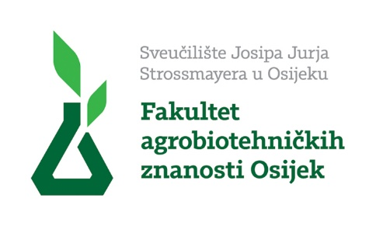
Faculty of Agronomy  University of Zagreb | Faculty of Agrobiotechnical Sciences  Josip Juraj Strossmayer University of Osijek
 | 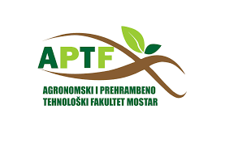
Faculty of Agriculture and Food  University of Sarajevo | Faculty of Agronomy and Food Technology  University of Mostar
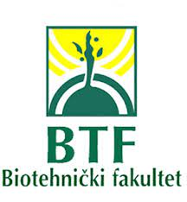 | 
Biotechnological Faculty  University of Montenegro | Faculty of Agricultural Sciences and Food  University of Skopje
 | 
Faculty of Agriculture  University of Banja Luka | Faculty of Agriculture  University of Novi Sad
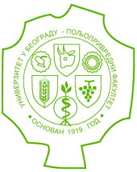
Faculty of Agriculture
University of Belgrade

is organizing

1st INTERNATIONAL SYMPOSIUM ON BIOTECHNOLOGY
(28th SYMPOSIUM ON BIOTECHNOLOGY
WITH INTERNATIONAL PARTICIPATION)

17–18 March 2023, Čačak, Republic of Serbia

More information on the web page https://www.afc.kg.ac.rs

1st INTERNATIONAL SYMPOSIUM ON BIOTECHNOLOGY
(28th SYMPOSIUM ON BIOTECHNOLOGY
WITH INTERNATIONAL PARTICIPATION)

17–18 March 2023

Faculty of Agronomy in Čačak, University of Kragujevac, Serbia

SECOND ANNOUNCEMENT

Call for participation
аnd abstract/paper submission

Dear Colleagues,

Our 1st INTERNATIONAL SYMPOSIUM ON BIOTECHNOLOGY (28th SYMPOSIUM ON BIOTECHNOLOGY WITH INTERNATIONAL PARTICIPATION) will take place at the Faculty of Agronomy, Čačak, Serbia on 17–18 March 2023. We are sure that the designed model of the Symposium (an international scientific meeting) will enable all interested parties to take part in this scientific event and thus contribute to its continuing tradition. We are convinced that many experts and dear colleagues from abroad will join us.

PRELIMINARY AGENDA

Friday, 17 March 2023, 10 a.m.
Opening Session
Six Scientific Sessions

Saturday, 18 March 2023, 10 a.m.
Scientific/Expert Workshops and Symposium Conclusions
Sightseeing tour - аn attractive tour of Čačak and the Ovčar-Kablar gorge, with tourist guides from the Tourist Organization of Čačak
Fourth Assembly of the Alumni Club of Agronomy and Food Technology Graduates

The 1st International Symposium will include the following sessions:

- Field, Vegetable and Forage Crops
- Pomology and Viticulture
- Livestock Production
- Plant Protection, Food Safety and the Environment
- Food Technology
6. Applied Chemistry

INSTRUCTIONS FOR AUTHORS

Full papers should be submitted electronically using the template form provided (SB2023_Paper Template) to sbcacak@gmail.com by 10 February 2023 at the latest.
Papers must be prepared and presented in English.

The Paper Template provides detailed manuscript preparation guidelines to be followed by the authors. Only papers written according to the instructions will undergo peer review; otherwise, they will be rejected.

Notification of paper acceptance will be sent by 20 February 2023. After payment of the registration fee, positively reviewed papers will be published in the Proceedings of the 1st INTERNATIONAL SYMPOSIUM ON BIOTECHNOLOGY (28th SYMPOSIUM ON BIOTECHNOLOGY WITH INTERNATIONAL PARTICIPATION) (М₃₃). The Symposium Proceedings will be assigned both an ISBN and CIP data, and all published papers will receive a DOI number.

Upon proposal made by the Symposium Programme Committee and on subsequent approval by the authors, selected papers may be published in Acta Agriculturae Serbica (М₅₁) in accordance with the journal’s Instructions for Authors.

Online access to the 1st INTERNATIONAL SYMPOSIUM ON BIOTECHNOLOGY (28th SYMPOSIUM ON BIOTECHNOLOGY WITH INTERNATIONAL PARTICIPATION) will be made available via the Faculty of Agronomy’s website (https://www.afc.kg.ac.rs), with links to the Symposium Sessions.

REGISTRATION FEE

Participants from the Republic of Serbia should pay a registration fee of RSD 12,000.00 (for one scientific paper). For authors who wish to submit multiple papers as first authors, the registration fee is RSD 6,000.00 per each additional paper.
For foreign participants, the registration fee is EUR 100 (for one scientific paper). For authors who wish to submit multiple papers as first authors, the registration fee is EUR 50 per each additional paper.
Registration fee payment deadline is 1 March 2023.

FEE PAYMENT METHOD

Fee payment should be made to the Faculty of Agronomy’s bank account No. 840-948666-13, Ref. No. 97-78-101122442, indication: 1st INTERNATIONAL SYMPOSIUM ON BIOTECHNOLOGY (28th SYMPOSIUM ON BIOTECHNOLOGY WITH INTERNATIONAL PARTICIPATION) – fee payment. The paying-in-slip should clearly state the first name and surname of the participant, as well as the name of the institution making the payment.
For foreign participants, fee payment should be made according to the Payment Instructions specified in the attached document.
The registration fee includes: symposium materials, a symposium bag with the Symposium Agenda, an electronic version of the Symposium Proceedings, a Certificate of Participation and a Certificate for authors of invited papers, credentials, lunch on the first day of the Symposium, gala dinner, coffee breaks and refreshments, a sightseeing tour).
*It is necessary to emphasize the presence at the gala dinner during registration process.

SYMPOSIUM DEADLINES:

Paper title submission deadline: 31 January 2023
Full paper submission deadline: 10 February 2023
Notification of paper acceptance: 20 February 2023
Registration fee payment deadline: 1 March 2023

The deadlines are firm and will not be extended!

For further information, please consult www.afc.kg.ac.rs or contact sbcacak@gmail.com.
Contact person:

Prof. Pavle Mašković
E-mail: sbcacak@gmail.com
Tel. + 381 32 303 400

Address:
Faculty of Agronomy
Cara Dušana 34
32000 Čačak
Serbia

Prof. Tomo Milošević, Ph.D.  Chair  Programme Committee | Prof. Pavle Mašković, Ph.D.  Chair  Organizing Committee

