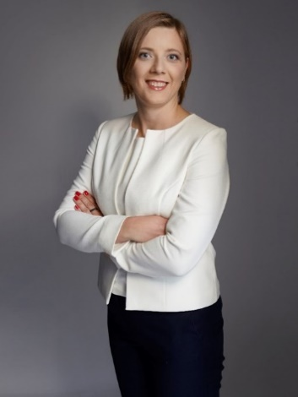**Katarzyna Świąder, PhD**

Warsaw University of Life Sciences-SGGW (WULS-SGGW), Poland

Assistant Professor with habilitation at the Faculty of Human Nutrition, Warsaw University of Life Sciences-SGGW (WULS-SGGW). She is a food expert, specialist in the field of functional food, sensory evaluation and new product development. The author or co-author of patents, several new food products implementations on the Polish and European market, publications, elaborations and international and national projects with the 20th years of experience. International academic lecturer. A member of the Polish Society of Nutritional Sciences and Polish Coeliac Society. She was the Polish representative of the working group of the European Commission, DG (SANCO) and CMDv in the European Medicines Agency. She has been repeatedly awarded for her scientific and didactic achievements. Promoter of healthy and sustainable lifestyles.