**ICT-REV Workshops: introductory information**

Language education in the (post-)pandemic time makes ample use of online materials, virtual classrooms, social networks and open-access resources based on ICT (information and communication technology). Still, many language professionals feel that, despite their practical experience, they lack adequate training which emphasises the relevant pedagogical rather than technical skills.

The ECML-funded ICT-REV workshop (<https://www.ecml.at/TrainingConsultancy123/ICT-REV/tabid/1725/language/en-GB/Default.aspx>) provides training in the integration of  ICT tools and open resources in language teaching and learning, based on sound pedagogical principles. The workshop participants will become aware that the blending of these principles with technology is crucial for the design and delivery of successful language learning activities. They will develop a set of practical skills to help them do this in their own professional context and they will also become aware of their own needs in terms of continuing professional development.

Participants will be required to take part in preparatory tasks prior to the workshop, and to participate actively in the workshop itself, completing a variety of different activities in pairs or small groups. They will also be expected to engage in post-workshop tasks, sharing with their colleagues the resources they have created and the training activities and skills they have developed during the workshop.

It is our pleasure to invite you to take part in this workshop which will be held in October 2022 in Montenegro. The number of participants is limited. You can apply for the workshop on the following email address: marijami@ucg.ac.me.The deadline for applying is 31 March 2022.

**Participant profiles**

·       Language teachers

·       Teacher trainers

·       Language policy makers

·       Multipliers

**ECML experts for the event in Montenegro**

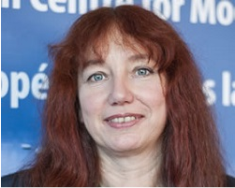**Dr Ursula Stickler** is a Senior Lecturer in German at the Open University in the UK. As a researcher and trainer she specialises in autonomous learning and online language teaching skills, contributing to an international network of experts. She has played a leading role in ECML projects (DOTS, moreDOTS, and ICT-REV) resulting in publications and multiple workshops across Europe and beyond. Her research areas include training of online tutors, VLEs, interaction in online language tutorials, and eye-tracking.

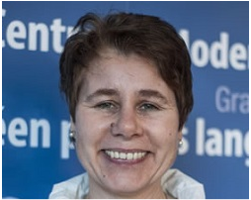**Dr Martina Emke** is an experienced English teaching professional and project manager who has worked in further, vocational and higher education.  She currently works as project coordinator in a German project concerned with improving digitally enhanced teaching in Higher Education. Martina has been involved in the DOTS, MoreDOTS and ICT-REV projects at the ECML as teacher educator, materials developer and co-coordinator. Her research interests include posthuman digital education, networked learning and the use of social media in education.

**Remote ECML expert for the event**

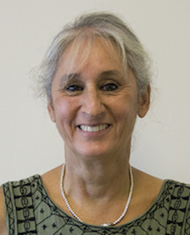**Aline Germain-Rutherford,** PhD, is Vice-Provost of Academic Affairs, at the University of Ottawa and Professor in the Faculty of Education. She received a *Doctorat de Didactologie/​Didactique des Langues et des Cultures* at La Sorbonne Nouvelle, Paris III, France and is the author of numerous publications on faculty development, second-language pedagogy, speech technology and the integration of sound pedagogy into e-learning practices. She has been a member of the DOTS, MoreDOTS and ICT-REV teams at the European Centre for Modern Languages (ECML). She is a recipient of the 3M National Teaching Fellow Award, a Canadian Award that recognises excellence in teaching and leadership in higher education.

**Expert and host for the event in Montenegro**

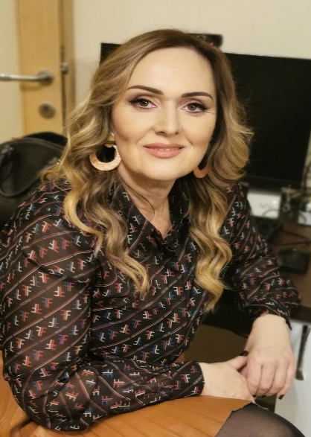

Dr Marija Mijušković is an assistant professor at the Faculty of Philology of the University of Montenegro. She teaches ELT methodology and is the author of numerous publications on foreign language teaching, language pedagogy, autonomous learning, teaching language skills and strategic learning. She has participated in numerous national and international conferences, teacher trainings in the area of methodics of teaching foreign languages and applied linguistics. She is a member of the English Language Teachers Association, the Modern Languages Association, the Society for American Studies of South Europe and the European Association for American Studies.