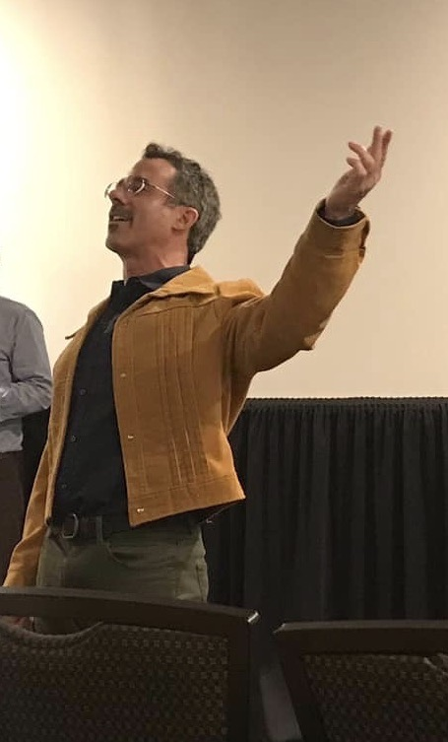

Michael Heyman is a Professor of English at Berklee College of Music in Boston, where he teaches courses on Literary Nonsense, Children’s Literature, Music, Poetry, Monsters, and Arthropodiatry. He is the head editor of The Tenth Rasa: An Anthology of Indian Nonsense (Penguin, 2007) and This Book Makes No Sense: Nonsense Poems and Worse (Scholastic, 2012). His scholarship has appeared in the ChLA Quartrly, Bookbird, The Horn Book Magazine, European Journal of Humour Research, and The Lion and the Unicorn, where he was also a judge for the Lion and the Unicorn Award for Excellence in North American Poetry. He has contributed chapters on music and children’s literature to The Edinburgh Companion to Nonsense (2022) and The Aesthetics of Children’s Poetry (Routledge, 2018). His poems and stories can be found in Poetry International, Solstice, The Dirigible Balloon, and The Moustache Maharishi and other unlikely stories (Scholastic, 2007). He is currently co-editing a new edition of Alan Watts’ Nonsense (1967).

