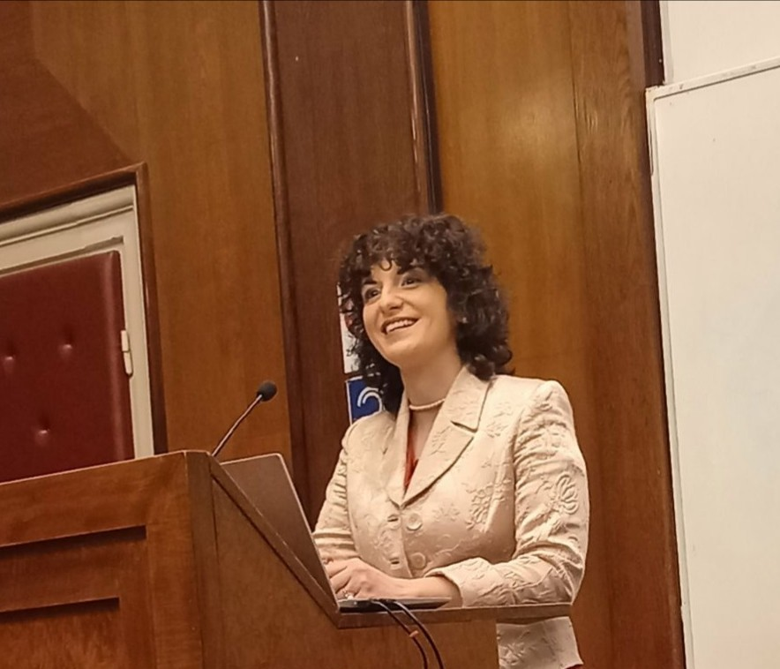
Dr. Mina M. Ðurić is an Assistant Professor of Serbian Literature of the 20th Century at the Faculty of Philology of the University of Belgrade. In 2017 she completed her doctoral dissertation on the modernization of 20th-century Serbian prose in relation to the creative reception of James Joyce’s literary works. Her research focuses on comparative literature, interdisciplinary studies of modern and contemporary Slavic literatures in the context of world literature, literary theory, music, and translation. She is a member of the Association for Serbian Language and Literature in Serbia, the Council of Vuk’s Endowment, the Commission on Slavic Literatures and Language Teaching of the International Committee of Slavists, the International James Joyce Foundation, the European Federation of Associations and Centres of Irish Studies, the John Updike Society, etc. She participated in many scientific meetings (Austria, Bosnia and Herzegovina, Bulgaria, Czech Republic, Germany, Ireland, Italy, Macedonia, Montenegro, Pakistan, Romania, Russia, Switzerland, Ukraine, USA), held guest lectures at universities abroad (Bosnia and Herzegovina, Czech Republic, Germany, Hungary, Poland). In addition to numerous papers and edited books, she is the author of an interdisciplinary monograph on modernist literature and music – Transmusicalization of the Text: The Music of Serbian Modernist Literature (in Serbian). She has edited and translated from German into Serbian a book on Dragoslav Mihailović, written by Robert Hodel, and edited books of selected Vasko Popa’s poetry and Dragoslav Mihailović’s prose. Mina Đurić has co-authored a digital exhibition Vuk and the Germans (in Serbian, German, and English). She has also co-authored more books for high school.

