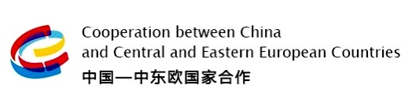

AGENDA

25 - 26 November 2021

DAY 1: 25 November

9:30 – 10:00 Inauguration

Address by the hosts:
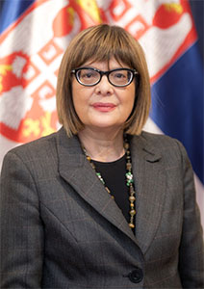
Ms. Maja GOJKOVIĆ
Deputy Prime Minister and Minister of Culture and Media of the Republic of Serbia
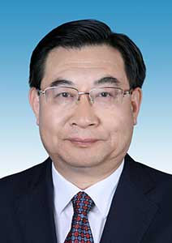
Mr. Hu HEPING
Minister of Culture and Tourism of the People’s Republic of China
European Capital of Culture – Novi Sad 2022 Showcase
Moderator: Mr. Ivica MILARIĆ, Academy of Arts - Novi Sad

10:00 – 11:30 Panel I – Visual Arts
- Mr. Xi ZHANG, Tutor of digital 3D animation studio of Central Academy of Fine Arts (China)
- Ms. Maja KOLARIĆ, Director, Museum of Contemporary Arts, Belgrade (Serbia)
- Ms. Tijana PALKOVLJEVIĆ, Director, Gallery of Matica srpska, Novi Sad (Serbia)
Moderator: Ms. Sonja RADAKOVIĆ, Academy of Arts - Novi Sad

11:45 – 13:15 Panel II – Film Art
- Ms. Samantha LU, Ori Animation (China)
- Mr. Gordan MATIĆ, Director, Film Center of Serbia (Serbia)
- Mr. Miroljub VUČKOVIĆ, Coordinator for International Cooperation, Film Center of Serbia (Serbia)
- Mr. Edin JAŠAROVIĆ, Dean of the Faculty of Dramatic Arts - Cetinje, University of Montenegro - "Current Trends of Montenegrin Creative Economy Development" (Montenegro)
- Mr. Milivoje GJORGJEVIKJ, FX3X Group CEO Skopje, Los Angeles, Toronto, Belgrade - “Digital technologies and film art – experiences” (North Macedonia)
- Mr. Bojan LAZAREVSKI, Director of the Film Agency of the Republic of North Macedonia – “The future of the new digital platforms for the distribution of the audiovisual works” (North Macedonia)
Moderator: Mr. Momčilo MILJKOVIĆ, Academy of Arts - Novi Sad

DAY 2: 26 November

10:00 – 11:30 Panel I - Animation
- Mr. Xinjun XIONG, Tutor of digital 3D animation studio of Central Academy of Fine Arts (China)
- Anđelka JANKOVIĆ, Head of marketing & communications, Iervolino Studios (Serbia)
- Mr. Leon AKSIN, Digital artist and Previz/Layout Artist at Platige Image (Serbia)
- Goce CVETANOVSKI, Film director at 351 Animation and Lynx Animation (North Macedonia)
Moderator: Mr. Mileta POŠTIĆ, Academy of Arts - Novi Sad

11:45 – 13:15 Panel II – Video Games
- Mr. Ke JIANG, Tutor of digital 3D animation studio of Central Academy of Fine Arts (China)
- Mr. Ivan ZORKIĆ, Game director, video game development studio Mad Head Games (Serbia)
- Mr. Davor GOLUBOVIĆ, Video game designer, State of game development in Montenegro - opportunities for artists and programmers (Montenegro)
- Mrs & Mr. Sanja & Dušan ČEŽEK, Fuchs+Dachs s.r.o, Indie gaming, from Zero to "Very positive" (Czechia)
Moderator: Mr. Vukašin ŠOĆ, Academy of Arts - Novi Sad

14:00 – 14:40 Conclusions & Recommendations

14:50 – 15:10 Presentation of the “Tesla and the Lamplighter” animated movie written and directed by Branislav Brkich

ABOUT
After two successful meetings at expert level among professionals of the Member States of the mechanism China - Central and Eastern European countries (CEEC), the 3rd Art Cooperation Forum whose host is the Republic of Serbia (Ministry of Culture and Media) together with the People‘s Republic of China (Ministry of Culture and Tourism), which will be held on 25 and 26 November 2021 (on-line from Belgrade / Novi Sad), in accordance with the Beijing List of Activities for China-CEEC Cooperation in 2021, is dedicated to the field of arts and contemporary culture linked with new approaches in line with the technology developments applicable in different fields of contemporary arts and culture.
The topics will cover the Culture of Innovation, AV, VR and International Culture Exchange under the circumstances of global culture. As part of the Agenda, experts from different innovation fields will address and share their valuable experience.
The Forum will gather the experts from 17 countries: Albania, Bosnia and Herzegovina, Bulgaria, Croatia, Czech Republic, Estonia, Greece, Hungary, Latvia, North Macedonia, Montenegro, Poland, Romania, Slovakia, Slovenia together with Serbia and China as active partners of the mechanism China – CEEC.
Cooperation between China and the countries of Central and Eastern Europe through this mechanism is an integral part of China's global initiative “Belt and Road”, initiated by the President of the People's Republic of China Xi Jinping, and all member countries will uphold openness, inclusive and win-win cooperation, and practice true multilateralism.
The aim of this year’s Art Cooperation Forum is an exchange of knowledge and ideas for professional networking and further development of cooperation fields and tools that can influence and dynamize the relations among the professionals in these specific fields of contemporary arts and culture.
Our vision is to bring together the experts from the specific fields of culture and arts in order to sensitize more professionals to connect and to create the new networks and common projects in the future that could further enhance the cooperation within the mechanism China-CEEC.
The Forum is an opportunity, not only to develop cultural ties between divers actors during the conference (although on-line), but also to better understand the key principles of China’s cultural trends and the development directions within the mentioned topics with an emphasis on the fact that the topics covered by the panels represent a vital part of global creative industries and their sub-sectors (design, film and video, interactive leisure software, publishing, software and computer games and others), whose activities and creativity are based on cultural values.

