

**UNIVALENS**

**UNIVALENS**

Overcoming Cross-border Educational Programs Recognition and Equivalence

limitations

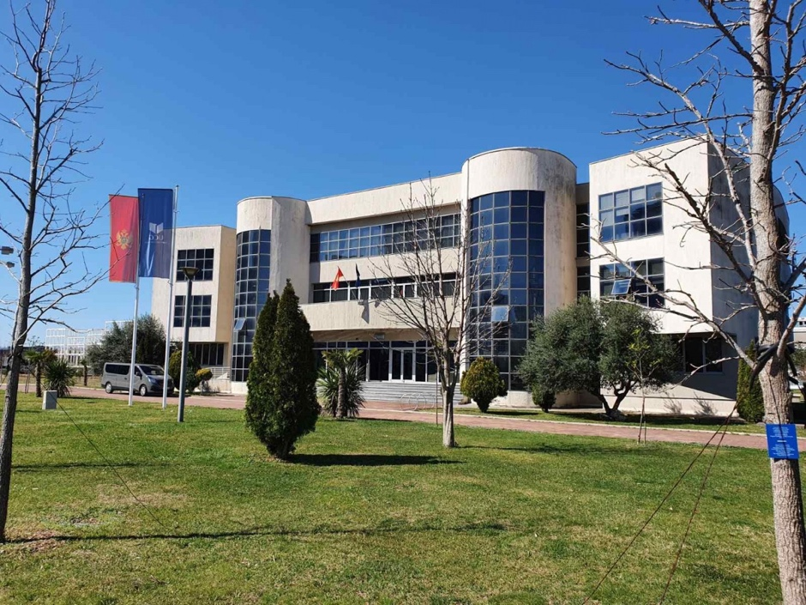

“Procedures and Recommendations for the development

of higher education programs in Montenegro”

Activity 1.3 Workshop

Managing Board Hall

University of Montenegro

7.03.2025

Podgorica

***WORKSHOP AGENDA***

***Managing Board Hall University of Montenegro***

***7th of March 2025***

|  |  |
| --- | --- |
| **h 8.30 – 09.00**  **Registration** | |
| **h. 09.00** | **Prof. Ph.D. Nedeljko Latinović – Director of the Institute for Interdisciplinary and Multidisciplinary Studies, University of Montenegro – Welcome Speech** |
| **Contents and inputs** | * The joint challenges for the new developments toward the joint study programs in Creative Industries – by **Prof. Edin Jašarović** – Dean of the Faculty of Dramatic Arts * Quality Assurance Control Mechanism and Processes at UoM, by Ph.D. **Svetalana Perović,** President and the Director of Quality Assurance Centre of UoM * Challenges of the accreditation processes of Higher education Joint Study programs: Montenegrin case – by **Mrs. Tamara Đuričković –** Assistant Director of the Agency for Control and Quality Assurance of Higher Education of Montenegro (ACQAHE) |
| **Expected output** | * New knowledge acquisition |
| **h. 11.30** | Coffee Break |
|  |  |
| **h. 12.00** | **Prof. Ph.D. Sara Vojošević – Jovanović,** Vice – Dean for International Collaboration – Faculty of Dramatic Arts, University of Montenegro |
| **Contents and inputs** | * Designing the programs for audio-visual education – by Ph.D. Prof: **Nikola Vukćević – Head of the study program Film and Media, Faculty of Dramatic Arts** * Interdisciplinary approaches to possible doctoral study program in arts – by prof. Ph.D. **Zdravko Delibašić**, Vice- dean for teaching, Faculty of Fine Arts * Artistic Research in Higher Education: Challenges, Experiences, and Perspectives - by Ph.D. **Jelena Martinović - Bogojević,** member of the Quality System Management Committee of UoM in the field of Arts |
| **Expected output** | * New knowledge acquisition |
| **h. 14.00** | * Lunch Break |
|  |  |
| **h.15.30** | **Prof. Janko Ljumović –** Faculty of Dramatic Arts, University of Montenegro - Moderator |
| **Contents and inputs** | * Training modules offers – **by Prof. Ph.D. Vuk Vuković**, member of the Managing Board of University of Montenegro   - Sharing the “rules of the game”  - Working groups and final round table |
| **Expected output** | * New knowledge acquisition |
| **h. 17.00 End of the Workshop** | |

