  - ENEMLOS NEWSLETTER Issue 1/2023
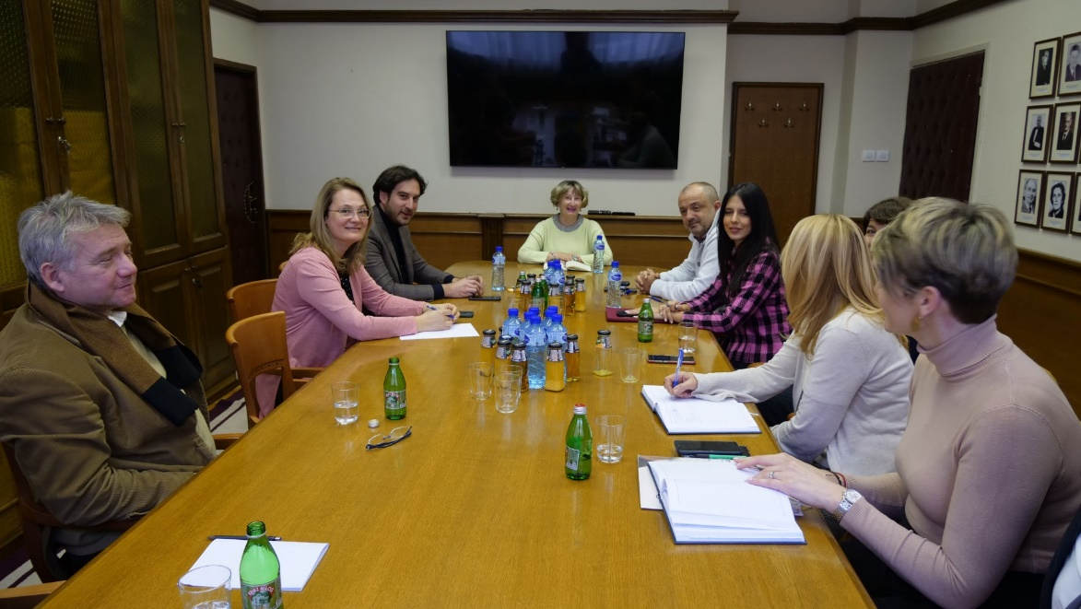 | - sue
    - 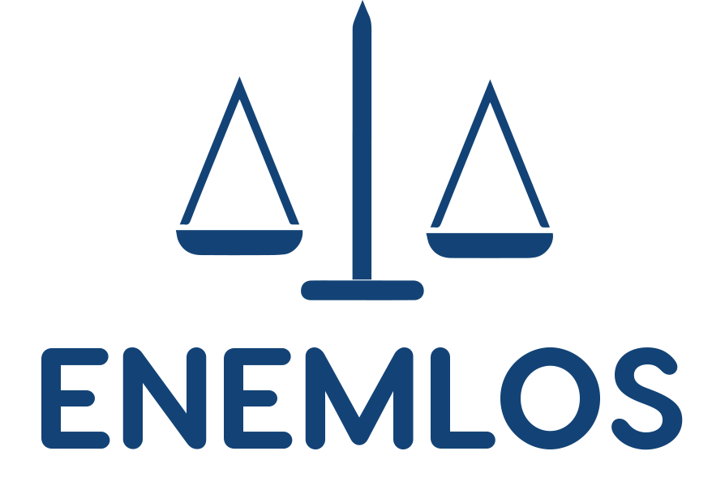
    - January, February and March 2023
PMT meating with non academic partners: The meeting discussed the implementation of legal clinics during the winter semester of 2022/23 school year.
In this issue:


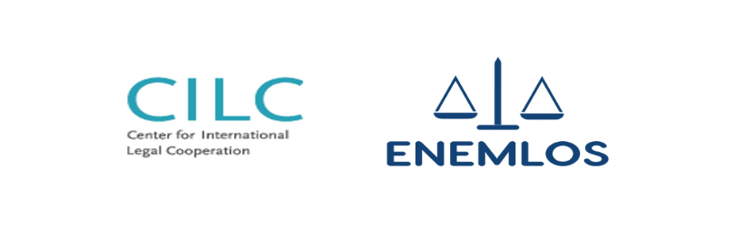
TRAINING OF LAW STUDENT by Prof. Dr. Biljana Đuričin, Assoc. Dr. Nikola Dožić and Assoc. dr Velibor Korać
PMT MEETING MARCH, 2023
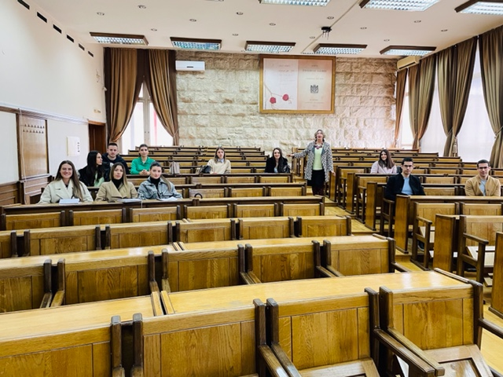
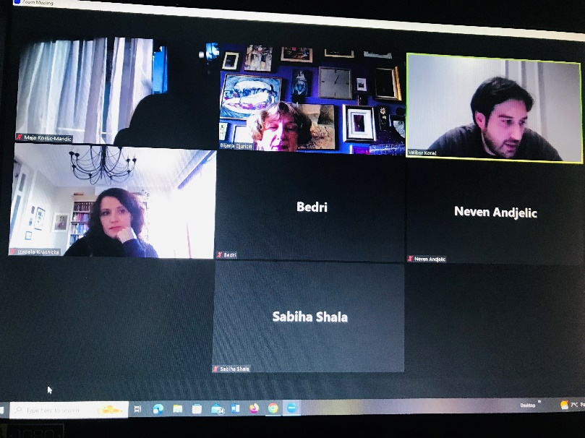ENEMLOS Editorial Board met on February 9, 2023. Meeting was organized online through ZOOM platform. Papers for the new book of best clinical legal education practice were accepted at the meeting.

