MONUSEN Training - Project Management

**AGENDA**

**2nd June 2024 (Sunday)**

|  |  |
| --- | --- |
| **Time** | **Description** |
| 13:45 – 14:30 | **Management of ongoing projects** by **R. Beroldo**  Management and reporting actions to be performed during the project activities |
| 14:30 – 14:45 | BREAK |
| 14:45 – 15:30 | **Project management: handling (un)expected risks** by **M. Caccia**  Discussion of how to handle project risks based on the lecturer experience |
| 15:30 – 15:45 | **Open discussion - MONUSEN follow-up: capitalization opportunities.** |

*No previous knowledge or experience needed.

**VENUE - Faculty of Maritime Studies, University of Montenegro, Address: Put I Bokeljske brigade 44, Dobrota, Kotor, Montenegro

BIOGRAPHY OF LECTURER

Raffaella Beroldo



Since 2002 she has been employed by National Institute for the Physic of the Matter which merged into CNR during year 2005. She managed projects since V European Framework Programme, National and Regional Programmes. Her tasks included the support to the Scientific Network in monitoring the grant opportunities, proposals submission, legal/financial project monitoring, definition management structure in the project, content analysis of contract, negotiation of projects, contract management and amendments.

She has been in charge as delegated member for the Italian State to participate to the European Synchrotron Radiation Facility Administrative Financial Committee for the Year 2007-2008. She has been member of the “External user group for the new grant management system (SyGMa)” for Horizon 2020 arranged by the European Commission and person in charge for the Project Office in CNR-ISSIA from 2014 to 2018.

Massimo Caccia

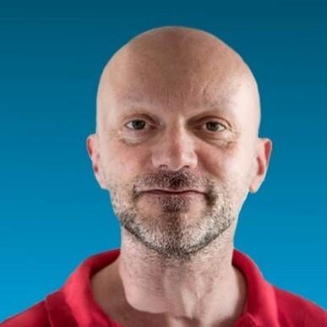

Massimo Caccia was born in Genova on the 26th of July 1966, and graduated in Electronic Engineering at the University of Genova on the 31st of January 1991. In the period October 16th, 2013 – October 15th, 2017 and October 16th, 2017 – May 10th, 2018 he served as Director and Acting Director, respectively, of the CNR Istituto di Studi sui Sistemi Intelligenti per l’Automazione (ISSIA-CNR). After joining CNR on the 2nd of May 1993, his theoretical and applied research activities focused on marine robotics, mainly addressing the topics of modeling and identification, cooperative guidance and control, vision-based motion estimation and control, and embedded real-time platforms and architectures for Unmanned Marine Vehicles.

He is among the European pioneer researchers in the field of unmanned surface vehicles. Research results, certified by more than 200 publications in international books, journals and conferences, led to the partnership in a number of EC, national and regional projects. Recently he coordinated the Interreg Maritime Italy-France MATRAC-ACP project, (total budget 863,016.40€), the Italian PON project ARS01_00682 ARES Autonomous Robotics for the Extended Ship (total budget 9,937,034.33€) and the EC EMFF-BlueEconomy-2018 Blue RoSES project (total budget 1,042,725.70€).

Massimo Caccia was member of the project steering committee and/or CNR principal investigator in the following EC projects: FP7-SST MINOAS, FP7-SME CART, FP7-ICT MORPH, FP7-ICT CADDY, H2020-TWINNING EXCELLABUST.