BIOGRAPHY OF LECTURER

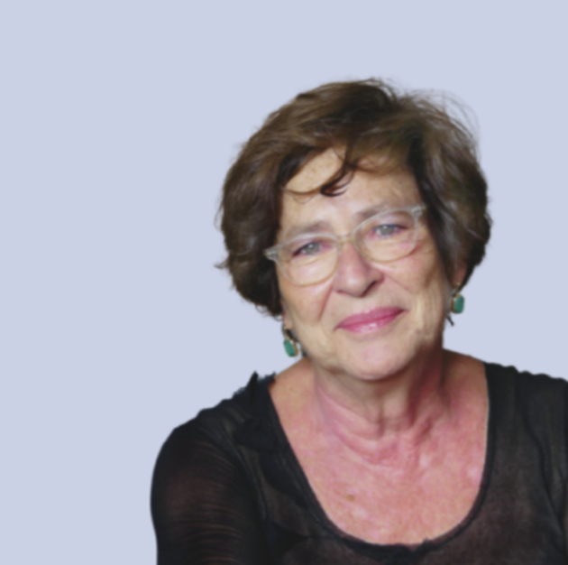

**Manuela Arata**, expert in Science and Innovation Management and Policies, Networking, International Partnerships and Projects, Knowledge & Technology transfer, Spin-off and IPRs, Science diffusion and education. She started working in Technology Transfer in 1986 at Genova Ricerche (Consortium among industries and basic research).

Since 1990 she served as General Director of the Italian Institute for the Physics of Matter, then since 2008 as Technology Transfer Officer at the National Research Council.

Founder and Past President of the Genova Science Festival, a model at the worldwide level, in 2012 she cofounded the SASE, Shanghai Academy for Scientific Explainers, for which she was awarded the Silver Magnolia Medal in 2013 by the Shanghai Municipality.

Teacher of Research Management at Turin Polytechnic between 1999 and 2005, she has been Visiting Professor at the USAE University in Buenos Aires and hold training courses to future TTOs of the Higher Council for S&T of the Jordan Kingdom in 2016.

Former member of ERIAB (the European Research and Innovation Advisory Board), she has been awarded the Merit Honour of the President of the Italian Republic in 2005, the Chevalier Merit Honour of the President of the French Republic in 2016 and the Golden Medal of the Genova Municipality in 2013.

Advisor to the Mayor of Genoa for Science and Technology (2017-2023).