BIOGRAPHY OF LECTURER

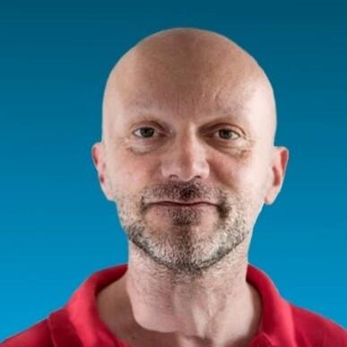

|  |
| --- |
|  |
| **Massimo Caccia** was born in Genova on the 26 of July1966, and graduated in Electronic Engineering at the University of Genova on the 31st of January 1991. In the period October 16, 2013 – October 15, 2017 and October 16, 2017 – May 10, 2018 he served as Director and Acting Director, respectively, of the CNR Istituto di Studi sui Sistemi Intelligenti per l’Automazione (ISSIA-CNR). After joining CNR on the 2nd of May 1993, his theoretical and applied research activities focused on marine robotics, mainly addressing the topics of modeling and identification, cooperative guidance and control, vision-based motion estimation and control, and embedded real-time platforms and architectures for Unmanned Marine Vehicles. He is among the European pioneer researchers in the field of unmanned surface vehicles. Research results, certified by more than 200 publications in international books, journals and conferences, led to the partnership in a number of EC, national and regional projects. Recently he coordinated the Interreg Maritime Italy-France MATRAC-ACP project, (total budget 863,016.40€), the Italian PON project ARS01_00682 ARES Autonomous Robotics for the Extended Ship (total budget 9,937,034.33€) and the EC EMFF-BlueEconomy-2018 Blue RoSES project (total budget 1,042,725.70€). He was member of the project steering committee and/or CNR principal investigator in the following EC projects: FP7-SST MINOAS, FP7-SME CART, FP7-ICT MORPH, FP7-ICT CADDY, H2020-TWINNING EXCELLABUST. | |