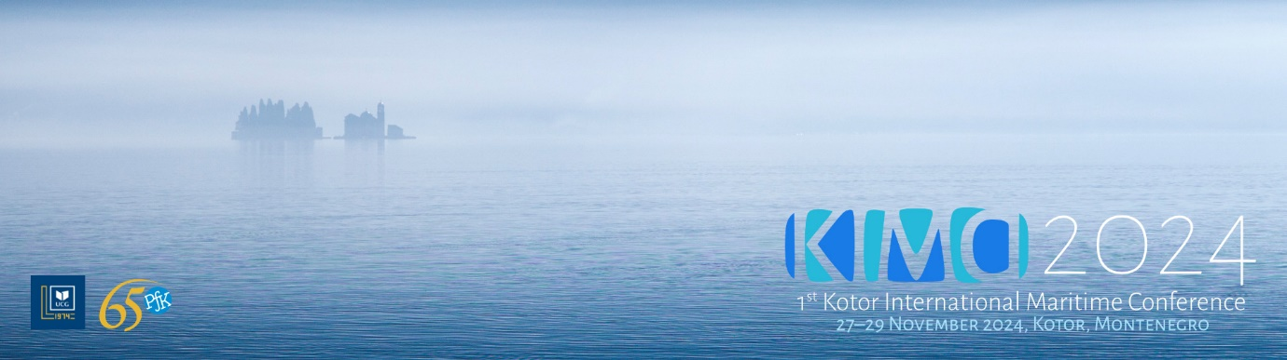

KIMC 2024 | 1st Call

*Dear colleagues,*

It is our great pleasure to invite you to take part in the *4th Kotor International Maritime Conference* - KIMC 2024 which will be held in Kotor, Montenegro, on 27–29 November 2024. The Opening Ceremony is scheduled for 28 November and this year it will also be the Ceremonial Academy celebrating the *65th Anniversary of the Faculty of Maritime Studies*.

The Conference will be organized and hosted by the *Faculty of Maritime Studies Kotor,* *University of Montenegro,* and co-organized by the *Municipality of Kotor* and *Port of Kotor*.

The Conference will cover the following topics:

1. Navigation
2. Marine Engineering
3. Marine Ecology and Blue Economy
4. Energy Efficiency in Maritime Sector
5. Green Shipping Transition
6. Marine Automation and Electronics
7. Transportation and Logistics
8. Information Technologies in Shipping
9. Maritime Law
10. Maritime Health Care
11. Maritime Education and Training
12. Quality Management System
13. English for Specific Purposes and Teaching Methodologies
14. Applied Mathematics and Programming in Maritime Sciences
15. Marine and Maritime Robotics
16. Nautical and Cruising Tourism
17. Artificial Intelligence and Maritime Industry
18. Safety and Security in Shipping
19. Autonomous Vessels
20. Yachting and Cruise Industry
21. Marketing Strategies in Maritime Affairs
22. Maritime Management and International Logistics
23. Human Resources in Maritime Transport

The Conference participants will be able to give their presentations in person, via a poster session or online. The Conference Proceedings will comprise the accepted abstracts, whereas the selected full papers can be published in *Časopis Pomorskog fakulteta Kotor - Journal of Maritime Science* (www.jms.ucg.ac.me) during 2025.

The abstract are to be submitted via EasyChair platform:  
<https://easychair.org/conferences/?conf=kimc2024>.

The submissions anticipate a previously registered account at: <https://easychair.org/account/signin>.

The Conference will also comprise versatile and interesting lectures, presentations and panel sessions of interest for modern trends in maritime industry, technology and science.

All further information, instructions for authors, and important dates are to be found on the official website: [www.kimc.ucg.ac.me](https://www.kimc.ucg.ac.me).

We look forward to hosting you in Kotor!

*Best regards,*  
KIMC 2024 Organizing Committee