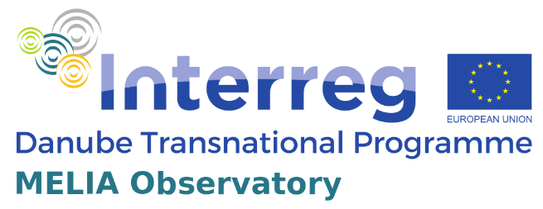

MELIA Observatory
Media Literacy Observatory for Active Citizenship and Sustainable Democracy

Invitation to the workshop

12th May 2022

Workshops to address general public over the topic of media literacy among youth and its importance for increasing political participation

About the meeting
Workshop presenting the learning interactions prepared within the project MELIA.

Details
The learning interactions for HEI and NGOs, carried out in the course of this activity will include educators and researchers in media studies, civil society, youth issues and democracy from higher education institutions as well as NGOs dealing with media and other related issues. They will present and reflect on the state of media service for youth in the region and discuss trends and tools to develop resilience.

Venue
On-line, via Zoom: Time: May 12, 2022 10:00 AM Budapest
https://us02web.zoom.us/j/88387438421?pwd=VDBNeCsyY0xZaWhpeDhFMFlRZ1VDdz09
Meeting ID: 883 8743 8421 Passcode: cSWCP6
Organizer
University of Montenegro, Faculty of Philosophy
Contact person for any questions regarding the meeting:
Name: Associate professor Vladimir Bakrač, Ph. D.
E-mail: vladimir.b@ucg.ac.me

Deliverable D.C.4.2

Agenda - Programme

10.00 – 10.10 | Opening of the meeting, welcoming speech  Vladimir Bakrač, Ph. D.  Associate professor
10.10 – 10.35 | Socijalne trajektorije junakinja klasičnih bajki – model za dekonstrukciju značenja transmedijskog narativa u obrazovanju  Social trajectories of traditional fairy tale heroines – a model to deconstruct transmedia narrative meaning in education  Dijana Vučković, Ph. D.  Associate professor
10:35 – 11.00 | Politička ili medijska pismenost: kako čitati audiovizuelnu kulturu danas?  Political or media literacy: how to read audiovisual culture today?  Vuk Vuković, Ph. D.  Associate professor
11.00– 11.25 | Ideološki aspekti medijske pismenosti (Svijet postmoderne kao okvir medijskog oblikovanja svijesti)  Ideological aspects of media literacy (Postmodern world as a framework for media shaping of consciousness)  Predrag Živković, Ph. D.  Assistant professor
11.25 – 11.55 | Stavovi romskih i egipćanskih aktivista/aktivistkinja o medijskoj pismenosti  Attitudes of Roma and Egyptian activists on media literacy  Marijana Blečić, M. Sc.
11.55 – 12.20 | Discussion
12.20 – 12.30 | Brainstorming & Conclusions

Learning Interactions for Higher Education Institutions and Non-Governmental Organizations

