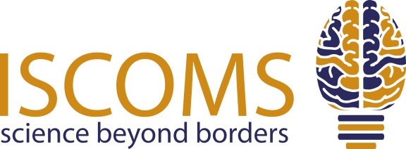

Dear student,

Are you conducting (bio)medical research and interested in presenting your work on an international platform? Or are you simply interested in learning about the latest (bio)medical research?

*The International Student Congress Of (bio)Medical* *Sciences* (ISCOMS) is one of the world’s leading student congresses in the field of (bio)medical sciences. Last year, over 600 students from more than 60 countries attended the 30th edition of ISCOMS. This year, the 31st edition will take place from the **3rd until the 6th of June 2023** in Groningen, The Netherlands.

Students can visit the congress both as a presenting and non-presenting participant. ISCOMS offers a scientific programme with a pre-course to master your research skills, student presentation sessions (plenary, oral, and poster), workshops and a surgical operation. You can also acquire information on working and performing research in Groningen during our network lunch, which gives you the opportunity to integrate with companies interested in recruiting ambitious biomedical students.

In addition, students can explore PhD opportunities at the University Medical Center Groningen (UMCG) with our ISCOMS Research Fellowships (IRF). The IRF consists of a challenging two week programme in which students are expected to actively participate in research at one of the UMCG’s Research Institutes and gather a great deal of knowledge related to the topic of research. As a student, you get the chance to perform research at a leading institute, meet top-researchers, and – more importantly – learn about the possibilities of doing a PhD-programme in the Netherlands. There have been many foreign students who were able to start a PhD-programme in the UMCG due to the IRF. **The IRF is available for presenting participants only.**

On top of all this, we will feature an exciting social programme, including a formal dinner, the amazing World Wide ISCOMS Night and a Post Congress Tour.

**CALL FOR ABSTRACTS**

Are you interested in presenting your research at ISCOMS? Send in your abstract! The abstract submission has been opened and will close onthe **21st of January 2024**. Each student is allowed to submit up to two abstracts. Abstracts can be submitted on our website [www.iscoms.com](http://www.iscoms.com).

For more information, please visit our [website](http://www.iscoms.com), [Instagram](https://www.instagram.com/iscoms/) and [Facebook page](http://www.facebook.com/iscoms) or check out our [after movie from ISCOMS 2022](https://www.youtube.com/watch?v=uBCBhv-3WKw). If you have any questions, feel free to contact us at [iscoms@umcg.nl](mailto:iscoms@umcg.nl).

Kind Regards,

Xander Hegeman, Nina Ruys

*International Contacts*ISCOMS 2024