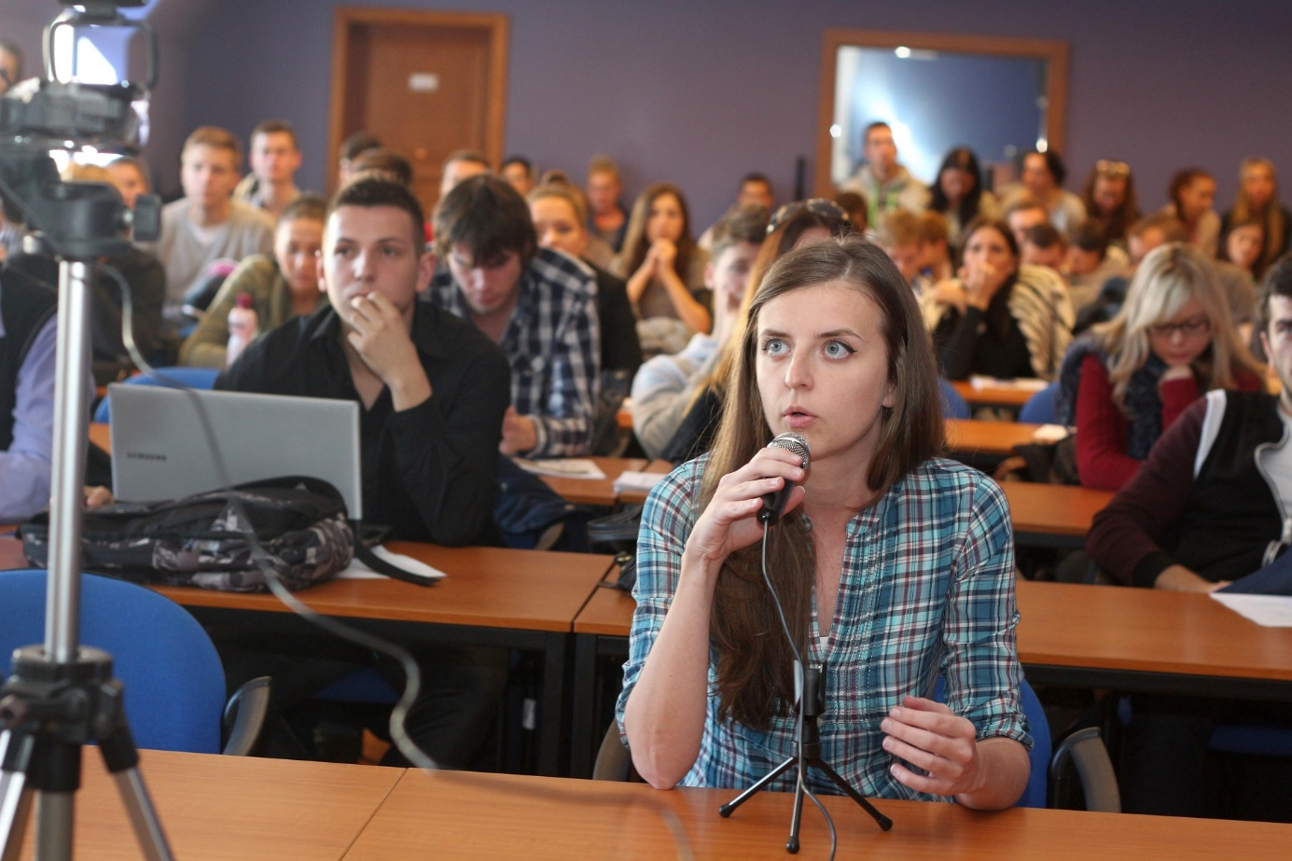
University Debates

Are you interested in international affairs? Are you hooked on European Union, Russia and China-related issues? Do you enjoy debating?

Join us!

You are cordially invited to the

International Debate of University Students´ Teams
Monday, 26 November, 2018, 10:00 AM
Room:
Teams from seven universities in five countries will participate in an online debate.

Academy of Economic Studies of Moldova, Chisinau
Faculty of political science, University of Montenegro, Podgorica
International University of Sarajevo
University of Novi Sad
University of Belgrade
Comenius University, Bratislava
Matej Bel University, BanskaBystrica

Questions from the audience are more than welcome.
For more information, visit our FB page
https://www.facebook.com/UniversityDebates/

