PERSONAL INFORMATION | Maja Laušević-Odalović
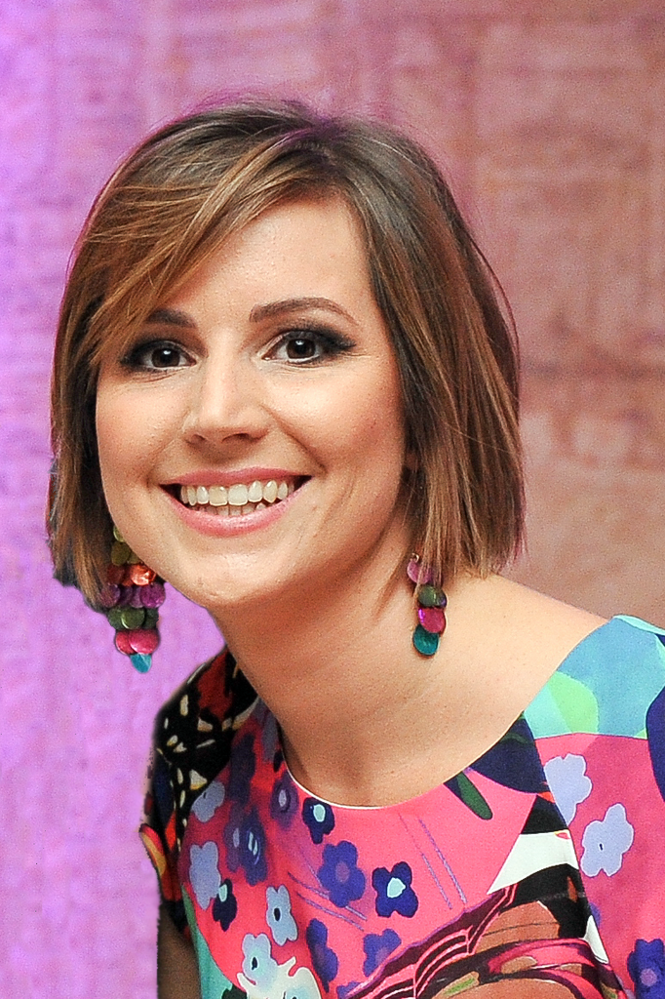 |   Ivana Vujoševića 8, 81000 Podgorica, Montenegro
 |  +38267336008

maja.lausevicodalovic@gmail.com
 | Sex Female | Date of birth 08/05/1987 | Nationality Montenegrin

WORK EXPERIENCE

September 2010 – present | Assistant Lecturer
September 2010 – present | University of Montenegro (UoM) [www.ucg.ac.me]  Faculty of Civil Engineering (FCE) [www.gf.ucg.ac.me]  Podgorica, Montenegro
September 2010 – present | - Assistant Lecturer in courses from the domain of: Concrete constructions, Design and construction of concrete structures, Construction materials, Basics of bridges, Concrete bridges, Foundation and Seismic Design  - Co-supervisor of Final/Diploma student projects  - Scientific-research and engineering activities  - Mentoring sessions  - Organizing of International Conference “GNP” (“Civil Engineering-Science and Practice”)
February 2015 – November 2015 | Senior Engineer
February 2015 – November 2015 | Geo-T, Podgorica, Montenegro  Responsibilities:
February 2015 – November 2015 | - Designing of a large number of construction objects  - Supervision and building of reinforced concrete structures  - Continuous update and preparation of technical documentation  - Regular reporting to superiors
February 2014 – November 2014 | Senior Engineer
February 2014 – November 2014 | Continental Engineering, Podgorica, Montenegro  Responsibilities:
February 2014 – November 2014 | - Planning and designing of a large number of construction objects  - Supervision and building of reinforced concrete structures  - Continuous update and preparation of technical documentation  - Regular reporting to superiors
January 2008 –March 2009 | Civil Engineering Consultant
January 2008 –March 2009 | ”Janko Lisjak” International, Bar, Montenegro  Responsibilities:
January 2008 –March 2009 | - Work organization (managing workforce, logistic and procurement activities)  - Supervision on construction of the continental and southern branch of the regional water supply system for the Montenegrin coast  - Quality control  - Monitoring and analysing the complete process, reporting and presenting results

EDUCATION AND TRAINING

2015 - present | PhD (Dr – Doctor) | EQF level 8
2015 - present | Faculty of Civil Engineering, University of Montenegro (Montenegro)
2015 - present | - Specialisation: Concete structures

September 2012 – March 2014 | MSc (Mr – Magistar) | EQF level 7
September 2012 – March 2014 | Faculty of Civil Engineering, University of Montenegro (Montenegro)
September 2012 – March 2014 | - Specialisation: Earthquake Engineering  - Structure: 5 courses/exams (2 semesters) + MSc Thesis  - MSc Thesis: The choice of the intensity measures of earthquake on the example of reinforced concrete frame structures
September 2006 – June 2010 | BSc (Dipl.Ing) | EQF level 6
September 2006 – June 2010 | Faculty of Civil Engineering, Podgorica, Montenegro  - Specialisation: Structures  - Structure: 46 courses/exams (7+1 semesters) + Final/Diploma project (1 semester)  - Final/Diploma project: Project of construction of a residential business building in Bar

PERSONAL SKILLS

Mother tongue(s) | Montenegrin / Serbian
Other language(s) | UNDERSTANDING |  | SPEAKING |  | WRITING
Other language(s) | Listening | Reading | Spoken interaction | Spoken production
English | B1 | B1 | B1 | B1 | B1
Russian | A2 | B1 | A2 | A2 | A2
Levels: A1/2: Basic user - B1/2: Independent user - C1/2 Proficient user
Common European Framework of Reference for Languages

Communication skills | - Good communication skills gained through teaching experience, through participation in numerous conferences.  - Good ability to adapt to new environment and to cooperate with new people.
Organisational / managerial skills | - Leadership/managerial/organisational experience as:  - Head of engineering design teams - responsible and/or principal design engineer,  - Head of supervising teams in construction process.  - Managerial/organisational experience as:  - Member of Organising Committee of International Conferences “Civil Engineering – Science  and Practice”: GNP 2010, GNP 2012, GNP 2014, GNP 2016.

Job-related skills | - Good command of project management acquired through regular job activities and by attending many “soft skills” trainings  - Vary organized, focused person with a professional approach to the task with creative, innovative and analytical approach to achieving goals

Computer skills | - Good command of relevant operating systems as Windows and Mac OS  - Good command of Microsoft Office tools  - Knowledge of software packages such as AutoCad, ArmCad, Tower, Sap, Etabs, X-tract
Other skills | Professional skills:  - familiar with structural engineering laboratory techniques and methods,  - experience in experimental testing of structures and materials.  Hobbies and interests:  - skiing, swimming and hiking,  - dancing,  - music (playing accordion),  - reading,  - cooking,  - travelling.

Driving licence(s) | - B

ADDITIONAL INFORMATION

Publications |  | - M. Laušević, Z. Tomanović: “Liquefaction presence in Montenegro” Fourth international conference of Engineering – Science and practice, Zabljak, Montenegro, 2014  - M. Laušević, S. Janković: "Comparison of non-linear seismic analysis according to EC8 on the example of reinforced concrete frame", Scientific Professional International Counseling, Divčibare, 2012.  - M. Laušević: “Application of prestressed concrete slabs in building construction” Tried international conference of Engineering – Science and practice, Zabljak, Montenegro, 2012
Diploma/Awards |  | - Award for Best student of 2006/7 generation with mark A 2010, Faculty of Civil engineering Montenegro  - Award for best overall student on Faculty for Civil engineering in Podgorica 2008, Company “Konstruktor Engineering” DD Split  - Award “19 December” for extraordinary student achievements 2008, Capital city Podgorica  - Best student of III year studies on Civil engineering Faculty 2008, Faculty of Civil engineering Montenegro  - Best student of II year studies on Civil engineering Faculty 2007, Faculty of Civil engineering Montenegro  - Best student of I year studies on Civil engineering Faculty 2006, Faculty of Civil engineering Montenegro
 | Memberships |  | Organasing committees of scientific and professional conferences:  - The 6th International Conference "Civil Engineering - Science & Practice", GNP 2016,  Žabljak, Montenegro, 2016. Scientific Committee.  - The 5th International Conference "Civil Engineering - Science & Practice", GNP 2014,  Žabljak, Montenegro, 2014. Scientific Committee.  - The 4th International Conference "Civil Engineering - Science & Practice", GNP 2012,  Žabljak, Montenegro, 2012. Scientific Committee.  Professional bodies:  - Member of Working Group for translation and elaboration of annexes of standard EN 1991, Institute for Standardisation of Montenegro (ISME), 2017-2018  - Member of Working Group for translation and elaboration of annexes of standard EN 1992, Institute for Standardisation of Montenegro (ISME), 2017-2018
 | Study/research/teaching mobility |  | - Универзитет „Св. Кирил и Методиј“, Скопје, Македонија; CEEPUS exchange programme –  – visiting teacher; June 2010

