LIČNE INFORMACIJE | Vesna Mačić
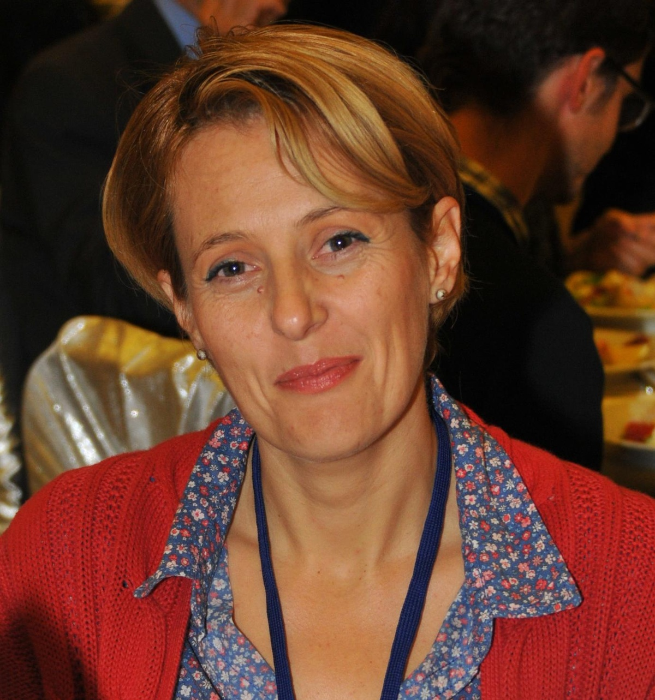 |   Dobrota bb, 85330 Kotor (Crna Gora)


+382 32 334 572  +382 (0) 67 562 184

macic.v@ac.me

RADNO ISKUSTVO

1997-2011  2011-2016  2016 | Saradniku istraživanju  Naučni saradnik  Viši naučni saradnik
1997-2011  2011-2016  2016 | Univerzitet Crne Gore, Institut za biologiju mora, Kotor (Crna Gora)
1997-2011  2011-2016  2016 | Istraživanje fitobentosa- izučavanje morskih algi i cvjetnica, mapiranje staništa i monitoring priobalne zone morskog dna, stvaranje zaštićenih zona u moru, problem invazivnih vrsta

OBRAZOVANJE I OSPOSOBLJAVANJE

26/09/1996  20/04/2001  08/07/2010 | Diplomirani profesor biologije, Fakuletet za biologiju, Univerzitet Novi Sad  Magistarski rad: Taksonomska, morfološko-anatomska i fiziološka ispitivanja morskih cvjetnica Posidonia oceanic (L.) Del. i Cymodocea nodosa (Ucria) Asch. u Bokokotorskom zalivu, u cilju zaštitu.  Univerzitet u Novom Sadu, centar za interdisciplinarne i multidisciplinarne studije i razvojna istraživanja za potrebe privrede-CIMSI  Doktorska disertacija: Ekološki potencijal i bioindikatorske karakteristike roda Cystoseira C.Agardh 1820(Phaeophyceae) u crnogorskom primorju
26/09/1996  20/04/2001  08/07/2010 | Univerzitet u Novom Sadu, Prirodno-matematički fakultet, Novi Sad (Srbija)

OSOBNE VJEŠTINE

Maternji jezik | Srpsko-Hrvatski
Ostali jezici | RAZUMIJEVANJE |  | GOVOR |  | PISANJE
Ostali jezici | Slušanje | Čitanje | Govorna interakcija | Govorna produkcija
engleski | C1 | C1 | C2 | C2 | C2
italijanski | C1 | C1 | C1 | C1 | C2
Stupnjevi: A1 i A2: Početnik - B1 i B2: Samostalni korisnik - C1 i C2: Iskusni korisnik
Zajednički europski referentni okvir za jezike
DODATNE INFORMACIJE

ostale vještine SCUBA ronioc R3; vozačka dozvola B kategorije

Međunarodni projekti | - Project- »Marine science of coastal management in Adriatic region, Western Balkan« (2006-2010). Norwegian cooperation program on Research and Higher Education with the Countries on the Western Balkans, regarding Marine Science and Coastal Management, saradnik na projektu.  - ADRICOSM project, 2006-2009 - Adricosm Integrated River Basin and Coastal Zone Managment System: Montenegro Coastal Area and Bojana river Catchment).- saradnik na projektu.  - MEDPOL project, 2009- 2010 - The marine pollution assessment and control component of Mediterranean Action Plan, saradnik na projektu.  - Komparativna istraživanja dinamike planktona Bokokotorskog zaliva i obalnih voda južnog Jadrana, 2011-2012. Projekat bilateralne saradnje između Crne Gore i Hrvatske. Ministarstvo nauke Crne Gore-saradnik na projektu.  - Alohtone vrste u obalnom području južnog Jadrana, 2013-2014. Projekat bilateralne saradnje između Crne Gore i Hrvatske. Ministarstvo nauke Crne Gore-saradnik na projektu.  - Joint Actions for Sea Pollution Prevention (JASPPer)- (2013-2015). IPA program prekogranične saradnje između Crne Gore i Hrvatske-saradnik na projektu.  - Ballast water management system for Adriatic Sea Protection (Balmas) –IPA saradnik na projektu.  - Sistem upravljanja napuštenim ribarskim alatima u Jadranskom regionu – DEFISHGEAR- IPA saradnik na projektu.  - Project - »Towards COast to COast NETworks of marine protected areas (from the shore to the high and deep sea), coupled with sea-based wind energy potential (CoCoNET) « FP7 projekt- saradnik na projektu.

Nacionalni projekti | - Biološki indikatori eutrofikacije u Bokokotorskom zalivu. Nacionalni projekat 2008-2011. Ministarstvo prosvjete i nauke Crne Gore, Sektor za nauku i visoko obrazovanje - saradnik na projektu  - Monitoring i biomonitoring kvaliteta vode za marikulturu (2009-u toku). Projekat Ministarstva poljoprivrede i ruralnog razvja, Sektor za ribarstvo i marikulturu -saradnik na projektu.  - Uticaj antropogenog faktora na živi svijet u priobalnom akvatorijumu Crnogorskog primorja. Nacionalni projekat 2012-2015. Ministarstva nauke Republike Crne Gore-saradnik na projektu.  - Izvještaj o istraživanju ekosistema mora (flore i faune) za izradu bazne studije - marinski biodiverzitet (nulto stanje) u dijelu nekadašnje kasarne Kumbor, Hercegnovski zaliv, za potrebe izgradnje marine- učesnik u izradi izvještaja.

REFERENCE:

- Mačić, V., (2000): Seagrass Posidonia oceanica(L.) Del. in the Bay of Boka Kotorska. Za{tita Voda pp: 103-108.
- Mačić, V., Sekulić, P. (2001): Investigation of mineral contents of seagrasses Posidonia oceanica (L.) Del. and Cymodocea nodosa (Ucria) Asch. Za{tita voda pp: 333-339.
- Budak, V., Mačić, V., Mačić, Lj. And Anačkov, G. (1999): Endemic plants in flora of surounding (Montenegro, Yugoslavia). VIII European Ecological Congress Eureco '99., Halkidiki, Greece, Abstract
- Budak, V., Mačić, V., Mačić, Lj. And Anačkov, G. (2000): Flora brda Sv Ivan u okolini Kotora. Zbornik radova o flori jugoistočne Srbije i susjednih područja. Abstract
- Mačić, V. (2000): Morska cvjetnica Posidonia oceanica(L.) Del. u akvatoriji od Herceg Novog do Budve. Zbornik radova o flori jugoistočne Srbije i susjednih područja. Abstract
- Mačić, V., Boža, P. (2001): Seagrasses meadows in the bay of Boka Kotorska. Zasavica 2001. Abstract.
- Mačić, V., Krstić, B., and Pajević, S. (2001): Mjerenje intenzitieta fotosinteze kod morskih cvjetnica Posidonia oceanica(L.) Del. i Cymodocea nodosa (Ucria) Asch. XIV Simposium of Yugoslav society of plant physiology. Abstract.
- Mačić, V. (2001): Phenology of seagrass Posidonia oceanica(L.) Del. in the south-East Adriatic (Cape of Koči{te). “Natural potentials of mainland, inland waters and sea waters of Montenegro and their protection" Abstract.
- Anačkov, G., Budak, V. and Mačić, V. (2001): West-Balcanic endems in the flora of Suraunding of Kotor. ). “Natural potentials of mainland, inland waters and sea waters of Montenegro and their protection" Abstract.
- Mačić, V., Pajević, S. and Krstić, B.: Rate of photosyntesis and dark respiration of seagrasses Posidonia oceanica (L.) Del. and Cymodocea nodosa (Ucria) Asch. Zaštita voda 2002, 319-322.
- Mačić, V. (2002): Phenology of seagrass Posidonia oceanica (l.) Del. in the south-east adriatic (cape of Kočište). Studija Marina 23 (1): 1-6.
- S. Mandić, N. Bajković, V. Mačić i A. Ivanović: Podvodni vješzački greben-pilot program. Hydrores information, Annuario 2001, Anno XVIII, n. 22. 28-31
- Mačić, V. (2001): Taxonomical, morphology-anatomycal and phisiological analisis of seagrasses Posidonia oceanica (L.) Del. and Cymodocea nodosa (Ucria) Asch. in the Bay of Boka Kotorska, in purpose of protection. MA degreee of Environmental Engineering TEMPUS, Univerity of Novi Sad, p. 97.
- Mačić, V. (2004): Alga Caulerpa racemosa i na crnogorskom primorju. Hydrores infromation, Ann XXI, n.26., 42-44
- Mačić, V. (2005):Unešena alga Caulerpa racemosa kao moguća prijetnja za morsko ribarstvo. Ribarstvo, Zemun, 10-12. II pp. 359-362
- Mačić, V. (2006): Seaweed Fucus virsoides J. Agardh in the Boka Kotorska Bay (south Adriatic sea) Annales, Ser. hist. nat. 16, 2006, 1: 1-4.
- Mačić, V. (2006): First record of marine benthic algae Nematochrisopsis marina in montenegrian coast. II International symposium of ecologists of Montenegro; The book of abstracts and programme, Kotor, 20-24. 09. 2006.
- Mačić, V. (2007): Prilog poznavanju nekih prirodnih naselja mušulja (Mytilus galloprovincialis Lam.) na crnogorskoj obali. III Međunarodna konferencija Ribarstvo 2007. 1-3, februar 2007. 359-362.
- Mačić, V., S. Kašćelan (2007): Caulerpa racemosa on the montenegrian coast. Rapp. Comm.int. Mer. Medit. 38.
- Mačić, V. (2007): Rasprostranjenost alge Cystoseira barbata u unutrašnjem dijelu Bokokotorskog zaliva. Voda 2007, Tara, 26-29. jun, 2007. pp:263-266
- Mačić V. (2008): Novo nalazište invazivne alge Womersleyella setacea (Hollenberg) R. E. Norris u crnogorskom podmorju. Vode 2008, Mataruška banja 3-6. jun 2008. pp:293-296.
- Macic, Vesna, Thierry Thibaut, Boris Antolic and Zorica Svircev (2010): Distibution of the most common Cystoseira species on the coast of Montenegro (South-East Adriatic Sea). Fresenius Environmental Bulletin (ISSN 1018-4619), Vol.19, No.6, pp. 1191-1198
- Mačić, V. (2010): Periodism of Cystoseira spinosa Sauv. (Phaeophyta) frond size on the montenegrian coast. Commission Internationale pour l’exploration Scientifique de la mer Mediterranee, Rapport du 39e Congres de la CIESM 2010, Venice 10-14 May 2010, pp.576.
- Mačić, V. (2009): Analiza naselja Cystoseira corniculata (Phaeophyceae) u Bokokotorskom zalivu. Zbornik radova 38. godišnje konferencije o aktuelnim problemima korišćenja i zaštite voda, Vode 2009., Urednik Aleksandar Đukić, Izdavač Srpsko društvo za zaštitu voda. Zlatibor, 8-10, jun 2009. pp: 297-300. (ISBN 978-86-904241-6-0)
- Mačić, V. (2010): Alge roda Cystoseira kao bioindikatori stanja morske akvatorije. Zbornik radova 39. godišnje konferencije o aktuelnim problemima korišćenja i zaštite voda, Vode 2010, Urednik Aleksandar Đukić, Izdavač Srpsko društvo za zaštitu voda. Divčibare, 8-10, jun 2010. pp: 209-213 (ISBN 978-86-904241-7-7)
- Santini, F., Palombo, A., Cavalli, R.M., Kljajić, Z., Mačić, V., Pescucci, S. and Pignatti, S. (2010): Discrimination of phanerogam communities through hyperspectral data: Preliminary results of Montenegro coastal area. 33rd International symposium on remote sensing of environment (ISRSE) 4-8 May 2009, Stressa, Italy, pp:132-135
- Mačić, V. (2010): Biodiversity and negative changes on the montenegrin rocky coast. XXI Conference on the sea, Alghero, 6-9 May 2010, Italy, pp.63-64.
- Da Ros L., Moschino V., macic V. and M. Schintu (2010): Preliminary ecotoxicological assessment of Boka Kotorska Bay (South-Eastern Adriatic Sea): Lysosomal responses and metallothionein induction in the mussel Mytilus galloprovincialis. 6th International conference on marine pollution and ecotoxicology, Hong Kong, 31 May-3 June 2010. pp. O-119.
- Tatjana P. Stanojković, Zoran Kljajić, Aleksandra Konić-Ristić, Gordana Zdunić, Vesna Mačić, Tatjana Srdić-Rajić, Katarina Šavikin, Zorica D. Juranić (2011): In vitro Cytotoxic, Anticoagulant, Antioxidant and Cell Cycle Effects of Extract of Brown Alga Cystoseira amentacea, from Boka Kotorska, Montenegro. ECCO 2011, Stockholm 23-27 October 2011.
- V. Mačić, P. Bernat, A. Molinari, M. Fant, M. Cassola, F. Polato, E. Giovannetti, A. Rzaničanin, J. Knežević and N. Čađenovć (2011). State of Posidonia meadows and fish assamblages in the future MPA „Katič“ (Montenegro). Studia Marina 25(1): 73-82.
- V. Mačić, P. Bernat, A. Molinari, M. Fant, M. Cassola, F. Polato, E. Giovannetti, A. Rzaničanin, J. Knežević and N. Čadjenović (2011). Zoning of the marine component of the coastal area of Petrovac (Adriatic Sea, Montenegro): A pilot study for the establishment of an MPA. 46th European marine Biology Symposium, 12-16 September 2011 Rovinj, Croatia, pp. 17.
- Lakušić D., Hadžiablahović S., Vuksanović S., Petrović S., Mačić V. And Z. Bulić (2011): Novi prodromus biljnih zajednica Crne Gore-osnova za klasifikaciju staništa. Zaštita prirode u XXI vijeku, Zbornik plenarnih referata (knjiga br 1), 20-23 septembar 2011., 169-171.
- Mačić V. (2011): Destrukcija priobalnih staništa – rastući problem u Crnoj Gori. Zaštita prirode u XXI vijeku, Zbornik referata, rezimea referata i poster prezentacija (Knjiga 2), 20-23 septembar 2011., pp. 925-926.
- Stelios Katsanevakis, Argyro Zenetos, Vesna Mačić, Sajmir Beqiraj, Dimitrios Poursanidis, Lefter Kashta (2011): Invading the Adriatic: spatial patterns of marine alien species across the Ionian–Adriatic boundary. Aquatic Biology Vol. 13: 107–118.
- Stelios Katsanevakis, Dimitrios Poursanidis, Mehmet Baki Yokes, Vesna Mačić, Sajmir Beqiraj, Lefter Kashta, Yassine Ramzi Sghaier, Y.M. Zakhama-Sraieb, Ibrahem Benamer, Ghazi Bitar, Zoheir Bouzaza, Paolo Magni, Carlo Nike BianchI, Louis Tsiakkiros and Argyro Zenetos (2011): Twelve years after the first report of the crab Percnon gibbesi (H. Milne Edwards, 1853) in the Mediterranean: current distribution and invasion rates. Journal of Biological Research-Thessaloniki 16: 224 – 236.
- L. Da Ros, V. Moschino, V. Macic, M. Schintu (2011): An ecotoxicological approach for the Boka Kotorska Bay (south-eastern Adriatic Sea): First evaluation of lysosomal responses and metallothionein induction in mussels. Marine Pollution Bulletin 63 (2011) 326–333.
- Mačić , V., Kljajić, Z. (2011): Monitoring fitobentosa u crnogorskom podmorju. Vode 2011, Zlatibor, 7-9. juna 2011.g. pp: 263-266.
- Mačić, V., Stanković, S., Joksimović D., Kljajić Z. (2011): Koncentracija nekih teških metala u algama roda Cystoseira u crnogorskom podmorju. Vode 2011, Zlatibor, 7-9. juna 2011.g. pp: 245-250.
- A. Molinari, P. Bernat, V. Mačić, M. Fant, F. Polato, A. Rzaničanin, J. Knežević and N. Čadjenović (2011): The use of scientific scuba diving activities to collect information on fish and benthic community for the establishment of an MPA in the coastal water of Montenegro, Adriatic Sea. Porto Cesareo (Lecce) Italy, 9-12 November 2011, pp. 49.
- Mačić, V., Kljajić Z. (2012). Pregled unešeneih vrsta u crnogorskom podmorju. Vode 2012, pp: 255-260.
- Mačić Vesna (2012): Tri zaštićene vrste mekušaca (Mollusca) u Bokokotorskom zalivu. Boka 32, 199-207.
- Badalamenti, F., Garcia Charton, J.A., Cebrián, D., Mačić, V. & S. Kašćelan. Ed. (2008): Development of a network of marine and coastal protected areas (MPAs) in Montenegro: First preliminary survey. UNEP-MAP RAC/SPA, Tunis. 48pp.
- Mačić, V. and Svirčev Z. (2013): Macroepiphytes on Cystoseira species (Phaeophyceae) on the coast of Montenegro. Fresenius Environmental Bulletin, Volume 23 – No 1. 2014, pp:29-34.
- Mačić, V. (2013): Some characteristics of the Cystoseira (Phaeophyceae) assamblages in the intertidal fringe on the coast of Montenegro. natura Montenegrina, 12(2): 325-333.
- L. Angeletti, M. Taviani, S. Canese, F. Foglini, F. Mastrototaro, A. Argnani, F. Trincardi, T. Bakran-Petricioli, A. Ceregato, G. Chimienti, V. Mačićand A. Poliseno (2013): New deep-water cnidarian sites in the southern Adriatic Sea. Mediterranean Marine Science 15/2, 2014, 1-11.
- Mačić Vesna (2013): Zaštićene marinske vrste u oblasti Paštrovića. Naučni skup po pozivu "Prirodni resursi Paštrovića u kontekstu crnogorskog primorja. Knjiga sažetaka, 12-13. oktobar 2013. g. "Crvena komuna", Petrovac, pp. 32.
- C. S. Martin, M. Giannoulaki, F. De Leo, M. Scardi, M. Salomidi, L. Knitweiss, M. L. Pace, G. Garofalo, M. Gristina, E. Ballesteros, G. Bavestrello, A. Belluscio, E. Cebrian, V. Gerakaris, G. Pergent,C. Pergent-Martini, P. J. Schembri, K. Terribile, L. Rizzo, J. Ben Souissi,M. Bonacorsi, G. Guarnieri, M. Krzelj, V. Macic, E. Punzo, V. Valavanis & S. Fraschetti (2014): Coralligenous and maerl habitats: predictive modelling to identify their spatial distributions across the Mediterranean Sea. Sci. Rep. 4, 5073; DOI:10.1038/srep05073 (2014).
- Mačić V. (2014): Regresija morskih trava u Risanskom zalivu (Crna Gora). Voda 2014. pp: 337-341.
- Mačić V. (2014): Anatomical features of seagrass Posidonia oceanica (L.) Del. Growing in Montenegro (Adriatic sea). Journal Agriculture and Forestry, Vol. 60. Issue 3, pp: 55-64.
- Mačić V. (2014): Anatomical features of Cymodocea nodosa growing in Montenegro (Adriatic Sea) J. Black Sea/Mediterr. Environ. Vol. 20 No.3. pp: 253-263.
- Mačić, V., Panou, A., Bundone L. and Varda D. (2014): Contribution to the knowledge of rare and endangered habitats - marine caves (Montenegro, South East Adriatic coast). 1st Mediterranean Symoposia on the conservation of the dark habitats (Portorož, Slovenia 31. October 2014. pp: 73-74.
- Pititto F., Trainito E., Mačić V., Rais C., Torchia G (2014): The resolution in benthic cartography: a detailed mapping technique and a multiscale GIS approach with applications to coralligenous assemblages. 2nd Mediterranean Symposium on the conservation of Coralligenous & other Calcareous Bio-Concretions, Portorož, Slovenia, 29-30 October 2014, pp: 141-146.
- Mačić Vesna, Lučić Davor, Gangai-Zovko Barbara, Drakulović Dragana, Petović Slavica, Mandić Milica, Marković Olivera, Aleksandra Huter, Miloslavić Marijana, Onofri Ivona, Njire Jakica, Onofri Vladimir, Dulčić Jakov, Joksimović Aleksandar, Žuljević Ante i Pestorić Branka (2014): Monografija alohtonih vrsta istočne obale južnog Jadrana. Univerzitet Crne Gore i Sveučilište u Dubrovniku, 2014. p. 64.
- Thibaut T., Blanfuné A., Markovic L., Verlaque M., Boudouresque C.F., Perret-Boudouresque M., Macic V., Bottin L. (2014): Unexpected abundance and long-term relative stability of Cystoseira amentacea (brown alga), hitherto regarded as a threatened species, in the north-western Mediterranean Sea. Marine Pollution Bulletin Vol. 89 Issue 1-2, pp: 305-323.
- Mačić, V., Antolić, B. (2015): Distribution of rare Cystoseira species along the Montenegro coast (South-Eastern Adriatic Sea). Periodicum Biologorum Vol. 117, No. 3: 57-63. ISSN 0031-5362
- Mačić, V., Petović, S., Backović, S. (2015): Contribution to the knowledge of protected Axinella (Porifera, Demospongiae) species along the Montenegrin coast. Studia Marina 28(1): 9-20. ISSN 0585-5349
- Petović S., Mačić V. (2015): Contribution to the designation of the Platamuni marine protected area. Studia Marina 28 (1): 27-38. ISSN 0585-5349
- Mačić, V., Petović, S., Đurović, M. (2015): Rasprostranjenje i ugroženost zaštićenih vrsta flore i faune u morskoj akvatoriji područja Paštrovića. Zbornik radova sa naučnog skupa održanog u petrovcu 12-13. oktobra 2013. g. Prirodnih resursa Paštrovića u kontekstu Crnogorskog primorja. CANU, pp: 57-64. ISBN 978-86-7215-374-3
- Milica Mandić, Vesna Mačić, Olivera Marković 2016. Spawning of alien nudibranch Melibe viridis (Kelaart, 1858) in South Adriatic Sea (Montenegro). Fresenius Environmental Bulletin Vol. 25 No. 11: 4566-4568.
- BOISSIN, E. D. MICU, M. JANCZYSZYN-LE GOFF, V. NEGLIA, L. BAT,§ V. TODOROVA, M. PANAYOTOVA, C. KRUSCHEL, V. MACIC, N. MILCHAKOVA, C_ . KESKIN, A. ANASTASOPOULOU, I . NASTO, L. ZANE and S. PLANES 2016. Contemporary genetic structure and postglacial demographic history of the black scorpionfish, Scorpaena porcus, in the Mediterranean and the Black Seas. Vol. 25. Issue 10: 2195-2209. DOI: 10.1111/mec.13616
- Argyro Zenetos, Vesna Mačić, Andrej Jaklin, Lovrenc Lipej, Dimitris Poursanidis, Riccardo Cattaneo-Vietti, Sajmir Beqiraj, Federico Betti, Diego Poloniato, Lefter Kashta, Stelios Katsanevakis and Fabio Crocetta 2016. Adriatic ‘opisthobranchs’ (Gastropoda, Heterobranchia): shedding light on biodiversity issues. DOI: 10.1111/maec.12306
- Aurélie Blanfuné, Thierry Thibaut, Charles F. Boudouresque, Vesna Mačić, Laurent Markovic, Laura Palomba, Marc Verlaque, Pierre Boissery 2017 The CARLIT method for the assessment of the ecological quality of European Mediterranean waters: Relevance, robustness and possible improvements. Volume 72, January 2017, Pages 249–259. http://dx.doi.org/10.1016/j.ecolind.2016.07.049

