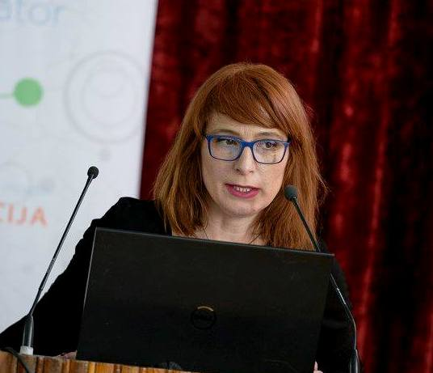

Marijana Blečić was born on December 29, 1978, Tripoly, Libia. She graduated Faculty of Philosophy in Nikšić, degree in Preschool education (9,87/10); Faculty of Political science in Podgorica, master degree in Contemporary social science and social work (9,50/10). Engaged in various positions in the NGO Pedagogical Center of Montenegro, international organization Roma Education Fund and the Council of Europe.
Publications:
- Manual for student volunteerism, PCCG and Roma Education Fond, Podgorica, (joint authorship), 2013;
- Manual for student volunteerism II, PCCG and Roma Education Fond, Podgorica, (joint authorship), 2014;
- Business communication for I grade of secondary vocational school, Bureau for textbooks and teaching aids Montenegro, Podgorica, (joint authorship), 2014;
- Seven women stories – examples of good practices for work with mothers of RE population, Help and Roma Education Fond, Podgorica, (author), 2014;
- Manual for student volunteerism for work with RE children in Serbia, Roma Education Fond, Belgrade, (joint authorship), 2015;
- Activities and games for work with children of preschool age (3-6), Pedagogical center of Montenegro, Podgorica, (joint authorship), 2016;
- Development and integration of first and second generation refugees, KNOWLEDGE, International Journal Institute of Knowledge Management, Scientific papers, Vol.17.2, Skoplje, (joint authorship), 2017;
- Good practices in fostering a democratic school culture in Montenegro (2016-2018), Council of Europe, Podgorica, (joint authorship), 2018;
- Analysis of the situation in the Regional Department of the elementary school "Božidar Vuković Podgoričanin" (desegregated education), Roma Education Fund, Podgorica, (joint authorship), 2018;
- Early childhood development of Roma and Egyptian, Roma Education Fund, Budapest, (author), 2019;
- Author and co-author of Program for professional training of Bureau of Educational Services 2016/17 and 2017/18 (Human library, Persona doll, 5 steps of quality…)

