
Curriculum Vitae Dragana Čarapić

PERSONAL INFORMATION Dragana Čarapić
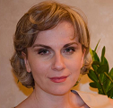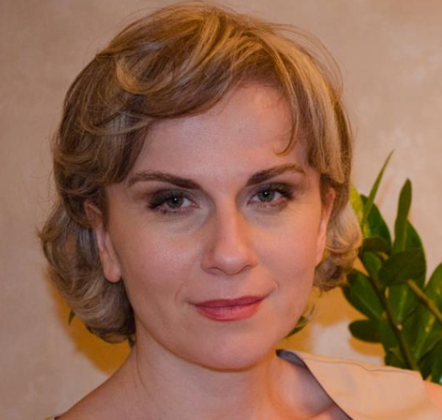

13 Jul 33/5 81000 Podgorica Montenegro

Sex Female

Date of birth 26 September 1975
Nationality Montenegrin

draganac@ac.me

WORK EXPERIENCE

2016 - present

2001 – 2015

EDUCATION

February 2016

Senior lector
University of Montenegro, Faculty of Philology, Department of the English language
and literature, Nikšić, Montengro

Teaching assistant
University of Montenegro, Institute of Foreign Languages, Podgorica, Montenegro (engaged at the Faculty of Law, Faculty of Economics, Faculty of Electrical engineering, Faculty of Fine Arts, Faculty of Medicine and at the Translation Studies department of the Faculty of Philology, as well as at the courses of the English language)

PhD in Linguistics – Thesis Title: ´Near-synonymy analysis in English and Montenegrin in contrast´
University of Montenegro, Faculty of Philology, Department for English language and literature (Nikšić, Montenegro)

July 2007 MA degree in Philology – Thesis Title: ´Comparative analysis of the English and Serbian slang´

Belgrade University, Faculty of Philology, Department for Linguistics

(Belgrade, Serbia)

December 2000

TRAINING
April 2021

July 2020

October 2020

December 2019

May 2017

Bachelors degree in Philology
University of Montengro, Faculty of Philosophy, Department for the English language and literature

“Blended Language Learning: Best Practices and New Perspectives“ within the Erasmus+ Project: Reforming Foreign Languages in Academia in Montenegro (ReFLAME).
"From texts to handouts and textbooks: Developing teaching materials for LSP",
within the Erasmus+ Project: Reforming Foreign Languages in Academia in Montenegro (ReFLAME).
“From Foreign Language Teaching Methodology to Syllabus Design”, within the Erasmus+ Project: Reforming Foreign Languages in Academia in Montenegro (ReFLAME).

Methods in Adult Education

A seven-day workshop for teaching the adults at the Center for occupational education, Podgorica, Montenegro

Languages and Linguistics: International Perspectives, University of Limerick, MIC, Ireland

© European Union, 2002-2013 | http://europass.cedefop.europa.eu Page 2 / 4
Page 1 / 4

Foreign language(s)
Italian

English
Curriculum Vitae Dragana Čarapić

UNDERSTANDING |  |  | SPEAKING |  | WRITING
Listening | Reading |  | Spoken interaction | Spoken production
B1 | B1 |  | B1 | B1 | B1
 | Austrian Language Certificate: ÖSD C1
C2 | C2 |  | C2 | C2 | C2
 |  | Cambridge Advanced

Levels: A1/2: Basic user - B1/2: Independent user - C1/2 Proficient user Common European Framework of Reference for Languages

Communication skills

Organisational / managerial skills

Job-related skills

Computer skills

Driving licence

ADDITIONAL INFORMATION

Publications

Memberships

ANNEXES

- good communication and presentation skills gained through my teaching experience
- experience as interpreter for English–Montenegrin
- court interpreter for English

- Brown Bag lectures organized at the Institute of Foreign languages in Podgorica
- organizing courses at the Institute of Foreign languages

- good time management gained through teaching experience
- good balancing of career and private life (married, two children)

- experience in curriculum development, part of the team for foreign language curricula reform

- literate in Microsoft Office Word, Excel, Google Chrome

Reviewer:
- Folia linguistica et Litteraria (Faculty of Philology, University of Montenegro)
- Logos & Littera: Interdisciplinary Approaches to Text (Faculty of Philology, University of Montenegro)
- Facta Universitatis (University of Niš), Faculty of Philosophy, Department of English

- Member of DPLCG (Applied Linguistics Society of Montenegro)
- Member of MONTESSE – Montenegrin Society for the study of English
- Member of the Montenegrin Society of Court Interpreters

See List of Publication in Annex

List of Publications

© European Union, 2002-2013 | http://europass.cedefop.europa.eu Page 2 / 4

Curriculum Vitae Dragana Čarapić

LIST OF PUBLICATIONS

Research articles published in the journals indexed in the Social Sciences Citation Index and Arts and Humanities Citation Index
- Čarapić, D. (2015): “ Near-synonymy analysis of descriptive adjectives debeo,-la,-lo in Serbian and its English counterpart fat in contrast“ Poznań Studies in Contemporary Linguistics, 51(2), Berlin: De Gruyter Mouton, ISSN 1897-7499.

Research articles published in other journals:
- Čarapić, D. (2014) “Near synonymy analysis of the descriptive adjectives beautiful in English and lep,-a,-o in Serbian in contrast“, u Jovanović, V. (ur.) Facta Universitatis, 12(1), Niš: Filozofski fakultet, ISSN: 0354 -4702, str. 11-24.
- Čarapić, D. (2013) „Uporedna analiza opisnog pridjeva mršav,-a, -o i njegovih približnih sinonima u engleskom i crnogorskom jeziku“, u Glušica, R. (ur.) Riječ, 9, Nikšić: Filozofski fakultet, ISSN: 0354-6039, str. 33-50.
- Čarapić, D. (2013) „Zašto se ne može oprati prljav obraz? Tranzitivnost značenja opisnog pridjeva prljav,-a,-o u crnogorskom i opisnog pridjeva dirty u engleskom jeziku u kontrastu“, u Knežević, M. (ur.) Folia Linguistica et Litteraria, 6, Nikšić: Filozofski fakultet: Nikšić, ISSN: 1800-18542, str. 86-98.
- Čarapić, D. (2014) „Sinonimija iz ugla lingvističkih anglističkih teorija”, u Lingua Montenegrina, 1(13), Cetinje: Institut za crnogorski jezik i jezikoslovlje „Vojislav P. Nikčević“, ISSN 1800-7007, str. 139-152.
- Čarapić, D. (2017) "Meaning extension and grammatical gender in near synonymy analysis: a corpus based study, u Logos et Littera 4(1), Faculty of Philology, University of Montenegro, Nikšić, ISSN 2336-9884, str. 40-59.
- Bulatović, V, Čarapić, D. (2018) “Gender: Social or Linguistic? u Lingua Montenegrina, 1(13), Cetinje: Institut za crnogorski jezik i jezikoslovlje „Vojislav P. Nikčević“, ISSN 1800-7007, str.19-37.
- Čarapić, D. (2020) "Near-synonymy analysis of the descriptive adjective pale in English and bled,-a,-o in Serbian" u Bells Belgrade English Language and Literature Studies, 12(1), 163–185. https://doi.org/10.18485/bells.2020.12.8

© European Union, 2002-2013 | http://europass.cedefop.europa.eu Page 3/4

Book chapters:
- Čarapić, D. (2014) „Kognitivna lingvistika i analiza diskursa: kognitivni sinonimi“, naučna monografija Analiza diskursa: teorija i metode, (ur.) Slavica Perović, Podgorica: , Institut za strane jezike, str. 249-264.

Conference papers:
- Čarapić, D. (2012) „Analiza leksičkih grešaka u esejima studenata“, u Perović, S. (ur.) Zbornik radova sa konferencije društva za primijenjenu lingvistiku „Mi o jeziku, jezik o nama“.(10.20). Podgorica: Institut za strane jezike i DPLCG, str. 191-199.
- Čarapić, D. (2012) „Rod i semantički sadržaj primjera opisnih pridjeva u crnogorskom i engleskom jeziku u kontrastu”, u Lakić, I. (ur.) Zbornik radova sa konferencije društva za primijenjenu lingvistiku „Primijenjena lingvistika u fokusu“. (25.10.2012). Podgorica: Institut za strane jezike i DPLCG, str. 29-44.

© European Union, 2002-2013 | http://europass.cedefop.europa.eu Page 4 / 4

