
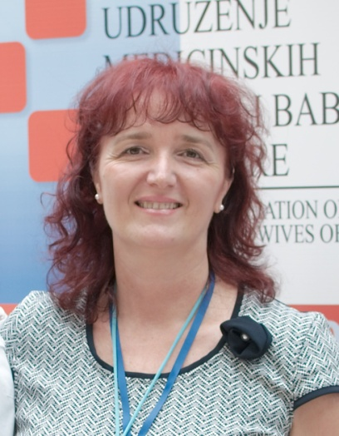
Nada Rondović
Ulica Đoka Miraševića, Ruske kule M3,

81000 Podgorica, Crna Gora
+382/69-484-965

nada.rondovic@kccg.me
Date of Birth 22 May 1961

WORK EXPERIENCE

1. Clinical-Hospital Center of Montenegro, Podgorica, Children’s Hospital, Head Nurse of the Intensive Care 1985-2000

2. Clinical-Hospital Center of Montenegro, Podgorica, Children’s Hospital, Head Nurse of the Hospital 2000-2008
3. Position of the Head Nurse of the Clinical Center of Montenegro from 2008

FORMAL EDUCATION

1976-1980 Medical High School, Midwifery Course, Subotica

1980-1983 Associate Degree of the Nursing School in Belgrade,
Pediatric Course

2011-2012. Higher Nursing School, Ćuprija
2015. Specialist studies in High medical school in Belgrade – Specialist of nursing care – field of Clinical patient care.

MEMBERSHIP IN PROFESSIONAL ASSOCIATIONS

1.President of the Association of Nurses and Midwives of Montenegro from 1996
2. President of the National Commission for Quality and Safety - Ministry of Health of Montenegro ( 2012.god.)
3. Member of Commission for Exams for health professionals within Ministry of Health of Montenegro (2015.-2019.)
4. University of Montenegro, member of Commission for coordinating the education program for nurses with the EU directive 2017.
5. University of Montenegro, Faculty of Medicine – Teaching assistant for practical classes (2017./2018. and 2018./2019. school year)
6. President of the National Commission for Nurses and Midwives – Ministry of Health of Montenegro
7. Representative of Montenegro in the European Federation of Nursing Associations (EFN)
8. Member of the International Council of Nurses (ICN)PARTICIPATION AT THE PROFESSIONAL MEETINGS

1. Workshop with international participation for nurses and midwives in organization of the Ministry of Health of Montenegro and National Association of Nurses and Midwives with the topic “Requirements of the Directive 2005/36/EC- specificities for the profession of nurses and midwives in Montenegro'' (November 2013)

2. TAIEX expert mission for compliance of the education of nurses and midwives with the Directive 2205/36/EC, Podgorica 2-6 December 2013

3. Workshop (with international participants) with the topic of General Care Nursing Curriculum delivery in Montenegro, organized by the Ministry of Health and National Association of Nurses and Midwives, 26-27 November 2014 in Podgorica.
Podgorica 04..02.2019. god.

