European
curriculum vitae
format

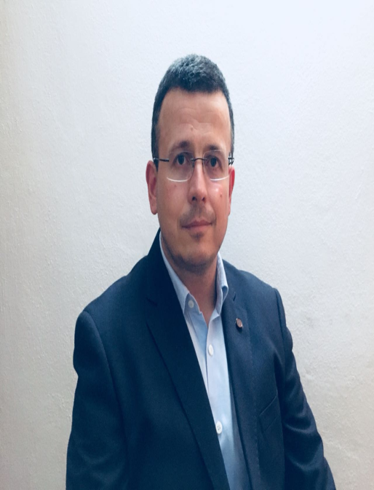

Personal information

Name |  | [ Campar D. Branko ]
Address |  | [ ul. Borisa Kidrica 18, 81000, Podgorica. Montenegro ]
Telephone |  | +38269304832
Fax
E-mail |  | camparb@gmail.com

Nationality |  | Montenegro

Date of birth |  | [ 07.01.1976 ]

Work experience

• Dates (from – to) |  | [ from 2002 Clinical doctor on surgery  2004 Residency in general surgery  2009 Work as general surgeon  2015 General and thoracic surgeon
• Name and address of employer |  | Clinical centar of Montenegro, Ljubljanska bb.
• Type of business or sector |  | Surgical clinic- Department for thoracic surgery
• Occupation or position held

Education and training

• Dates (from – to) |  | [ 2001 Medical school Belgrade  2009 specialist in general surgery  2009 Basic and advance laparoscopic course Split. Croatia. ]
• Name and type of organisation providing education and training |  | 2010 Basic thoracoscopic course, Split. Croatia  2011 Advance thoracoscopic course, Thessaloniki, Grece
• Principal subjects/occupational  skills covered |  | 2011 Advance thoracoscopic course , Elancourte, France  2012 Doctoral studies  2012 Residency in thoracic surgery  2014 Felowships thoracic surgery Kirurgija Bitenc-Slovenia  2015 Specialist in thoracic surgery
• Title of qualification awarded |  | 2017 Felowships in thoracic surgery divison AKH Viena- Austria
• Level in national classification  (if appropriate) |  | VII

Personal skills
and competences
Acquired in the course of life and career but not necessarily covered by formal certificates and diplomas.

2012 Trauma and Emergency surgery- SALZBURG WEILL CORNELL SEMINAR
2012/ 20th European Conference on general Thoracic Surgery - Essen- Germany
2014 / 22th European Conference on general Thoracic Surgery - Copenhagen- Denmark
2015/ 23th European Conference on general Thoracic Surgery – Lisabon- Portugal
2017/25th European Conference on general Thoracic Surgery-Inssbruck – Austria
2019/27th European Conference on general Thoracic Surgery-Dublin- Ireland

Other languages

 |  | [ English ]
• Reading skills |  | [ good. ]
• Writing skills |  | [good. ]
• Verbal skills |  | [ excellent]

Social skills  and competences  Living and working with other people, in multicultural environments, in positions where communication is important and situations where teamwork is essential (for example culture and sports), etc. |  | [ communicative, social ]

Organisational skills  and competences  Coordination and administration of people, projects and budgets; at work, in voluntary work (for example culture and sports) and at home, etc. |  | [I can do jobs related to general and thoracic surgery specialists. I'm currently working in the Department of Thoracic Surgery. I perform different kind operations from thoracic, abdominal and urgent surgery. In 2017, I perform 250 operations, 65 lung resection due to cancer, 65 thyreoidectomies,15 mediastinoscopy, 55 VATS procedures, 2 subtotal esophagectomies, and other abdominal surgery. I am interesting in teamwork, periodic training, and constant improvement of the surgery.]

Technical skills  and competences  With computers, specific kinds of equipment, machinery, etc. |  | [ Work with computers, software. ]

.

Other skills
and competences
Competences not mentioned above.

Driving licence(s) |  | B driving licence

Additional information

Annexes

