PERSONAL INFORMATION | Džana Lukač
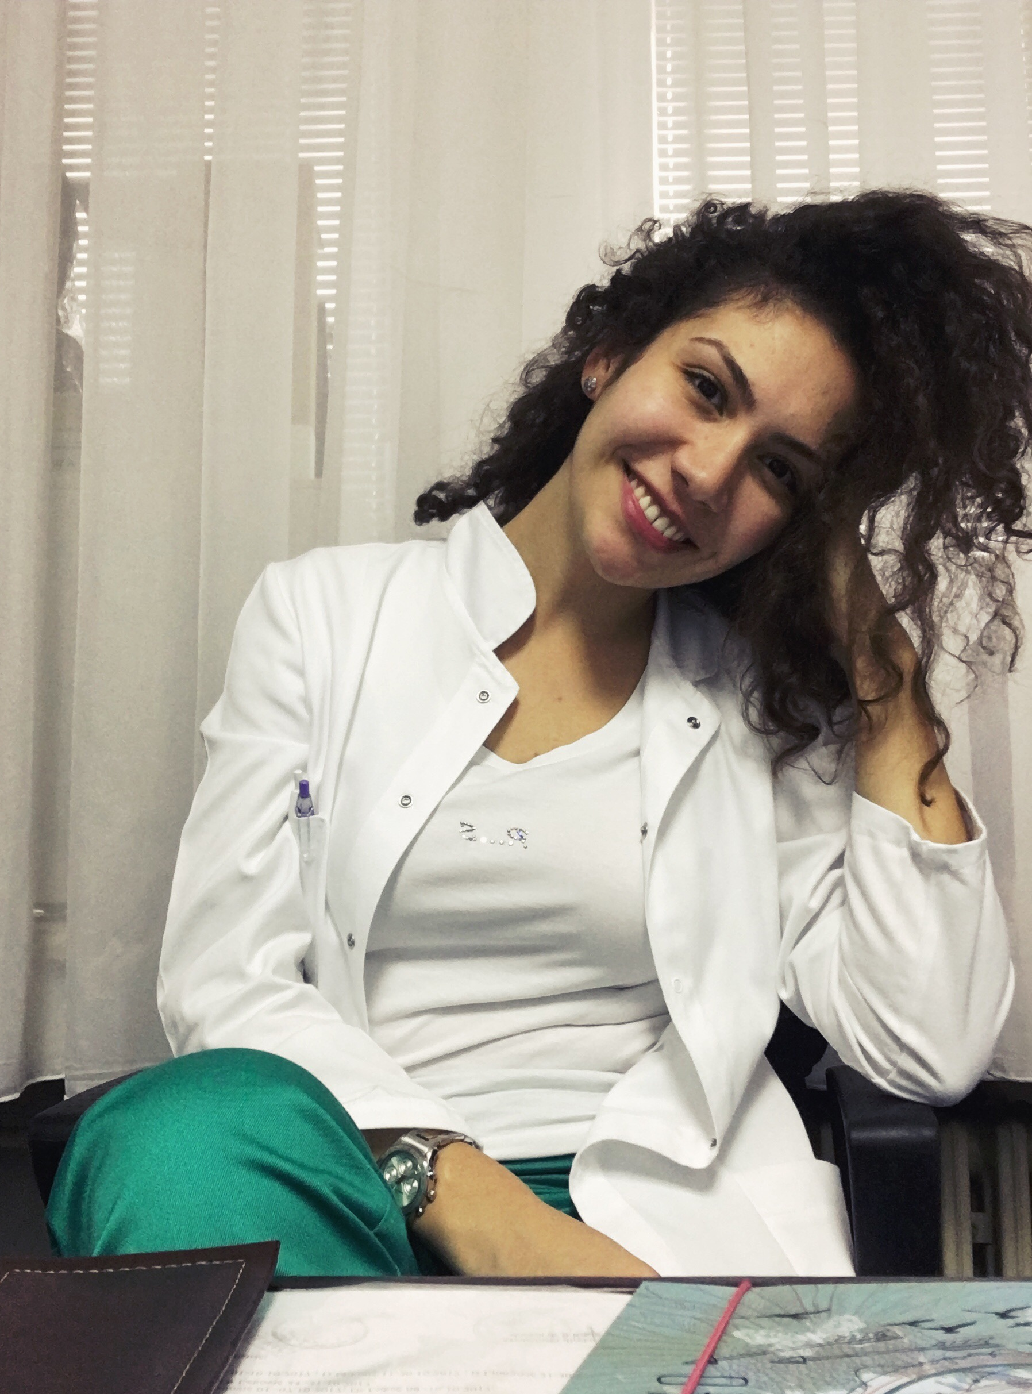 |   Podgorica, Montenegro

dzanalukac@gmail.com
dzana.lukac@kccg.me

 | Sex Female | Date of birth 30/08/1992 | Nationality Montenegrin

WORK EXPERIENCE

09/2016 – Present  12/2017 - Present | Teaching Assistant at Department of Pharmacology, Faculty of Medicine, University of Montenegro
09/2016 – Present  12/2017 - Present | Clinical pharmacy resident at Clinical Centre of Montenegro

EDUCATION AND TRAINING

10/2018 – Present  09/2011 – 06/2016  2007-2018  1999 - 2007 | Clinical pharmacy resident
10/2018 – Present  09/2011 – 06/2016  2007-2018  1999 - 2007 | Faculty of pharmacy, University of Belgrade  Doctor of pharmacy  Faculty of medicine, University of Montenegro  Medical high school, Podgorica  Elementary school ‘Maksim Gorki’, Podgorica
PERSONAL SKILLS

Other language(s) | UNDERSTANDING |  | SPEAKING |  | WRITING
Other language(s) | Listening | Reading | Spoken interaction | Spoken production
English | B2 | B2 | B2 | B2 | B2
Turkish | B2 | B2 | B2 | B2 | B2

Communication skills | Good communication skills gained through my experience as pharmacist and teaching assistant

Organisational / managerial skills | Good organisational skills gained through my experience as pharmacist

Digital skills | SELF-ASSESSMENT
Digital skills | Information processing | Communication | Content creation | Safety | Problem solving
 | Proficient user | Proficient user | Independent user | Independent user | Independent user

Driving licence | B category

ADDITIONAL INFORMATION

Publications  Honours and awards | - Lukač Džana, Drljević Ivana, Potpara Zorica, The role of pharmacist in self-medication, II Congress of pharmacists of Montenegro with international participation, 2015  - Drljević Ivana, Lukač Džana, Pačariz Amina, Đurković Alisa, Potpara Zorica, Allergies – the most common symptoms and causes , II Congress of pharmacists of Montenegro with international participation, 2015  - Lukač Džana, Inhalacioni preparati, Bilten farmaceutske komore Crne Gore, 2016  Award for Exceptional Students of the Faculty of Medicine of the University of Montenegro (December 2015)

