PERSONAL INFORMATION | Natasa Kopitovic Vukovic
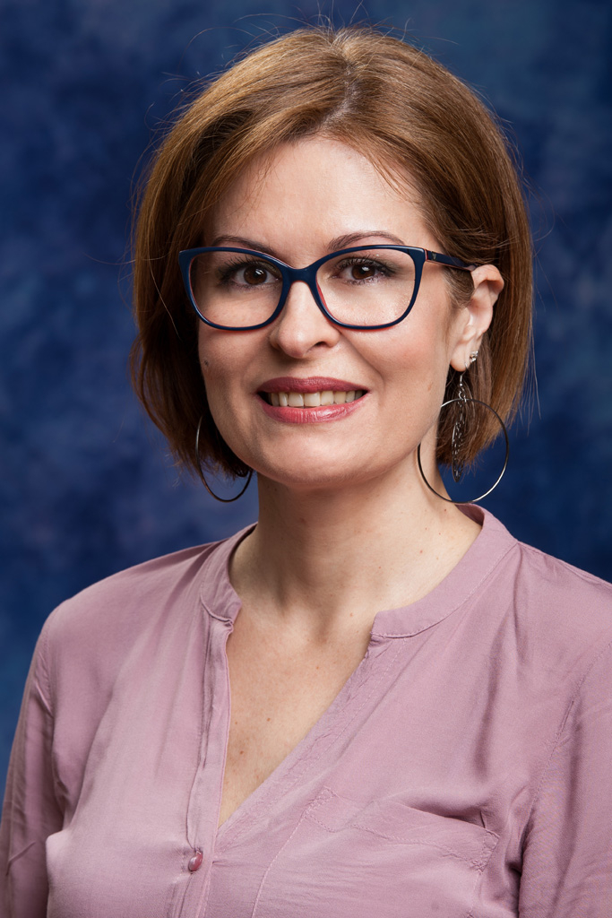 |   81000 Podgorica, Montenegro

nataly@ac.me
 | 

2003 - Present | Assistant Lecturer
2003 - Present | University of Montenegro (UoM) [www.ucg.ac.me]  Faculty of Civil Engineering (FCE) [www.gf.ac.me]  Podgorica, Montenegro
2003 - Present | - Assistant Lecturer; Subjects taught include building materials, technology of concrete and examination of materials and construction methods as well as energy efficiency of buildings (Faculty of Civil Engineering and Faculty of Architecture)  - Coordinator for International Cooperation of the FCE UoM (2008-2010)  - Co-supervisor of Final/Diploma student projects
- Examination of materials in the Laboratory for technical research of materials and construction on the Faculty of Civil Engineering;
- Scientific-research and engineering activities;
- Projects of concrete works for many objects

2003 - 2005 | Consultant in Montenegro Judicial Reform Project
2003 - 2005 | Checchi and Company Consulting, Inc./ USAID
2003 - 2005 | - Preparing layouts of all Court facilities in Montenegro (23 buildings) using program AutoCAD;  - Providing a list of priority modifications and renovations, based on detailed analyses of construction. Estimating costs to upgrade; Making the necessary decisions for facilities improvements, furniture, and equipment in all judicial buildings under the scope of the Project;  - Assisting in preparing and reviewing drawings and layouts for the two new Courts and the new Administrative Office of Courts;  - Assisting the Team Leader in developing three publications (Design Guide, Long Range Plan and a Capital Plan), and integrating the results of above-mentioned work into these publications, to assist the Courts of Montenegro in dealing with the various facility issues, currently and in the future;  - Providing engineering assistance in roundtable discussions of use and implementation of the three publications;  - Monitoring of work of the Project Contractor, including daily supervision of quality control, to ensure compliance with local buildings regulations

2003 | Junior Engineer
2003 | Ministry of Maritime Affairs and Transport  - Provided general assistance to senior engineers in project design;  - Assisted in supervising the reconstruction and rehabilitation of unstable slopes and roads;

EDUCATION AND TRAINING

2010 - Present | PhD studies | EQF level 8
2010 - Present | Faculty of Civil Engineering, University of Montenegro (Montenegro)
2010 - Present | - Specialisation: Composite structures / FRP materials  PhD Thesis: “Behavior of RC structures reinforced with composite materials under long-term loading " (extensive experimental and theoretical research, including FEM modelling)
2003 - 2008 | MSc | EQF level 7
2003 - 2008 | Faculty of Civil Engineering, University of Montenegro (Montenegro)
2003 - 2008 | - Specialisation: Structures  - Structure: 5 courses/exams (3 semesters) + MSc Thesis (1 semester)  - MSc Thesis: “Comparative analysis of the ultimate bearing capacity of the elements of prestressed concrete, according to our regulations and the Eurocode 2”
1993 - 2001 | BSc | EQF level 6
1993 - 2001 | Faculty of Civil Engineering, University of Montenegro (Montenegro)
1993 - 2001 | - Specialisation: Structures  - Structure: 43 courses/exams (9 semesters) + Final/Diploma project (1 semester)  - Final/Diploma project: “The construction project of the warehouse hall in Bar”

PERSONAL SKILLS

Mother tongue(s) | Montenegrin / Serbo-Croatian
Other language(s) | UNDERSTANDING |  | SPEAKING |  | WRITING
Other language(s) | Listening | Reading | Spoken interaction | Spoken production
English | C2 | C2 | C2 | C2 | C2
 | Levels: A1/2: Basic user - B1/2: Independent user - C1/2 Proficient user Common European Framework of Reference for Languages
Communication skills | Excellent communication skills gained through:  - teaching experience  - participation in numerous conferences (national and international)  - participation in university exchange programme  - roundtable discussions as consultant in USAID company
Organisational / managerial skills | Managerial/organisational experience as:  - coordinator for international cooperation of the FCE UoM (2008 - 2010),  - member of the commission for taking corrective exams in high school  - consultant in Montenegro Judicial Reform Project and only engineer responsible for renovation of all Court facilities in Montenegro (23 buildings); Monitoring of work of the Project Contractor, including daily supervision of quality control, to ensure compliance with local buildings regulations
Computer skills | - excellent command of Microsoft Office™ tools  - excellent command of AutoCAD™  - good command of structural design software SAP 2000™
Hobbies and interests ▪ reading
Driving licence B
Memberships  Publications  Presentations  Projects  Conferences | - Engineering Chamber of Montenegro (IKCG)  - A member of the team for creating Eurocodes  Papers in international journals (SCI/SCIE list):  - Jevrić M., Knežević M., Kalezić J., Kopitović-Vuković N., Ćipranić I.: „Application of fractal geometry in urban pattern design”, Tehnički Vjesnik – Technical Gazette, p.873-879, 2014.  Introductory lecture at the scientific conference of national importance:  - Pavićević S.B., Zejak R., Kopitović-Vuković N.: “EVROKODOVI: Osnovni principi i njihov značaj u praksi“, Okrugli sto: Evropski standardi, Podgorica, 2009.  - Zejak R., Kopitović-Vuković N.: “EN 1991 – EVROKOD 1: Dejstva na konstrukcije, dio 1-3; Dejstvo snijega”, Okrugli sto: Evropski standardi - Evrokod 0 i Evrokod 1 - Osnove proračuna konstrukcija i dejstva na konstrukcije, Podgorica, 2010.  Scientific projects  - Zejak R., Kopitović-Vuković N.: „Arsenal, Tivat, jetties 1-4 - Survey of supervisory quality control of built-in concrete“, Podgorica, 2007.  - Pavićević S.B., Zejak R., Kopitović-Vuković N.: „EUROCODES: Background and Applications“, Izvještaj sa učešća na Workshopu Evropske komisije u Briselu, 2009.  Main projects of concrete structures  - Glavni projekat rekonstrukcije dvije lamele u Momišićima, projektant, Podgorica, 2003.  - Glavni projekat sportske dvorane JU Gimnazije ‘Slobodan Škeroviću Podgorici, projektant, Podgorica, 2005.  Projects of concrete works  - Projekat betonskih radova za objekat „Atlas Capital Center“, Podgorica, 2008.  - Projekat betonskih radova za objekat „Onkologija i Radiologija“ Kliničkog Centra Crne Gore u Podgorici, 2008.  - Projekat betonskih radova za sportski objekat – halu u kompleksu policijske akademije – Danilovgrad, 2009.  - Projekat betonskih radova za hangar ‘Montenegro Airlines’ Aerodrom – Podgorica, 2009.  - Projekat betonskih radova za temeljnu ploču nosive čelične konstrukcije elektrofiltera u termoelektrani Pljevlja, 2009.  International conferences:  - Zejak R., Kopitović-Vuković N.: “Reološke karakteristike svježeg i očvrslog samozbijajućeg - SCC betona“, Građevinarstvo - nauka i praksa, Internacionalni naučno-stručni skup, Žabljak, 2006.  - Zejak R., Kopitović-Vuković N.: “Proračunski model za jedan slučaj eksperimentalnog ispitivanja na vitkim AB stubovima“, International scientific symposium: Modeling of structures , Mostar, 2008.  - Zejak R., Kopitović-Vuković N., Starčev-Ćurčin A.: “Uticaj obloge od armiranog betona na naponsko deformacijsko stanje čeličnih cijevi za vodovod“, Građevinarstvo - nauka i praksa, Internacionalni naučno-stručni skup, Žabljak, 2010.  - Zejak R., Kopitović-Vuković N.: “Komparativna analiza nosivosti na savijanje montažnog betonskog elementa za odvodnjavanje“, Građevinarstvo - nauka i praksa, Internacionalni naučno-stručni skup, Žabljak, 2010.  - Bošković, Zlatičanin B., Jaćimović N., Krgović M., Vukčević M., Zejak R., Kopitović-Vuković N.: „Influence of the mineral content of clays as binders on the properties of the sintered product on the basis of electrofilter ash“, XXI Congress of Chemists and Technologists of Macedonia, Ohrid 2010.  - Zejak R., Kopitović-Vuković N., Krgović M.: “Possibility of using slag from steel-mill Nikšić in concrete production“, International scientific conference - People, buildings and environment, Krtiny, Czech Republic, 2010.  - Đuranović N., Kopitović-Vuković N.: “Pregled trenutnog stanja primjene kompozitne armature u sanaciji konstrukcija“, VII naučno-stručno savetovanje: Ocena stanja, održavanje i sanacija građevinskih objekata i naselja, Savez građevinskih inžinjera Srbije, Zlatibor, 2011.  - Kopitović-Vuković N.: “Inovativna upotreba FRP materijala u betonskim konstrukcijama“, Građevinarstvo - nauka i praksa, Internacionalni naučno-stručni skup, Žabljak, 2012.  - Kopitović-Vuković N.: “Ispitivanja vremenskih deformacija na betonskim gredama armiranih kompozitnom armaturom“, Građevinarstvo - nauka i praksa, Internacionalni naučno-stručni skup, Žabljak, 2014.  - Zejak R., Kopitović-Vuković N.: “Eksperimentalna analiza ponašanja AB greda ojačanih kompozitnim materijalima”, Banja Luka, 2015.

