Docent dr Slavica Stamatović Vučković
e- mail: slavicas@t-com.me, mob.: + 382 69 07 62 64

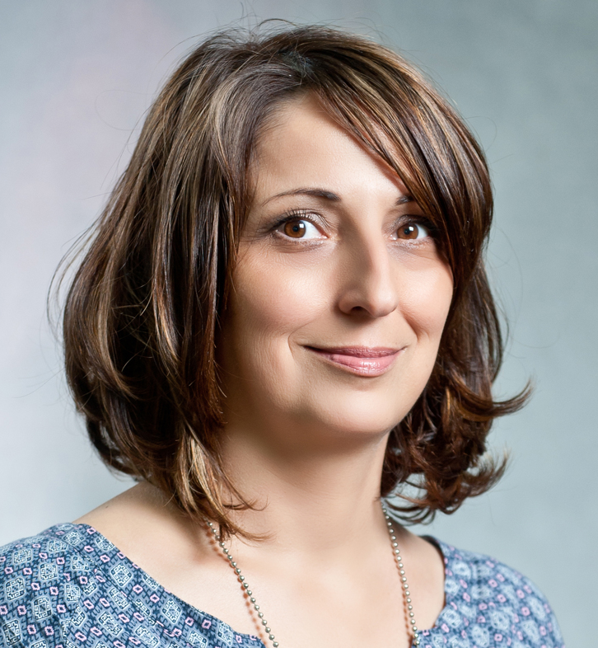

Docent je na Arhitektonskom fakultetu Univerziteta Crne Gore u Podgorici, gdje je zaposlena od 2004. godine. Magistrirala je na Arhitektonskom fakultetu „Ludovico Quaroni“ na Univerzitetu „La Sapienza“ u Rimu, kao stipendista italijanske Vlade i doktorirala na Arhitektonskom fakultetu u Beogradu. Dobitnica je brojnih inostranih stipendija (National Technical University of Athens; Institute for advanced interdisciplinary studies - I.S.U.F.I., University of Lecce; Junior Faculty Development Program College of Design, Iowa State University, Ames, USA). Saradjivala je sa kolegama i projektnim biroima u Crnoj Gori i inostranstvu, na brojnim arhitektonskim i urbanističkim projektima i realizacijama i učestvovala na arhitektonsko-urbanističkim konkursima i izložbama. Učestvovala je na XI Bijenalu arhitekture u Veneciji 2008. godine, kao i na velikom broju domaćih i medjunarodnih konferencija, seminara, radionica. Bila je mentor na više studentskih radionica i kongresa. Jedan je od dobitnika Trinaestojulske nagrade 2009. godine.
Bavi se naučno-istraživačkim radom u oblasti istorije i teorije arhitekture, interdisciplinarnih studija, javnih objekata i javnog prostora.

She is Assistant professor at Faculty of Architecture in Podgorica, where she works since 2004. Graduated at the Faculty of Architecture in Belgrade, obtained her M.Sc. at “Ludovico Quaroni“ Faculty of Architecture, University La Sapienza, Rome, as a scholar of the Italian Government and PhD thesis at the Faculty of Architecture in Belgrade. She was awarded of numerous scholarship (National Technical University of Athens; Institute for Advanced Interdisciplinary Studies - ISUFI, University of Lecce; Junior Faculty Development Program, College of Design, Iowa State University, Ames, USA). She has collaborated with colleagues and design offices in Montenegro and abroad in numerous architectural and urban projects and realizations, architectural and urban competitions and exhibitions. Participated in the XI Venice Architecture Biennale 2008, as well as in a large number of national and international conferences, seminars and workshops. She was a mentor to several student workshops and conferences, and a member of several professional jury and working groups. She was one of the award winners of the 2009 Montenegro State Award.
She is engaged in scientific research in the field of history and theory of architecture, interdisciplinary studies, public buildings and public space.

