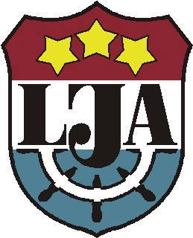


ERASMUS+ WEEK in LMA
23 – 27, April 2019
GENERAL INFORMATION

Time and Venue

Erasmus+ week will take place in April 23 – 27, 2019 (Tuesday-Saturday) in the premises of the
Latvian Maritime Academy located in 12 k-1, Flotes Street in Riga, Latvia

Preliminary programme

Tuesday, 23rd April – Arrival and/or guest lectures

Wednesday, 24th April – Welcome and a get-together meeting at LMA, opening remarks, presentations of partner universities; LMA campus tour; guest lectures/job shadowing; a visit to VTS and MRCC Riga (TBC)

Thursday, 25th April – Guest lectures and/or job shadowing; a workshop on motivation to participate in Erasmus+ mobility; a visit to Riga History & Navigation Museum (TBC)

Friday, 26th April – Lectures and/or individual staff meetings with counterparts at LMA; job shadowing; processing of Erasmus+ staff mobility papers; a closing discussion

Saturday, 27th April – cultural programme - a guided one-day trip to Rundāle Palace (see http://rundale.net/en/ ) (together with Erasmus+ incoming students). Arrival to Riga planned around 17.00 o’clock.

Sunday, 28th April – departure

Accommodation

We can offer accommodation in our hostel in the LMA campus. Accommodation comprises a single room with a kitchen, a shower and a WC being shared by tenants of two adjacent rooms for the price of 15 EUR per person per night. The LMA campus is located in Daugavgrīva, in the coastal area of Riga, about a 40 minutes trip from the city centre.

For information about recommended hotels in the city centre of Riga see an attachment.

For other options of hotel accommodation, please, see the website: http://www.liveriga.com/en/10-arrival or www.booking.com

We kindly ask you to make your own arrangements for travel and accommodation and remind that travel and accommodation costs related to participation in the Erasmus+ Week can be covered within the framework of the Erasmus+ programme staff mobility for teaching or training by your home HEI.

Transportation to Venue

We are planning to arrange a shuttle-bus transportation from a recommended hotel in the city centre to the campus of LMA on Tuesday and Wednesday. Detailed information will follow.

You can also reach LMA campus by a public bus No.3 which leaves from a bus stop in 13 Janvara Street in the city opposite the International Bus Terminal and goes to Daugavgrīva. It takes about 40-45 minutes to get to LMA campus from the city centre by bus. You should get off at the bus stop “Daugavgrivas cietoksnis” (Daugavgriva’s Fortress) and then walk about 200m along Flotes Street.

You can also reach the LMA campus by mini-buses No 246 and No 346.

It is cheaper to buy tickets for public transport in the newspaper kiosks NARVESSEN (1.15 EUR per trip) rather than from the drivers (2.00 EUR per trip). A trip by taxi will cost about 12-15 EUR.

Public transport schedules available at: http://saraksti.rigassatiksme.lv/index.html#riga/en

TAXI in Riga:
TAXIFY service in Riga: https://taxify.eu/cities/riga/
Panda Taxi: phone +371 67600000
Baltic Taxi: phone +371 20008500
Red Cab: phone +371 80001313

Getting to RIGA

By Bus

International bus schedules are available on the website: http://www.ecolines.net/?l=2

By Plane

Plain timetable are available on the website: http://www.lidot.lv/en/index.html

By Car

Information about travelling by car can be found on the website: www.viamichelin.com

Map
- Riga – Old Town (marked as Vecpilsēta, 11.novembra krastmala)
- Latvian Maritime Academy (marked as Flotes iela 12)
Address: 12 k-1, Flotes Street, Riga LV 1016, LATVIA

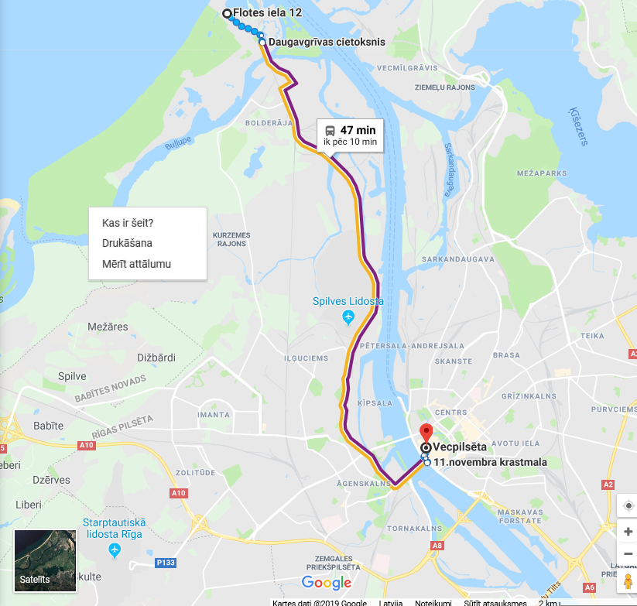

Additional information

More information about Riga is available here: http://www.liveriga.com/en/ and on the website of Latvian Institute: http://www.li.lv/en/news

If you have any questions, do not hesitate to contact us by email, phone or fax.

Latvian Maritime Academy  Foreign Relations Department  Address: 12 k-1, Flotes Street, Riga LV 1016, LATVIA  Phone: +371 67161130  Fax: +371 67830138  Email: vija.kasakovska@latja.lv  Website: www.latja.lv | Contact person:  Vija Kasakovska,  Head of Foreign Relations Department  Cell phone+371 28614151

