**Expressing habit**

Present Simple

1 Adverbs of frequency come before the main verb, but after the verb *to be.*

*We hardly ever go out.*

*She frequently forgets what she's doing.*

*We don't usually eat fish.*

*J rarely see Peter these days.*

*We are seldom at home in the evening.*

*Is he normally so bad-tempered?*

*2 Sometimes, usually,* and *occasionally* can come at the beginning or the end of a sentence.

*Sometimes we play cards.*

*We go to the cinema occasionally.*

The other adverbs of frequency don't usually move in this way.

*~~Always I have~~ tea in the morning.*

**Present Continuous**

1 The Present Continuous can be used to express a habit which happens often and perhaps unexpectedly. It happens more than is usual.

*I like Peter. He's always smiling.*

*She's always giving people presents.*

2 However, there is often an element of criticism with this structure.

Compare these sentences said by a teacher.

*Pedro always asks questions in class.* (This is a fact.)

*Pedro is always asking questions in class.* (This annoys the teacher.)

3 There is usually an adverb of frequency with this use.

*I'm always losing my keys.*

*She's forever leaving the bath taps running.*

***will* and *would***

*1 Will* and *would* express typical behaviour. They describe both pleasant and unpleasant habits.

*He'll sit at his computer for hours on end.*

*She'd spend all day long gossiping with the neighbours.*

*Would* cannot be used to express a state.

*~~He’d live in a large house~~.*

*2 Will* and *would,* when not contracted and stressed, express an annoying habit or action.

*He WILL come into the house with his muddy boots on.*

*She WOULD make us wash in ice-cold water.*

***used* to + infinitive**

1 This structure expresses a past action and/or a state. It has no present equivalent.

*When I was a child, we used to go on holiday to the seaside.* (action)

*He used to live* in *a large house.* (state)

2 Notice the negative and the question.

*Where did you use to go?*

*We didn't use to do anything interesting.*

3 We cannot use *used to* with a time reference + a number.

*~~We used to have holiday there for ten years/ three times.~~*

But…

*We used to go there every year.*

In a narrative, when expressing a series of past actions, it is common to begin with *used to,* then continue with *would,* for reasons of style.

*When I was a child, we used* to *go on holiday to the seaside. We'd play on the beach, then we'd eat at a small cafe at lunchtime.*

***be/get used* to + noun + *-ing* form**

1 This is totally different from *used to* + infinitive. It expresses an action that was difficult, strange, or unusual before, but is no longer so. Here, *used* is an adjective, and it means *familiar with.*

*I found it difficult to get around London when I first came, but I'm*

*used* to *it now.*

*I'm used to getting around London by tube.*

2 Notice the use of *get* to express the process of change.

*I'm getting used* to *the climate.*

*Don't worry. You'll get used to eating with chopsticks.*

*Unit 9 The way we are*

Test your grammar, p.70:

* Do exercises 1 and 2 after reading the section on expressing habits above. Recognize the forms of different ways of expressing present and past habit, and *be used to*.

Move to *Getting back in touch* section on the same page and read the message from Alison. Do exercise 2 and 3, p. 70 and exercises 4 and 5, p.71.

The aim of this section is to revise and practice ways of expressing present habit: the Present Simple, the Present Continuous with a frequency adverb, and *will + infinitive*. It also looks at used to and would to express a past habit and the confusion between *used to + infinitive* to describe past state or habit and *be/get used to + -ing* to talk about the situations that you are familiar with or becoming familiar with. The practice exercises focus on the importance of context in choosing and using these forms.

Read the Language Focus section on page 71. The following are the answers to the questions in this section:

1. 
2. 
3. 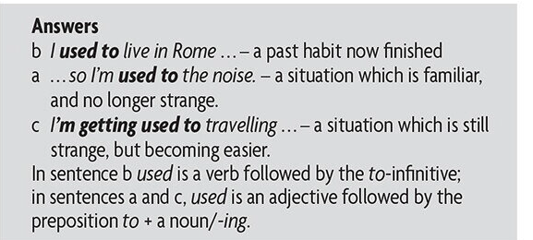

PRACTICE

What’s she like, p.71 Do exercise 1

Vocabulary help:

Clumsy

Sensible-able to make good judgements (razuman)

Sensitive-easily offended/sympathetic to others’ feelings (osjetljiv ili saosjećajan)

Bump into-knock into

Bloke-informal, British for “man”)

Pick a fight-start a fight on purpose

Discussing grammar, p.72

Do exercises 3 and 7 on page 72

Vocabulary help:

Gadget-a small specialized mechanical or electronic device

Techno-geek-someone obsessed with technology

Sandcastle-a mass of sand moulded into a castle-like shape, esp. as made by a child on the seashore

Wasteful- tending to waste or squander; extravagant

Key to exercises:

p. 70 Test Your Grammar

Exercise 1



Exercise 2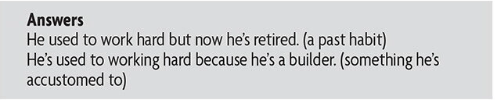

Getting back in touch, p. 70

An email to a friend

Dear Sally,

I hope you don't mind me contacting you out of the blue like this. It's taken me a while to track you down, but now I have, thanks to the wonders of Facebook! I don't know if you remember but we used to go to Allendales School together. You were the first person 1 got to know when I started there. We used to sit next to each other in class, but then the teachers made us sit apart because we were always giggling so much. I remember we'd go back to your house after school every day and listen to music for hours on end. We'd get all the Guns N' Roses CDs as soon as they came out. Once we ate all the food in your fridge and your mother was furious. Do you remember that time we nearly blew up the science lab? The teacher went crazy, but it wasn't our fault. We used to call him 'Homer Simpson' because he was small, fat, and bald. I still see Penny, and she's still as mad as ever. We meet up every now and again, and we'll always end up chatting about old times together. She's always talking about a school reunion. So if you're interested, drop me a line.

Looking forward to hearing back from you. It would be great to know how you're doing.

Your old schoolmate

Alison Makepeace

PS I'm not used to calling you Sally Davies! To me, you're still Sally Wilson!

Exercise 3

Exercise 4, p.71

We used to go to school together….is more factual.

We’d go back to your house….is more nostalgic.

Exercise 5, p.71

Practice, What’s she like?, p.71, Exercise 1

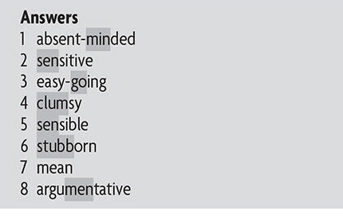

Discussing grammar, p.72

Exercise 3



Exercise 7

Exercise 7