GEOLOGIJA I GEOMORFOLOGIJA SVJETSKOG MORA

1. Navedi I opiši teorije o nastanu planete Zemlje?

* Kant-Laplasova teorema

_________________________________________________________________________________________________________________________________________________________________________________________________________

* Džinskova teorema

_________________________________________________________________________________________________________________________________________________________________________________________________________

* Hipoteza vruće magline

_______________________________________________________________________________________________________________________________________________________________________________________________________________________________________________________________________________________________________________________________________________

1. Gradja zemljine kore – u građi Zemlje izdvajaju se tri sloja, na slici ispod upisite koji su to slojevi, a u prostoru ispod slike napisite i objasnite karakteristike slojeva:

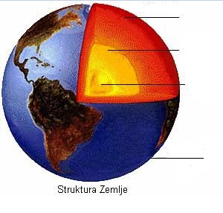

______________________________________________________________________________________________________________________________________________________________________________________________________________________________________________________________________________________________________________________________________________________________________________________________________________________________________________________________________________________________________________________________________________________________________________________________________________________________________________________________________________________________________________________________________________________________________________________________________________________________________________________________________________________________________________________________________________________________________________________________________________________________________________________________________________________________________________________________________________________________________________________________________________________________________________________

1. Šta je geotermalni stupanj (gradijent)?

_________________________________________________________________________________________________________________________________________________________________________________________________________

1. Opiši kontinentalnu i okenasku koru?

____________________________________________________________________________________________________________________________________________________________________________________________________________________________________________________________________________

1. Na karti upišite imena tektonskih (litosfernih) ploča?

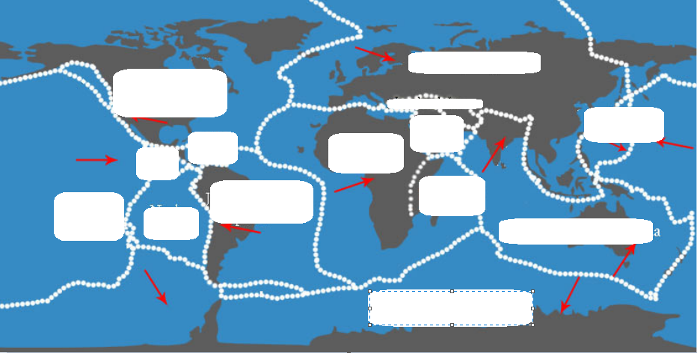

1. Prepoznaj i opiši sledeće tipove granica ploča?

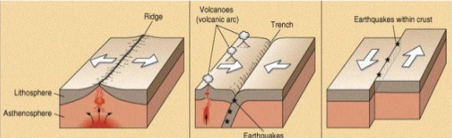

___________________________________________________________________________________________________________________________________________________________________________________________________________________________________________________________________________________________________________________________________________________________________________________________________________________________________________________________________________________________________________________________________________________________________________________________________________________________

1. Koje instrumente koristimo za mjerenje dubine mora?

______________________________________________________________________________________________________________________________________

1. Šta je batimetrija?

______________________________________________________________________________________________________________________________________

1. Koja je standardna jedinica za mjerenje dubine?

______________________________________________________________________________________________________________________________________

1. Objasnite sledeće pojmove:

* Kontinentalni šelf ili kontinentalni odsjek

__________________________________________________________________________________________________________________________________________________________________________________________________________________________________________________________________________________________________________________________________________________________________________________________________________________

* Kontinentalni odsjek ili kontinentalna padina

_______________________________________________________________________________________________________________________________________________________________________________________________________________________________________________________________________________________________________________________________________________

* Abisalna ravnica

______________________________________________________________________________________________________________________________________

* Koline, jarci i druga udubljenja

______________________________________________________________________________________________________________________________________

1. Udubljeni ooblici dubokog mora:

* Korito ________________________________________________________ _____________________________________________________________
* Kotlina ili zavala _______________________________________________ __________________________________________________________________________________________________________________________
* Žlijeb __________________________________________________________________________________________________________________________
* Potolina, jarak ili rov ____________________________________________ __________________________________________________________________________________________________________________________
* Kazan ________________________________________________________ _____________________________________________________________
* Brazda _______________________________________________________ _____________________________________________________________
* Dolina _______________________________________________________ __________________________________________________________________________________________________________________________
* Kotline, jarci i rovovi ____________________________________________ _____________________________________________________________

1. Uzvišenja u morskom reljefu:

* Prag _________________________________________________________
* Bilo ili hrbat ___________________________________________________ _____________________________________________________________
* Plato ili ravnjak ________________________________________________ _____________________________________________________________
* Banak ________________________________________________________
* Greben _______________________________________________________
* Plićak ________________________________________________________
* Ostenjak _____________________________________________________

1. Šta je abisalna ravnica ?

________________________________________________________________________________________________________________________________________________________________________________________________

1. Objasni razliku između kontinentalnog odsjeka i kontinentalnog nagiba?

________________________________________________________________________________________________________________________________________________________________________________________________________________________________________________________________________________________________________________________________________________________________________________________________

1. Šta su okeanski lanci ili hrptovi?

_________________________________________________________________________________________________________________________________________________________________________________________________________

1. Šta je srednjeokeanski greben?

_________________________________________________________________________________________________________________________________________________________________________________________________________________________________________________________________________________________________________________________________________________________________________________________________________________________________________________________________________________________________________________________________________________________________________________________________________________________________________________________________________________________________________________________________________________________________

______________________________________________________________________________________________________________________________________

1. Koje su tri velike oblasti okeanskog dna?

* _______________________________________________________________________________________________________________________________________________________________________________________
* _______________________________________________________________________________________________________________________________________________________________________________________
* _______________________________________________________________________________________________________________________________________________________________________________________

Zemljotrsi i mora

1. Navedi tri glavna seizmička pojasa:

* _______________________________________________________________________________________________________________________________________________________________________________________
* _______________________________________________________________________________________________________________________________________________________________________________________
* _______________________________________________________________________________________________________________________________________________________________________________________

1. Objasni korelaciju između zemljotresa i talasa?

_____________________________________________________________________________________________________________________________________________________________________________________________________________________________________________________________________________________________________________________________________________________________________________________________________________________________________________________________________________________

1. Šta je hipocentar, a šta epicenter?

_______________________________________________________________________________________________________________________________________________________________________________________________________________________________________________________________________________________________________________________________________________

1. Obala, tipovi obala, razuđenosti i oblici

* Tipovi obala:
* ____________________________________________________________________________________________________________________________________________________________________________________________________________________________________________________
* _______________________________________________________________________________________________________________________________________________________________________________________
* __________________________________________________________________________________________________________________________
* __________________________________________________________________________________________________________________________
* __________________________________________________________________________________________________________________________
* __________________________________________________________________________________________________________________________
* __________________________________________________________________________________________________________________________

1. Kako možemo podijeliti obale?

_________________________________________________________________________________________________________________________________________________________________________________________________________

1. Podjela obala po genezi (objasniti)?

* _______________________________________________________________________________________________________________________________________________________________________________________
* _______________________________________________________________________________________________________________________________________________________________________________________
* _______________________________________________________________________________________________________________________________________________________________________________________

1. Objasni sledeće oblike reljefa duž obaleČ:

* Klif _________________________________________
* Rt ___________________________________________________________ __________________________________________________________________________________________________________________________
* Tombola ili prevlaka________________________________________________________________________________________________________________________________________________________________________________
* Ostrva _______________________________________________________ ___________________________________________________________________________________________________________________________________________________________________________________________________________________________________________________________________________________________________________________________________________________________________________________________________________________________________________
* Poluostrva ____________________________________________________ _______________________________________________________________________________________________________________________________________________________________________________________
* Zalivi ________________________________________________________ _____________________________________________________________
* Fjordovi ______________________________________________________
* Rijasi ________________________________________________________ _____________________________________________________________
* Zatoni ________________________________________________________ _____________________________________________________________
* Estuari _______________________________________________________ _______________________________________________________________________________________________________________________________________________________________________________________
* Limani _______________________________________________________ _______________________________________________________________________________________________________________________________________________________________________________________
* Lagune _______________________________________________________ __________________________________________________________________________________________________________________________
* Zemljouzi _____________________________________________________ __________________________________________________________________________________________________________________________
* Morski prolazi _________________________________________________ __________________________________________________________________________________________________________________________
* Morski kanali __________________________________________________ _______________________________________________________________________________________________________________________________________________________________________________________