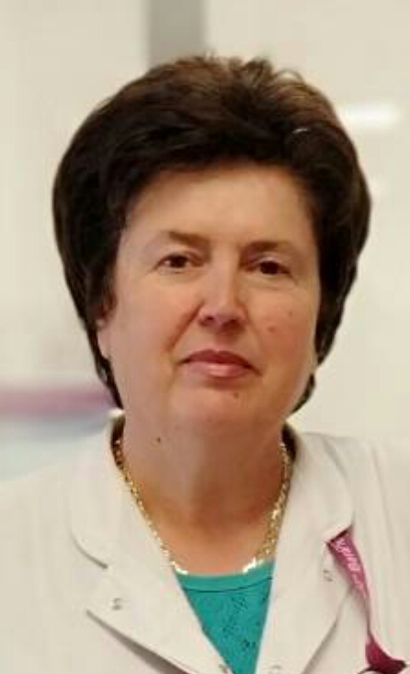
CV RADMILA PREMOVIĆ

PERSONAL DATA
Name | RADMILA
Surname | KILIBARDA PREMOVIĆ
Date and place of birth | 07.07.1959 god. Nikšić  (lived in Herceg Novom od 1965 do 1985)
Address | Beranselo bb
Town | 84300 Berane
Country - Citizenship | Montenegro
  Contact phone
  e-mail
  +38268449831
  +38267816660

- Completed the College of Physiotherapy – University of Zagreb
- Started to work in 1981 in Medical center “Dr Nika Labovic” in Berane
- Major physiotherapist since 1981.
- Physiotherapist in charge since 2018.

Teacher of practical classes in Medical school “Dr Branko Zogovic” in Berane since academic year 2008/2009.

Teacher of practical classes for the following subjects:

- Manual techniques
- Patient care
- Physiotherapy
- Special chinese therapy
- Neurorehabilitation

