Ime i prezime____________________________ Br. bodova ________/45

I Match the given items with their definitions. There are some extra items (5 pts)
feat seal rebate feed carpooling draught telecommute gap dissipate utility alloy anticipate pick up thereby fraction latitude keen peak

1. by that means, as a result of that ………………………….
2. a metal made from two or more metals ………………………….
3. part, portion ………………………….
4. continue, start again ………………………….
5. a public service such as electricity or water ………………………….
6. enthusiastic ……………………..
7. work from home ……………………..
8. the distance from the equator ……………………..
9. think that something will happen, expect ………………………….
10. gradually be lost or disappear ………………………….

II Complete the sentences below using the words from the box. There are some extra words that you will not have to use (10 pts)
Diverse plummet volatile zigzag soars rocketed slumped set off strung vulnerable insulated transmitted plateaued dissipated blackout

1. Distribution companies' profits have …………………………. as electricity demand dropped during the lockdown.
2. Overhead cables are not …………………………. and are …………………………. To the weather but are cheaper to install than underground power cables
3. There is a growing need for reliable, …………………………. sources of electricity.
4. An Ohio power company …………………………. the largest …………………………. in human history due to human error.
5.Toxic emissions have …………………………. since 2018.
6. How much electricity is …………………………. in transit?
7. When temperatures …………………………., electricity use typically …………………………..

III Make the sentences passive or active ( 6 pts):
1. To make high-voltage electricity transport possible, the electricity must first be converted to higher voltages with a transformer_________________________________________________________________________________________
2. A digital meter measures how much electricity is being used.
___________________________________________________________________________________________________
3. The engineers were doing some final calculations when the manager came.
___________________________________________________________________________________________________
4. We cannot yet build batteries with sufficient energy storage
______________________________________________________________________________________________
IV Make the sentences passive using reporting verbs (8 pts)
Scientists know that pollen allergy affects a lot of people.

________________________________________________________________________________________________
Scientists believe that the big bang happened 13.7 billion years ago.

________________________________________________________________________________________________
Experts say that 8 hours sleep is the perfect amount.
________________________________________________________________________________________________

Researchers think that over 75% of road accidents are avoidable.
_____________________________________________________________________________________________

IV Complete the following chart description (10 pts ).

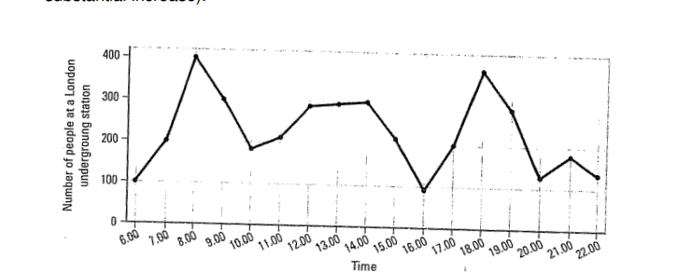
The graph shows the f………………… in the number of people at a London underground station over the course of a day. According to the graph there is a sh…………………increase between 6:00am and 8:00am in the morning, with 400 people using the station at 8am. After this, the numbers fall d…………………to fewer than 200 at 10am. Between 11:00am and 3:00pm the number of people rises and falls within a pl…………………around lunchtime of just under 300 people using the station. Numbers then d………………… with the lowest number being re …………………at 4:00pm in the afternoon. There is then a ra………………… r…………………between 4:00pm and 6:00pm in the evening rush hour with a …………………of 380 people at 6:00pm. After 7pm numbers fall s…………………, with only a s………………… increase again just after 8pm, tailing off after 9pm. The graph shows that the station is most crowded in the early morning and early evening rush-hour periods.
V Complete the second sentence so that it has the same meaning as the first. Write two or three words ( 6 pts 1.5 pts each

1.Sales grew rapidly in the first quarter, then slowed down considerably.

The _______________ sales was rapid in the first quarter, then slowed down considerably.

2. There was a lot of fluctuation in their income between 2014 and 2016.
Their income _______________ between 2014 and 2016.

3. The popularity of the sport declined considerably over the following few years.
There was a _______________ in the popularity of the sport over the following few years.

4.Ownership of tablets surged dramatically between October and December.
There was a _______________ ownership of tablets between October and December.

