Ime i prezime____________________________ Br. bodova ________/45
I Match the given items with their definitions. There are some extra items (5 pts)
Facility adjust ramp up utility vital alloy reinforced pick up anticipate fluctuation blackout diverse fraction peak rebate draught seal latitude feat recoup fairly prevailing telecommute gap
1. different from each other ………………………….
4. adapt ………………………….
6. the highest point ………………………….
7. something impressive achieved by someone ………………………….
11. a period when there is no electricity ………………………….
13. rising and falling in the amount of something ………………………….
16. premises and equipment ………………………….
18. important, essential ………………………….
21. dominant ……………………..
25. to some degree, rather ……………………..
26. close tightly ……………………..
II Complete the sentences below using the words from the box. There are some extra words that you will not have ro use (10 pts)
ramped up evolved demand blackout growing demand reliable peaks transmission accommodate zigzag soars rocketed slumped transmitted plateaued dissipated

1. A historic ……………………… in 2003 showcased why effective grid ……………………… is so important.
2 It has changed and ……………………… rapidly over the last century to ……………………… new technologies, increases in electricity ………………………, and a……………………… need for ………………………, diverse sources of electricity.
3. Other plants, such as natural-gas fired plants, can be ……………………… very quickly, and are often used to meet ……………………… in ……………………….
III Make the sentences passive or active ( 6 pts):
1. By the year 2030 engineers will have made more efficient grids_________________________________________________________________________________________
2. Some final calculations were being done when the manager came.
___________________________________________________________________________________________________
3. At first they ignored electric service for rural areas.
___________________________________________________________________________________________________
4. In some areas of Brazil they stole up to 40% of energy from the grid.
___________________________________________________________________________________________________
IV Make the sentences passive using reporting verbs (8 pts)
They believe that the fossil dates back to the Miocene. __________________________________________________________________________________
They know the suspect left the city after the murder.
________________________________________________________________________________________________
Newspapers allege that the CEO disappeared with over £1.5 million.
________________________________________________________________________________________________

They believe the fire started in the lounge.
__________________________________________________________________________________

V Complete the following chart description ( 10 pts each ).
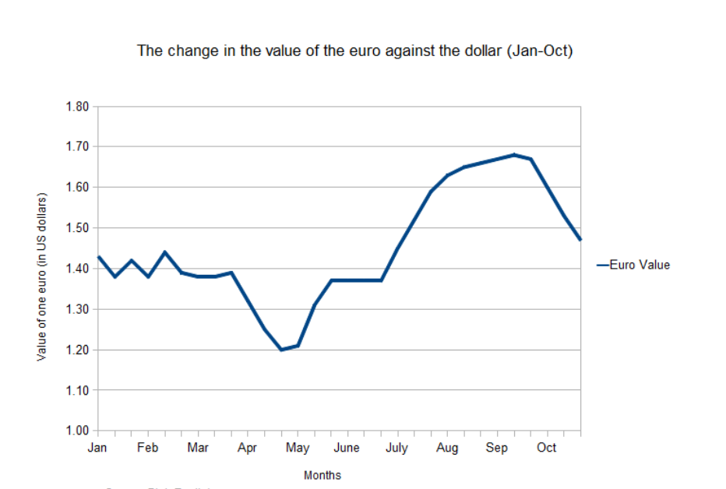This chart shows the changes in the value of the euro against the US dollar between January and October of 2010.
As you can see, in January and February the value of one euro f………………… between $1.38 and $1.45. By March, this fluctuation stopped and the value se………………… down. During the month of April, the value of the euro p…………………. It reached its lo………………… point of $1.20 at the end of April. During May, the value of the euro re…………………. Slightly at first, but then more sharply between the middle and the end of the month.
Throughout the month of June, the value of the euro remained c………………… at a value of $1.37. But this changed in July, when the value s………………… from $1.37 to $1.66 due to fears about the level of US government debt. In August, this dramatic rise l………………… off. This levelling off continued into the month of September, where the euro's value p………………… at $1.68. But during October the value f………………… back, finishing the month with a value of $1.47.'
V Complete the second sentence so that it has the same meaning as the first. Write two or three words ( 6 pts 1.5 pts each

- There was a gradual increase in levels of interest after 2013.
Levels of interest _______________ after 2013.
- Despite the levelling-off of sales in 2012, production was increased.
Although sales _______________ in 2012, production was increased.
- There was a significant decline in profits in the second quarter.
Profits _______________ the second quarter.
- The price suddenly surged at the end of 2016.
The price _______________ up at the end of 2016.

