**Accelerating Change at Microsoft**

* [John P. Kotter](https://hbr.org/search?term=john%20p.%20kotter)

A recent Wall Street Journal [article](http://online.wsj.com/news/articles/SB10001424052702303460004579194150724298162)quotes Steve Ballmer as saying: “the best way for Microsoft to enter a new era is with a new leader who will accelerate change.” Amen to that.

Since I didn’t load up on [Microsoft stock](http://qz.com/105974/microsofts-weak-performance-makes-it-more-vulnerable-to-activist-pressure/) when Mr. Ballmer took the reins, I have no personal peeve against him. In fact, I can actually feel sympathy for him. He took over an organization that had gone through a period of incredible success. With it came all of the usual problems of such success: A culture of arrogance. Competitive juices turned inward creating a deeply political environment. Complacency. Good luck trying to accelerate with those anchors hanging on the corporate ship.

And that brings us to the challenge for the new boss. He or she needs to get the organization to accelerate, yes. But the new CEO will have people who probably think they are already going as fast as they can. And they’re probably going in six different directions, or around in circles. He will have people who think they’re smarter than the new boss and who probably begrudge that they, or their mentor, didn’t get the CEO job. And he will likely be surrounded by people who will tell him that if only we do this little thing, or that little set of things, we can break out of our stall — which is a fantasy. It’s a big, heavy stall and nothing little is going to break them out of it.

**Can such a large, hierarchical organization accelerate into a better future? Can it become more strategically nimble in an increasingly chaotic environment?**Yes. But the problem is systemic and can’t be solved with a quick fix. As I have written about [previously](https://hbr.org/2012/11/accelerate/ar/1), we need a whole new system that enables the organization to capitalize on opportunities and dodge threats, and yet still make the numbers — a kind of dual operating system. This system is real and I have seen it in action,  but it takes real work to build.

Step one in the journey toward building this totally new way of operating at Microsoft will be creating a genuine sense of urgency around the right big, rational yet emotionally compelling opportunity. And I mean urgency not just among the 5% of “important” people. The new boss will need at least 51% of everyone. 80% would be better. This is so far from where they’re at right now. Where there is arrogance, people have no sense of urgency, and where there is politics, people, even if they do have urgency, will never have any alignment.

So, is it possible for the new boss to break Microsoft out of its slump, where for the last decade its batting average has been about .109? The answer is yes. But change will only be real and sustainable if he or she steps back to look at the whole operating system, and then focuses on the right opportunities to raise urgency.

**What Do You Really Mean by Business “Transformation”?**

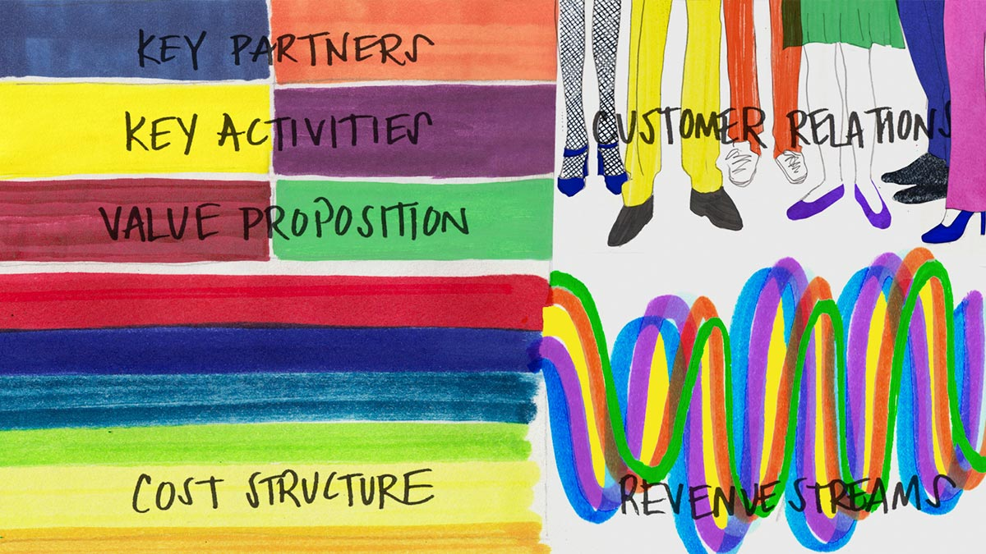

JENNIFER MARAVILLAS FOR HBR

Today’s corporate watchword word is *transformation*, and for good reason. One [study](http://www.innosight.com/innovation-resources/strategy-innovation/upload/creative-destruction-whips-through-corporate-america_final2015.pdf) suggests that 75% of the S&P 500 will turn over in the next 15 years. [Another](https://hbr.org/2016/01/the-biology-of-corporate-survival) says that one in three companies will delist in the next five years. A third [shows](https://hbr.org/2005/03/the-faster-they-fall) that the “topple rate” of industry leaders falling from their perch has doubled in a generation. [Software](http://www.wsj.com/articles/SB10001424053111903480904576512250915629460) is eating the world. [Unicorns](http://fortune.com/2015/01/22/the-age-of-unicorns/) are prancing unabated. Executives at large companies rightly recognize that they need to respond in turn.

And yet.

When executives say transformation what do they *really* mean? Often, the word confuses three fundamentally different categories of effort.

The first is *operational,*or doing what you are currently doing, better, faster, or cheaper. Many companies that are “going digital” fit in this category — they are using new technologies to solve old problems. A big operational change can be jarring and drive real business impact, but it doesn’t fit dictionary definitions of transformation, such as “a marked change in form, nature, or appearance” or “to change (something) completely and usually in a good way.” Sure, costs will be lower, customer satisfaction might go up, but the essence of the company isn’t changing in any material way. And, in a quickly changing world playing an old game better is simply insufficient.

The next category of usage focuses on the *operational model.*Also called core transformation, this involves doing what you are currently doing in a fundamentally different way. Netflix is an excellent example of this type of effort. Over the last five years Netflix has shifted from sending DVDs through the mail to streaming video content through the Web. It also has shifted from simply distributing other people’s content to investing heavily in the creation of its own content, using its substantial knowledge of customer preferences to maximize the chances that content will connect with an audience. Customers still turn to Netflix to be entertained and to discover new content, but the fundamental way Netflix is solving that problem has changed almost completely.

The final usage, and the one that has the most promise and peril, is *strategic*. This is transformation with a capital “T” because it involves changing the very essence of a company. Liquid to gas, lead to gold, Apple from computers to consumer gadgets, Google from advertising to driverless cars, Amazon.com from retail to cloud computing, Walgreens from pharmacy retailing to treating chronic illnesses, and so on. Executed successfully, strategic transformation reinvigorates a company’s growth engine. Poor execution leads naysayers to pounce and complain that a company should have “stuck to its knitting.”

Defining what leaders mean when they drop the word *transformation* matters, because these different classes of efforts need to be measured and managed in vastly different ways. Operational model transformation should change the metrics the company uses to track performance. For Netflix, a DVD-based model requires managing warehouse utilization and physical distribution costs. A streaming model requires managing website uptime and bandwidth costs. If a company is using the same metrics before and after its so-called “transformation” effort, it really hasn’t transformed in any material way. Strategic transformation changes a company’s competitive set. In its core advertising business, Google competes against other content and technology players; its driverless car will competes against manufacturers like General Motors and BMW. Similarly, historically Apple competed against Microsoft, IBM, and Dell; the iPod and iPhone led it to take on new companies like Sony, Nokia, Motorola, and more.

Not all of these efforts are of equal impact. Focusing on “today better” operational efforts does nothing more than create parity with the best executors of yesterday’s model. It is a recipe for short-term survival, not long-term sustainability. Leaders instead should be thinking about how to blend together operational model and strategic transformation to execute what Innosight calls a [*dual transformation*](https://hbr.org/2012/12/two-routes-to-resilience). “Transformation A” strengthens today by reinventing the core operating model. “Transformation B” creates tomorrow’s core business. The efforts should be connected and coordinated through a carefully constructed capabilities link. This is the way that leaders can rise to the existential challenge of disruptive change to own their future, rather than be disrupted by it.