PERSONAL INFORMATION | Anja Glogovac
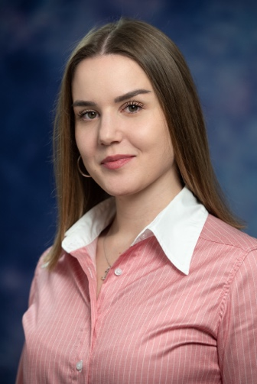 | Moskovska 76, 81 000 Podgorica, Montenegro
 | +382 (0)68 688 287
 | anja.g@ucg.ac.me, anjaglogovac2803@gmail.com
 | Viber +382 (0)68 688 287
 | Sex female | Date of birth 28 March 2000 | Nationality Montenegrin

WORK EXPERIENCE

2024 - present | Teaching Assistant
University of Montenegro (UoM) [https://www.ucg.ac.me/ ]
Faculty of Civil Engineering (FCE) [https://www.ucg.ac.me/gf ]
Podgorica, Montenegro
- Teaching assistant in courses from the domain of Technical mechanics and theory of structures
- Scientific research and engineering activities

2022 - 2023 | Student Demonstrator
University of Montenegro (UoM) [https://www.ucg.ac.me/ ]
Faculty of Civil Engineering (FCE) [https://www.ucg.ac.me/gf ]
Podgorica, Montenegro
 | - Demonstrator in courses from the domain of Construction materials and Geotechnics

EDUCATION AND TRAINING

2022-present | MSc (Master of Science) | EQF level 8
 | Faculty of Civil Engineering, University of Montenegro (Montenegro)
- Specialisation: Construction
- Structure: 12 courses/exams + MSc thesis (4 semesters)
- MSc thesis: Analysis of the material imperfections influence on the ultimate load capacity of locally loaded metal I girders.

2019-2022 | BSc (Bachelor of Science) | EQF level 6
 | Faculty of Civil Engineering, University of Montenegro (Montenegro)
 | - Structure: 36 courses (6 semesters)

PERSONAL SKILLS

Mother tongue(s) | Montenegrin
Other language(s) | UNDERSTANDING |  | SPEAKING |  | WRITING
 | Listening | Reading | Spoken interaction | Spoken production
English | C1 | C1 | C1 | C1 | C1
French | A2 A2 A2 A2 A2
Levels: A1/2: Basic user - B1/2: Independent user - C1/2 Proficient user
Common European Framework of Reference for Languages

Communication skills | - Good communication skills gained through teaching experience.

Organisational / managerial skills | I am a responsible and well-organized person. I complete all my tasks and obligations ahead of time. I equally enjoy and excel in both team and individual work. I learn quickly, adapt easily, and I am motivated by challenges.

Computer skills | - excellent command of Microsoft Office™ tools  - good command of AutoCAD  - good command of ArmCAD  - good command of SAP 2000  - good command of Tower7  - good command of Abaqus

Other skills | /

Driving licence | B

ADDITIONAL INFORMATION

Honours and awards | - Award for the best student of the Faculty of Civil Engineering by the University of Montenegro, 2021.  - Award for the best student by the Faculty of Civil Engineering in the following years:  2020  2021  2022  - in elementary and high school; diploma “Luča I”

