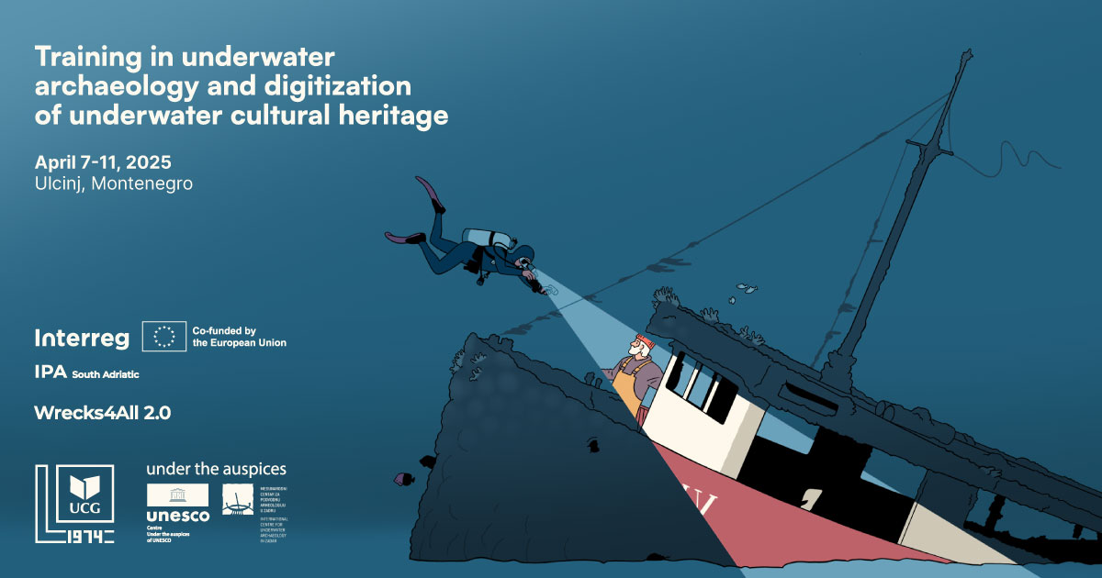

**🌊 Call for Participants: Underwater Archaeology & Digital Heritage Training**

📍 **Ulcinj, Montenegro**  
📅 **April 7–11, 2025**

🚀 **Join a specialized training program on underwater archaeology, 3D photogrammetry, and digital heritage promotion!**

👥 **Who can apply?**  
🔹 Citizens of **Montenegro & Albania**  
🔹 Background in **diving, archaeology, or cultural heritage**  
🔹 **Scuba certification desirable, but not required**📌 **Selection of participants will be based on the quality of the submitted CVs, with priority given to candidates whose experience and professional background demonstrate the potential to apply the gained knowledge within their respective organizations, institutions, and research initiatives.**

📌 All project participants are required to independently arrange **insurance for any accidents**, including diving-related incidents.

📩 **Apply now!** Send your **CV & dive certification (if available)** to [**darkok@ucg.ac.me**](mailto:darkok@ucg.ac.me) by **10th of March 2025**.

🎓 **International certification of attendance upon completion!**

📌 **Organized by Center of Archaeology, University of Montenegro & International Center for Underwater Archaeology, Zadar within (under the auspices of UNESCO and UNESCO UNITWIN network for Underwater Archaeology) WRECKS4ALL 2.0, co-funded by IPA South Adriatic Programme.**